
_______________________________________________________________________________________
AWARDEE REPORT FORM
_______________________________________________________________________________________

NAME |  | Maclyn Abraham Augustine
UNIVERSITY |  | University of Southampton
NAME OF AWARD |  | Barclay Smith Award
PURPOSE OF AWARD conference/event attended/organised (full name) with city and dates.
To enable my attendance at the IFAA Congress, ExCel Centre, London, 9th-11th August 2019.

REPORT: What were your anticipated benefits?
I anticipated that the award would enable me to attend the IFAA 2019 and present a poster detailing results of research conducted during the summer vacation with the support of the Anatomical Society via the Undergraduate Summer Vacation Research Scholarship.
COMMENTS: Describe your experience at the conference / lab visit / course / seminar/ event.
The conference was a fantastic experience, with many learning and networking opportunities available. Attending various talks helped deepen my understanding of a variety of anatomy-related subjects, from the latest research in anatomical education to forensic clinical anatomy. Presenting my poster to an international audience provided the opportunity to meet and share ideas with delegates from different institutions around the world.

The photo displayed below is one of me standing (extremely proudly!) beside my poster during the session at the IFAA. 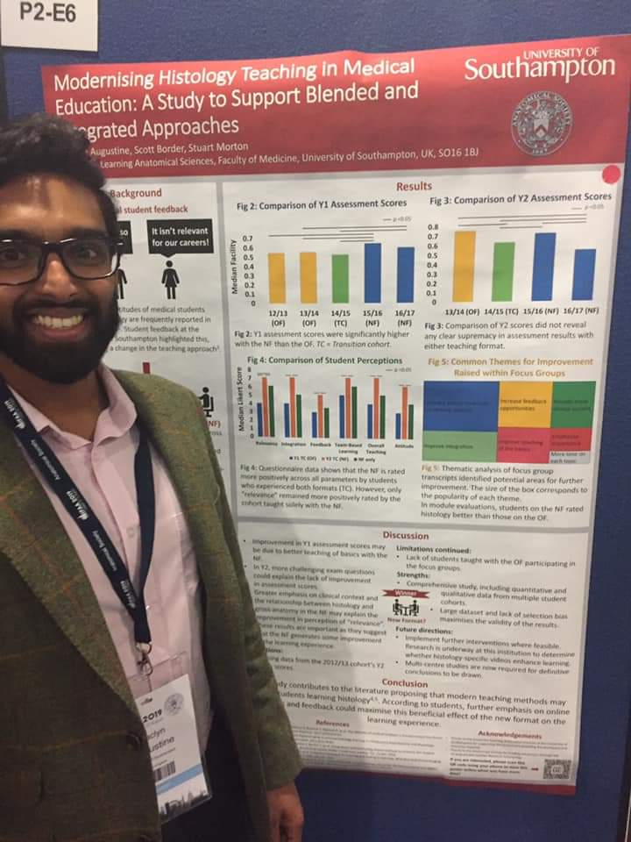
REPORT: In relation to skills, what were the most important things you gained? (does not apply to equipment grant. For public engagement/outreach awards what did your audience gain and how did you evaluate success?
I gained vital experience of the organisation of an international conference, and was able to develop my networking and presentation skills as I shared details of my research with many delegates at the IFAA 2019.

REPORT: How do you think you will put this learning experience into practice in the future? For public engagement/outreach awards how will the materials/knowledge generated by this activity be used in the future?
These experiences will be vital for success in my future career as an academic clinician, as I aim to conduct research to a high standard and disseminate results through both publication and attendance at future conferences. As such, gaining an understanding of the workings of international, academic conferences such as the IFAA 2019 are hugely important for me. Additionally, presenting a poster at the IFAA gave me invaluable experience of designing an academic poster whilst taking into consideration an international audience, and physically presenting the poster to delegates will help me in any future presentations/talks, when I hope to describe and discuss any research in the future.
Data Protection/GDPR: I consent to the data included in this submission being collected, processed and stored by the Anatomical Society.
YES
Graphical Images: If you include graphical images you must obtain consent from people appearing in any photos and confirm that you have consent. A consent statement from you must accompany each report if relevant. A short narrative should accompany the image.
YES.

Copyright: If you submit images you must either own the copyright to the image or have gained the explicit permission of the copyright holder for the image to be submitted as part of the report for upload to the Society’s website, Newsletter, social media and so forth. A copyright statement must accompany each report if relevant.
YES

SIGNATURE | Maclyn Abraham Augustine |  | DATE | 11/08/2019
If submitted electronically, a type-written name is acceptable in place of a hand-written signature

File: AS-Award-Report-Form-BLANKCO-SEAL-date110216-Amended AT-070818

