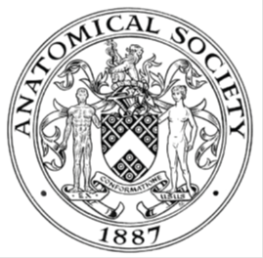
_______________________________________________________________________________________
AWARDEE REPORT FORM
_______________________________________________________________________________________

NAME |  | Kayleigh Scotcher
UNIVERSITY |  | Newcastle University
NAME OF AWARD |  | Symington Bequest Fund Awards 2021/22
PURPOSE OF AWARD conference/event attended/organised (full name) with city and dates.
Early Career Anatomy Academics Conference 2022, School of Anatomy University of Bristol, Bristol, 14th to 15th June 2022

REPORT: What were your anticipated benefits?
I submitted an abstract for the platform presentation on my teaching approach and research called ‘Draw Along with Complete Anatomy: A teaching tool for neurovasculature’. I wanted to share my experience and findings around this approach.

I also felt I would benefit from networking with other early career anatomists.
COMMENTS: Describe your experience at the conference / lab visit / course / seminar/ event.
The Early Career Anatomy Academics Conference was fantastic. A particular highlight was the comparative anatomy workshop. I saw a range of animal specimens and learned a fair bit of new anatomy! It was great to see the similarities between species.

It was an amazing opportunity to meet fellow early career anatomists. I was able to network with individuals from a range of higher education institutions. We shared best practice and career advice. I was inspired by those who have recently completed PhDs in anatomy and anatomical education. I am now hoping to pursue a part-time PhD myself.

Finally, the experience of presenting a platform presentation was very useful. I received feedback on the presentation and teaching approach which I can take forward in my teaching and research.
REPORT: In relation to skills, what were the most important things you gained? (does not apply to equipment grant. For public engagement/outreach awards what did your audience gain and how did you evaluate success?
I gained skills in public speaking, communication, and networking. It was a good opportunity to discuss research and teaching with various people. I also further developed my knowledge of pedagogical techniques through such conversations and through the posters and talks presented at the conference.

REPORT: How do you think you will put this learning experience into practice in the future? For public engagement/outreach awards how with the materials/knowledge generated by this activity be used in the future?
I plan to submit abstracts to other anatomical conferences in the future with the hope to present future research. This experience has provided me with useful feedback on abstract writing, presentation making and delivering material at conferences.

One keynote talk (Mr Philip Adds) focussed on publications, and I plan to use the knowledge gained from this talk in the future when disseminating research findings.

Another keynote talk (Dr Scott Paterson) focussed on diversifying anatomy in education. I plan to read the literature shared in this talk and adapt my teaching resources to ensure they are inclusive.

Data Protection/GDPR: I consent to the data included in this submission being collected, processed and stored by the Anatomical Society. Answer YES or NO in the Box below
YES

Graphical Images: If you include graphical images you must obtain consent from people appearing in any photos and confirm that you have consent. A consent statement from you must accompany each report if relevant. A short narrative should accompany the image. Answer N/A not applicable, YES or NO in the box below
YES

The attached image shows Kayleigh Scotcher presenting on her teaching approach ‘Draw Along with Complete Anatomy: a teaching tool for neurovasculature’

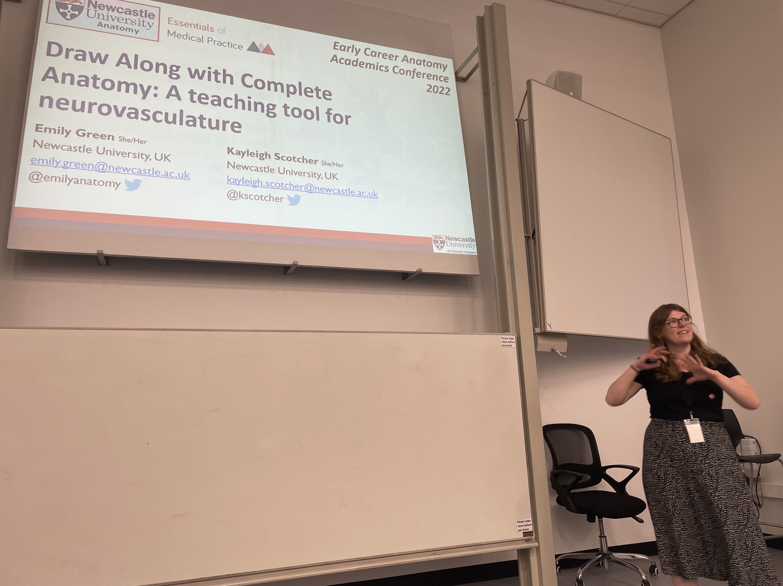
Copyright: If you submit images you must either own the copyright to the image or have gained the explicit permission of the copyright holder for the image to be submitted as part of the report for upload to the Society’s website, Newsletter, social media and so forth. A copyright statement must accompany each report if relevant. Answer N/A not applicable, YES or NO in the box below
YES – Photograph of myself presenting.
SIGNATURE | K.Scotcher |  | DATE | 20.07.2022
If submitted electronically, a type-written name is acceptable in place of a hand-written signature

File: AS-Award-Report-Form-190919

