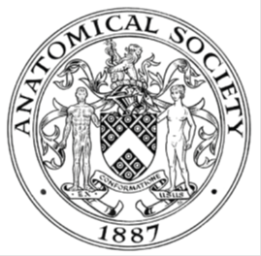
_______________________________________________________________________________________
AWARDEE REPORT FORM
_______________________________________________________________________________________

NAME |  | Cian O’Connor
UNIVERSITY |  | Royal College of Surgeons in Ireland
NAME OF AWARD |  | Barclay Smith Travel Award
PURPOSE OF AWARD conference/event attended/organised (full name) with city and dates.
This award supported attendance at the Anatomical Society Winter Meeting held in UCD, Dublin, Ireland from the 4-6th July, 2022. This award supported travel, conference registration and food.

REPORT: What were your anticipated benefits?
This conference was my first in person conferences with the Anatomical Society despite engagement virtually over the past 2.5 years. As such, this conference provided an invaluable platform to present my research and network with various members of the society.
COMMENTS: Describe your experience at the conference / lab visit / course / seminar/ event.
As part of my attendance at this conference I presented my research for the Dr Sophie Miller prize talk – providing an invaluable platform to disseminate the work from my Anatomical Society funded PhD studentship to date. Meeting the family of Dr Sophie Miller prior to and following my talk truly was a highlight of my PhD to date. This talk also later allowed me to engage with various people from the society who were interested in my work and form connections in my field from across Ireland and the UK. Furthermore, the other talks were extremely beneficial and saw representation from the 3 main spinal cord injury research groups in Ireland. As a result, we feel the conference attendance has laid the groundwork for future collaborative spinal cord research projects and seminar events. Finally, as I approach the end of my PhD, this conference provided a great opportunity to identify future employers and labs to work with. Overall, this conference was of great benefit to me both personally and professionally.

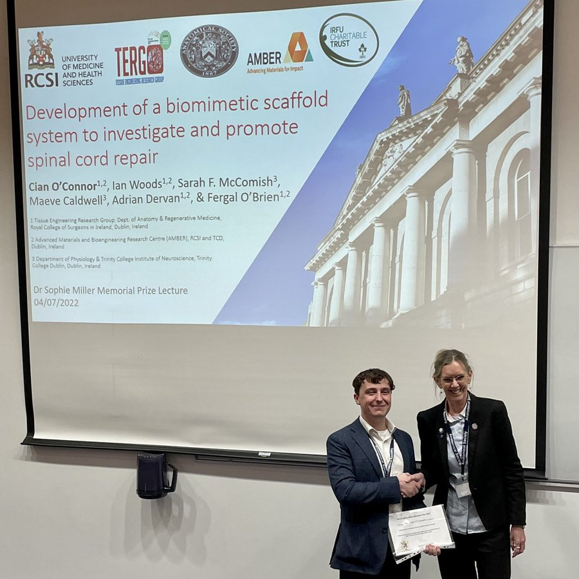

REPORT: In relation to skills, what were the most important things you gained? (does not apply to equipment grant. For public engagement/outreach awards what did your audience gain and how did you evaluate success?
Overall, this travel award provided support to attend and speak about my research at my first Anatomical Society conference, an invaluable experience.

REPORT: How do you think you will put this learning experience into practice in the future? For public engagement/outreach awards how with the materials/knowledge generated by this activity be used in the future?
As discussed, the connections made at this conference with other Irish spinal cord researchers seems very promising for future collaborative work and talks are underway to host a joint spinal cord injury research symposium.
Data Protection/GDPR: I consent to the data included in this submission being collected, processed and stored by the Anatomical Society. Answer YES or NO in the Box below
Yes

Graphical Images: If you include graphical images you must obtain consent from people appearing in any photos and confirm that you have consent. A consent statement from you must accompany each report if relevant. A short narrative should accompany the image. Answer N/A not applicable, YES or NO in the box below
The copyright for this image belongs to the Anatomical Society official twitter account – Please use it providing the society policy approves

Copyright: If you submit images you must either own the copyright to the image or have gained the explicit permission of the copyright holder for the image to be submitted as part of the report for upload to the Society’s website, Newsletter, social media and so forth. A copyright statement must accompany each report if relevant. Answer N/A not applicable, YES or NO in the box below
The copyright for this image belongs to the Anatomical Society official twitter account – Please use it providing the society policy approves

SIGNATURE | Cian O’Connor |  | DATE | 12/07/22
If submitted electronically, a type-written name is acceptable in place of a hand-written signature

File: AS-Award-Report-Form-190919 – CO website version160722

