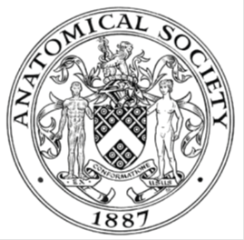
_______________________________________________________________________________________
AWARDEE REPORT FORM
_______________________________________________________________________________________

NAME |  | Dr Declan McLaughlin
UNIVERSITY |  | Queen’s University Belfast
NAME OF AWARD |  | Symington Bequest Fund Awards 2018/19
PURPOSE OF AWARD conference/event attended/organised (full name) with city and dates.
The Award was for financial support towards participation in The 19th Congress of the International Federation of Associations of Anatomists (IFAA 2019), 9th to 11th August 2019, ExCel, London.

REPORT: What were your anticipated benefits?
Having looked at the conference programme prior to attending, I had selected a number of sessions that appealed to me and that I would like to attend. Importantly, a number of these sessions seemed to be closely associated with aspects of my current job. These included:
- 21st century Anatomist: Social media use in anatomy education and research.
- Digital technology and teaching methods for Anatomical education.
- Brave new E-world! The promises and pitfalls of digital learning resources for teaching the Anatomical sciences

COMMENTS: Describe your experience at the conference / lab visit / course / seminar/ event.
I attended the IFAA Conference with some of my colleagues from Queen’s University Belfast. This alone was a great start, as we as a team were able to share collegially in our experiences of the IFAA. It also meant that we could divide and conquer, and allow us to get to as many of the sessions as possible. Indeed, we met after a few of the breakout symposia and let each other know how we got on, and if there were any interesting points we could take away with us.
One of the first things that I noticed was that the facilities at the Conference were great. Registration and bag collection was a breeze, and all of the staff were very helpful and welcoming. The size and space afforded to the breakout rooms was excellent. It really does make a difference when you can clearly hear and see the speakers and the presentations.
There were plenty of fascinating lectures and workshops covering all aspects of anatomy, including education. The plenary speakers were also fantastic, with all of them giving engaging talks. Of note, I particularly enjoyed the lectures by Professor Susan Standring on the History of ‘Gray's Anatomy’, Professor Clive Lee on ‘Art and Anatomy’ and Mr Philip Thomas’ talk on the anatomical considerations in transgender surgery.
Apart from attending all of the symposia, I had plenty of time to network and chat to colleagues. I got to catch up with old colleagues as well as getting to chat with the external examiners for our courses at Queen’s. This aspect of the Conference really highlights the social and networking opportunities that being a member of the Anatomical Society adds. There is never any pressure to talk work all of the time, and it was nice just to get caught up with people that I hadn’t seen in years. By talking and networking, it also gave me some suggestions for speakers to invite to my own department in the future, and may look to the Anatomical Society again for funding through the Departmental Seminar Scheme.
The poster sessions were also very enjoyable. I was amazed by the breadth of topics covered; yet also reassured to see that many investigators often stumbled into overlapping areas of interest, and found it refreshing to see that some of the ‘issues’ or ‘problems’ being investigated are the same worldwide.
I also was able to spend a good amount of time perusing the trade exhibitors stands and chatting with the reps. I especially enjoyed getting to try out the augmented reality (AR) and virtual reality (VR) experiences, as well of course as being a bit more traditional and getting hands on building some Lego! With the conference being in London, it also allowed us to be tourists in the evening! Myself and colleagues were able to get into the city very easily, and even managed to squeeze in a show or two!
I gained a lot of new knowledge at conference, and really enjoyed my first experience of the Congress. Thank you again to the Anatomical Society and the organising committee for putting on a great conference. I look forward to the next one!
REPORT: In relation to skills, what were the most important things you gained? (does not apply to equipment grant. For public engagement/outreach awards what did your audience gain and how did you evaluate success?
I definitely gained a lot of experience from colleagues involved in the use of social media for anatomy education. One of my roles in my current job is to be in charge of my Centre social media accounts. I learned lots of tips and tricks, which I hope to be able to implement in the incoming academic year. Some of the ideas are better suited to longer-term plans, but I am sure that opportunities will arise.
I found the symposium, “Brave new E-world! The promises and pitfalls of digital learning resources for teaching the Anatomical sciences” one of the most pertinent sessions to my own learning. I am currently involved in a lot of work surrounding the integration of pre-recorded annotated videos for gross and histological anatomy teaching. I found it extremely valuable hearing from colleagues who have been involved in this area for a while, the problems they face (and continue to face) and solutions they have come up with.

REPORT: How do you think you will put this learning experience into practice in the future? For public engagement/outreach awards how with the materials/knowledge generated by this activity be used in the future?
I will definitely take forward new knowledge surrounding the use of different technologies in the teaching anatomy. I’ve gained some new ideas and concepts that I’d like to bring forward into my teaching and will try to incorporate some of these into the incoming academic year.

I attended the symposium, “Ultrasound as a tool for teaching anatomy,” and found it most interesting. On returning to Belfast, I have passed on information on the session to colleagues back at Queen’s who are interested in using the technology in the teaching of physiology. I’m hopeful that my colleagues at Queen’s University can avail of new ideas and build working relationships with other colleagues from the Anatomical Society, across the disciplines of basic sciences education.
Data Protection/GDPR: I consent to the data included in this submission being collected, processed and stored by the Anatomical Society.
YES/NO
Graphical Images: If you include graphical images you must obtain consent from people appearing in any photos and confirm that you have consent. A consent statement from you must accompany each report if relevant. A short narrative should accompany the image.
YES/NO

Copyright: If you submit images you must either own the copyright to the image or have gained the explicit permission of the copyright holder for the image to be submitted as part of the report for upload to the Society’s website, Newsletter, social media and so forth. A copyright statement must accompany each report if relevant.
YES/NO

SIGNATURE | Dr Declan McLaughlin |  | DATE | 14/08/19

If submitted electronically, a type-written name is acceptable in place of a hand-written signature

File: AS-Award-Report-Form-BLANKCO-SEAL-date110216-Amended AT-070818
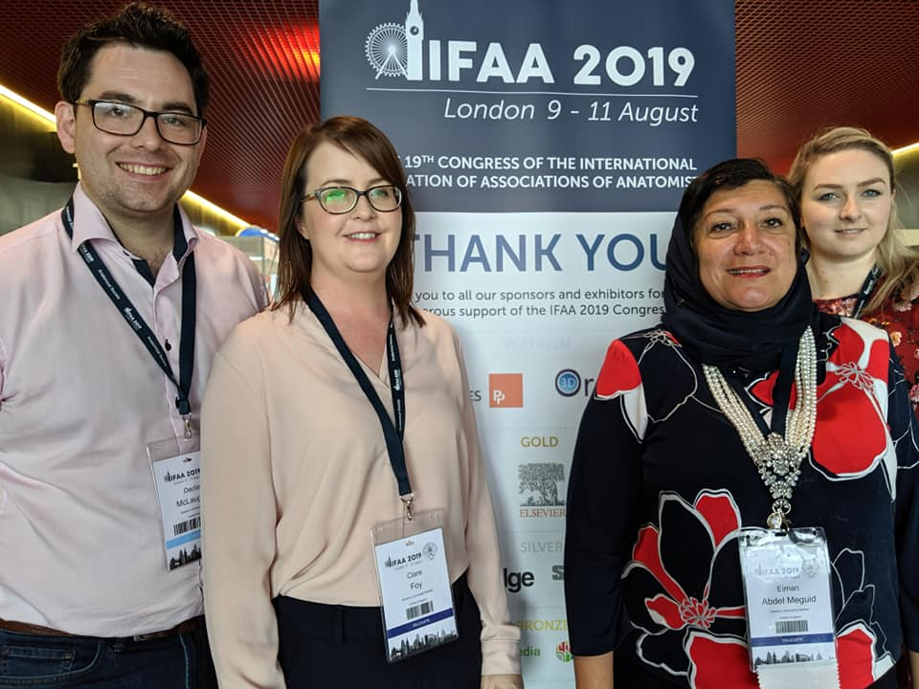
Dr Declan McLaughlin, Dr Clare Foy, Dr Eiman Abdel-Meguid and Dr Eva Sweeney from Queen’s University Belfast.

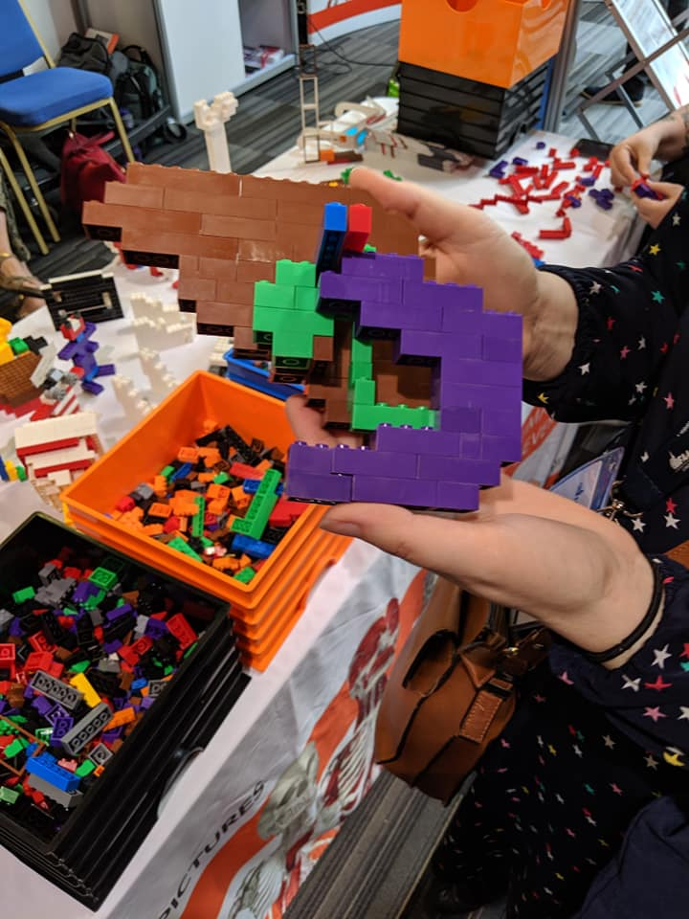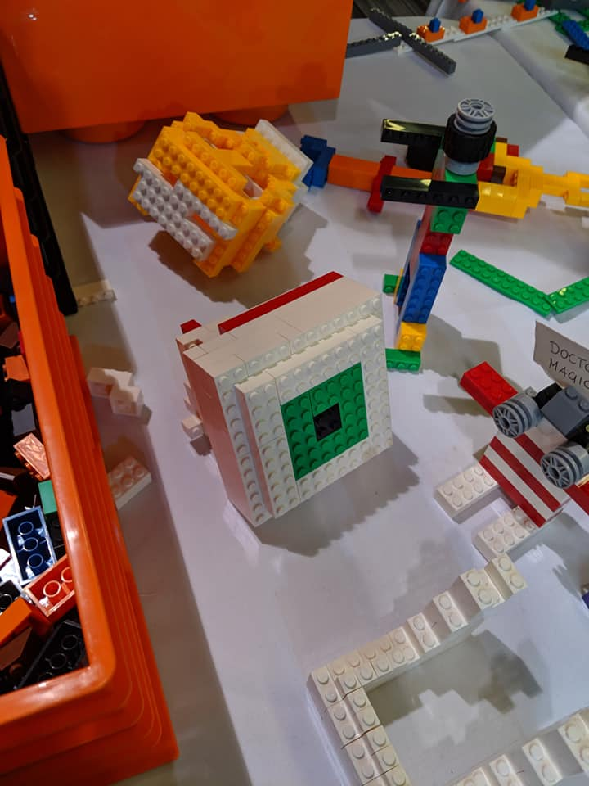
Some attempts at being creative with Lego! Dr Clare Foy’s liver, gallbladder and duodenum and Dr Declan McLaughlin’s eye. Thanks to the folks at Primal Pictures for providing the fun!
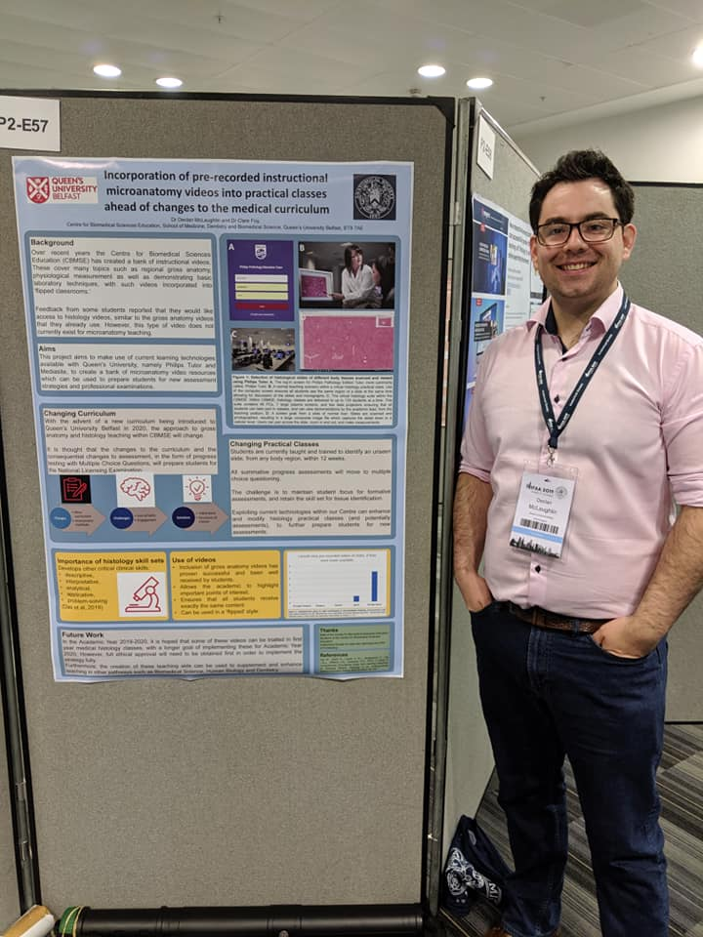
Dr Declan McLaughlin presenting a poster titled, “Incorporation of pre-recorded instructional microanatomy videos into practical classes ahead of changes to the medical curriculum.”

Declaration of consent and copyright.
I confirm that I have gained consent and permission from colleagues whose images appear in the above pictures, to be included in this report. I own the copyright of all the images submitted along with this report.
Declan McLaughlin
14 August 2019

