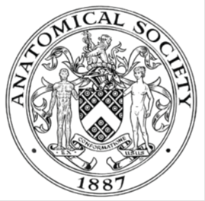
_______________________________________________________________________________________
AWARDEE REPORT FORM
_______________________________________________________________________________________

NAME |  | Adit Magudia
UNIVERSITY |  | University of Sheffield
NAME OF AWARD |  | Support for Student Societies Round 2
PURPOSE OF AWARD conference/event attended/organised (full name) with city and dates.
The award granted by the Anatomical Society was put towards the organisation of the National Sheffield Student Neuroscience Conference, ‘The Brain in Flux 2019.’
This event took place on the 2nd March 2019 in Sheffield at the Edge Conference Rooms.
The event was led by the Sheffield Student Neuroscience Society.

REPORT: What were your anticipated benefits?
The Brain in Flux 2019 aimed to benefit undergraduate and postgraduate students across the UK. By attracting eminent speakers both within and outside of Sheffield, we aimed to inspire students interested in neuroscience to realise the broad aspects of research within the brain and mind. We believed that our delegates would find the conference to be accessible to their academic level and anticipated that delegates would leave with a more comprehensive understanding of brain plasticity. As a benefit to the society, the conference was forecasted to increase participation at future events and conferences hosted by the society.
COMMENTS: Describe your experience at the conference / lab visit / course / seminar/ event.
On Saturday 2nd March, to mark some of the developments in brain plasticity research, over seventy delegates gathered to participate in the third annual conference, entitled ‘The Brain in Flux.’ In the morning session, Dr Gary Dennis, a consultant sleep neurologist, captured the importance of sleep as a protective element against non-communicable diseases, citing the positive contribution of sleep to brain plasticity.

During the lunch break, delegates were given the opportunity to view posters submitted by students from across the UK. The breadth of the student research on display was inspiring and each of the students gave noteworthy explanations of their aims and outcomes of research. It was also heartening to see delegates from different disciplines and stages of their education networking and sharing experiences.

In the afternoon plenaries, Dr Paresh Malhotra from Imperial College London fascinated the audience with his research into memory loss and spatial neglect syndrome in the aftermath of stroke.

Before the conclusion of the conference, the audience got the chance to attend workshops on some novel ideas being tested by researchers in sleep and memory. A standout from the workshop sessions was the use of wearable technology as a sleep monitoring tool in psychosis. This workshop was run by Dr Nicholas Meyer, a consultant psychiatrist at King’s College London.
REPORT: In relation to skills, what were the most important things you gained? (does not apply to equipment grant. For public engagement/outreach awards what did your audience gain and how did you evaluate success?
In terms of the society, this was our third conference following a year hiatus. From this conference, we have attracted and engaged with a much wider selection of students with different backgrounds. An illustration of this was a contingent of cognitive neuroscience and psychology students that attended on the day. From the feedback received, our delegates gave positive feedback. Some of the individual comments of praise we received highlighted ‘the brilliant mixture of academic speakers’ and the ‘great opportunity to view student research.’

REPORT: How do you think you will put this learning experience into practice in the future? For public engagement/outreach awards how with the materials/knowledge generated by this activity be used in the future?
The society will seek to consolidate on their experiences of the conference in determining the direction for the future. We envisage that undergraduate students from Sheffield now have a better scope of brain plasticity, which they may not have encountered in their curriculum. I personally have thoroughly enjoyed the experience and the experience has served as a catalyst for me to get more involved in science events management.
Data Protection/GDPR: I consent to the data included in this submission being collected, processed and stored by the Anatomical Society.
YES/NO
Graphical Images: If you include graphical images you must obtain consent from people appearing in any photos and confirm that you have consent. A consent statement from you must accompany each report if relevant. A short narrative should accompany the image.
YES/NO

Copyright: If you submit images you must either own the copyright to the image or have gained the explicit permission of the copyright holder for the image to be submitted as part of the report for upload to the Society’s website, Newsletter, social media and so forth. A copyright statement must accompany each report if relevant.
YES/NO

SIGNATURE | ADIT MAGUDIA |  | DATE | 08/04/19
If submitted electronically, a type-written name is acceptable in place of a hand-written signature

File: AS-Award-Report-Form-BLANKCO-SEAL-date110216-Amended AT-070818
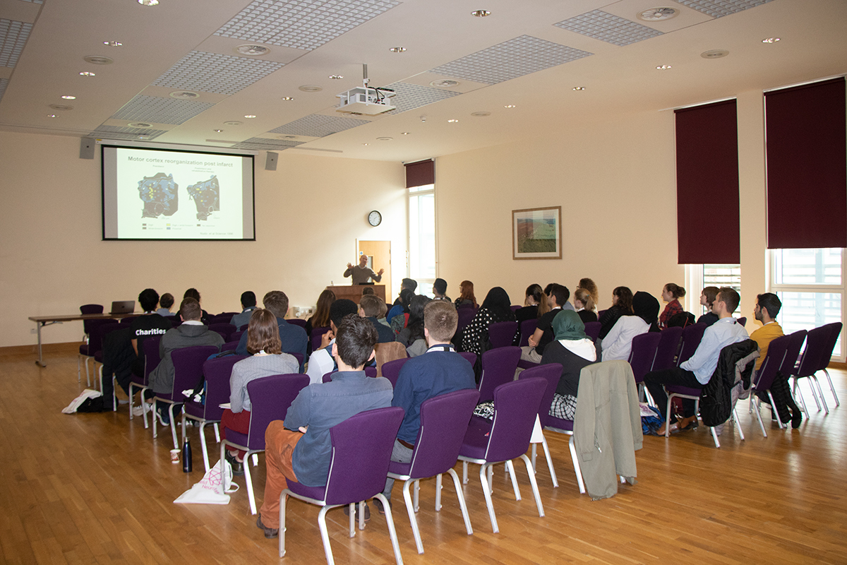

A talk by Dr Gerald Finnerty entitled ‘Rewiring the Connectome’. Dr Finnerty showcased research in rodents that examined the potential of boosting rewiring in the brain by removing the molecular brakes that regulate the process of rewiring.

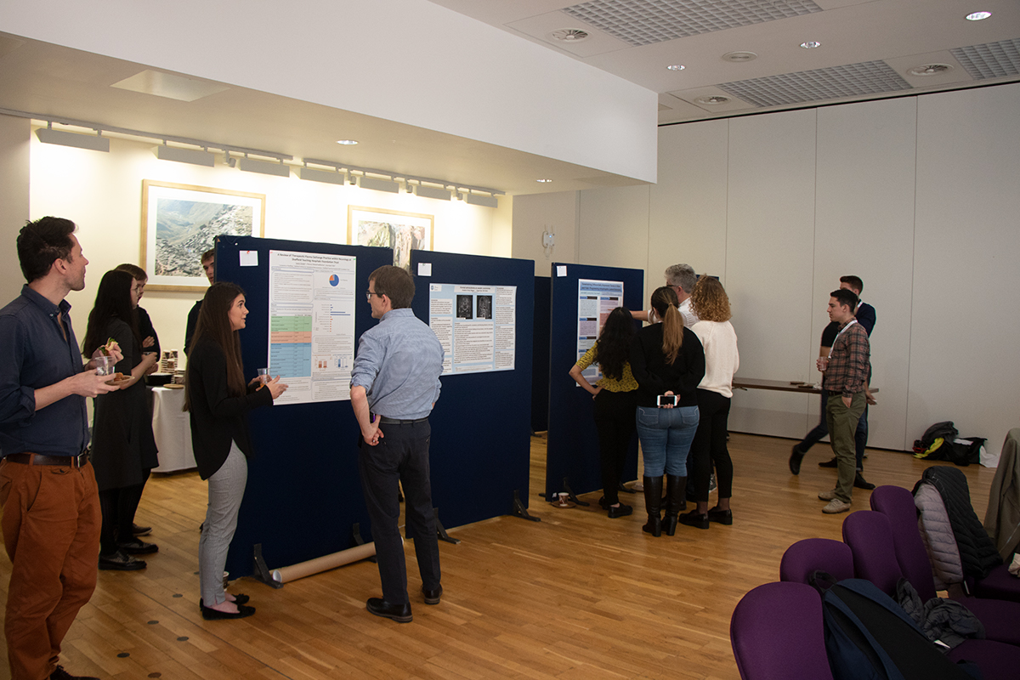

Poster presentations that took place during the lunch break with delegates and researchers taking the opportunity to network. Each poster presenter was judged by a panel of academics.

