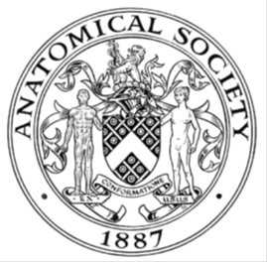
_______________________________________________________________________________________
AWARDEE REPORT FORM
_______________________________________________________________________________________

NAME |  | Solomon Page Godfrey
TWITTER HANDLE* optional
UNIVERSITY |  | University of Glasgow
NAME OF AWARD |  | Barclay-Smith Travelling Awards 2023/24
PURPOSE OF AWARD conference/event attended/organised (full name) with city and dates.
To present a poster at the Society’s Winter Meeting, 3rd to 5th January 2024, Liverpool.

REPORT: What were your anticipated benefits?
Minimum number of words between 200-400. Please write in coherent paragraphs.
Having no previous experience at an academic conference, I was not sure exactly what to expect from the Anatomical Society's winter meeting. My primary aim was to effectively communicate the findings of my research with the anatomy community. Additionally, I wanted to compare my results with other related projects to provide a greater comprehension of current understanding within the field. I hoped to receive supportive feedback on my research and poster, but also constructive feedback from experts in the field, in order to find areas of improvement to enhance my future work and presentations. Additionally, I wanted to use this opportunity to network with early career researchers and academics from various institution, to engage in constructive discussion and investigate options for postgraduate study (as I am approaching the conclusion of my undergraduate degree). Additionally, I know the anatomy community is diverse and I was excited to communicate and compare experiences with individuals from different areas in the UK and abroad. I was also excited about listening to the variety of different talks over the three days and hear about the many unique avenues of current anatomy research. I anticipated that this experience would stimulate my academic curiosity and expand my scope of scientific interest.

COMMENTS: Describe your experience at the conference / lab visit / course / seminar/ event.
Minimum number of words between 200-400. Please write in coherent paragraphs.
This was my first academic conference, and it was a truly rewarding experience. The talks expanded my understanding of anatomical research and explored many interesting concepts I have had little previous exposure to. Comparative anatomy is something I do not often come across in my undergraduate degree, however, I found learning about the impact of food source on squirrel evolution within the UK particularly interesting. I also very much enjoyed the social aspect of the conference, networking with like-minded people who share the same interests as me and building professional relationships. When it came to presenting my poster, I was naturally apprehensive having never presented at an academic event before. The supportive atmosphere at the event, however, was remarkable. From early career academics, to seasoned professionals, I was taken aback by how encouraging and supportive everyone was. This atmosphere allowed me to relax and present my poster with confidence, in turn, this facilitated constructive discussion which provided useful insights. Overall, this experience has not only enriched my understanding of anatomy in a broad range of areas, but also affirmed the welcoming and collaborative spirit within the community, which motives me to continue to peruse my academic interest in this field.

REPORT: In relation to skills, what were the most important things you gained? (does not apply to equipment grant. For public engagement/outreach awards what did your audience gain and how did you evaluate success?
Minimum number of words between 200-400. Please write in coherent paragraphs.
From presenting my research at the winter meeting, the most important skill I gained was verbal communication with an academic audience. I was able to clearly describe the rational, aims, findings and future implications my research. From hour to hour, I became more confident in my presentation and was soon able to engage in constructive discussion, as well as simply presenting information. I developed my reflective skills, thinking about how I could implement this feedback into my current undergraduate degree and future endeavours. Being my first conference presentation, I learned a lot about the design of a scientific poster, in terms of formatting and the inclusion of an appropriate amount of detail to inform yet engage the readers. I also developed my networking skills; talking to numerous early career and experienced academics from a range of universities and background was really rewarding in terms of expanding my understanding of the scope and applications of anatomical research. Following this conference, I hope to reach out to some new contacts for advice about my career. Overall, I believe that my experiences at the conference reaffirmed my ambitions to peruse an anatomy-based career, developed my networking and communications skills, and provided me with confidence in my own ability to present scientific information.

REPORT: How do you think you will put this learning experience into practice in the future? For public engagement/outreach awards how with the materials/knowledge generated by this activity be used in the future?
Minimum number of words between 200-400. Please write in coherent paragraphs.
The most important skill I gained from the conference was effective verbal communication to an academic audience. I will apply this newfound confidence in presenting information, not only in university discussions, group projects, and future research presentations, but in my personal endeavours out with academia as well. I will actively leverage networking skills developed during the conference to build professional connections. The skills I developed whilst producing my poster, along with the constructive feedback I received at the conference, will be used to enhance the visual appeal and informativeness of future presentations. Importantly, my experience at the winter meeting significantly boosted my overall confidence, not just in relation to my academic ability, but also in relation to interpersonal communication and discussions. I believe this heightened motivation will drive a proactive and curious approach to learning, opening doors to a wider range of academic opportunities. Additionally, the conference has improved my skills of reflection, enabling me to provide introspective feedback on my current and future academic pursuits. Overall, this experience was immensely rewarding and has allowed me to develop a broad range of academic and interpersonal skills which I endeavour to carry though to both my future academic and personal pursuits.

Data Protection/GDPR: I consent to the data included in this submission being collected, processed and stored by the Anatomical Society. Answer YES or NO in the Box below
Yes

Graphical Images: If you include graphical images you must obtain consent from people appearing in any photos and confirm that you have consent. A consent statement from you must accompany each report if relevant. A short narrative should accompany the image. Answer N/A not applicable, YES or NO in the box below
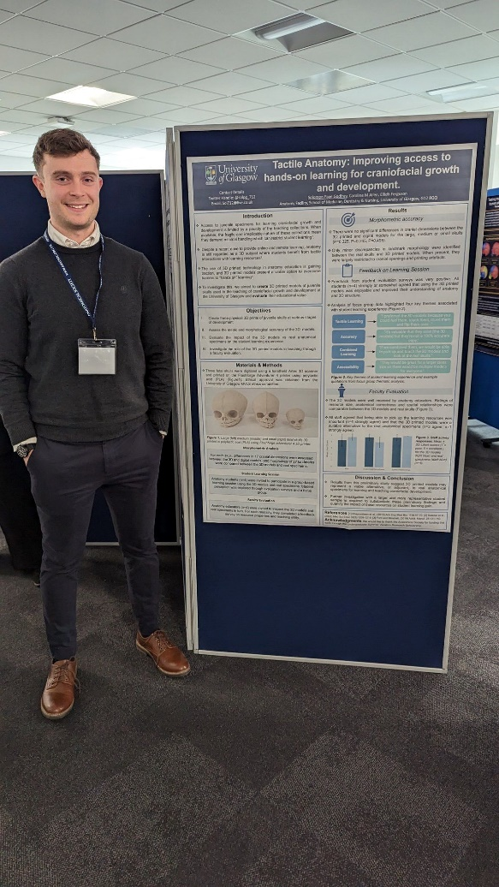 N/A – Image is of me

Copyright: If you submit images you must either own the copyright to the image or have gained the explicit permission of the copyright holder for the image to be submitted as part of the report for upload to the Society’s website, Newsletter, social media and so forth. A copyright statement must accompany each report if relevant. Answer N/A not applicable, YES or NO in the box below
N/A

SIGNATURE | Solomon Page Godfrey |  | DATE | 26/01/24
If submitted electronically, a type-written name is acceptable in place of a hand-written signature
File: AS-Award-Report-Form-171023

