UNDERGRADUATE SUMMER VACATION SCHOLARSHIP AWARDS – FINAL SUMMARY REPORT FORM 2022/23
NB: This whole report will be posted on the Society’s website therefore authors should NOT include sensitive material or data that they do not want disclosed at this time.

Name of student:
Ms Emi Goto Yavari, Lancaster University

Name of supervisor(s):
Dr Rebecca Shepherd, Lancaster University / University of Bristol

Project Title: (no more than 220 characters)
How do changes to collagen in the extracellular matrix of osteosarcomas affect cell behaviour

Project aims: (no more than 700 words)
Osteosarcoma is a type of bone cancer that predominantly affects children and young adults. It is an aggressive cancer that can metastasize to other parts of the body and is often resistant to chemotherapy. The extracellular matrix (ECM) is the complex network of proteins and other molecules that surround cells in the body, providing support and influencing cell behaviour. It is known that as cells progress towards a cancerous phenotype that there are changes in the extracellular matrix.

Within breast cancers, as the grade of cancer increases, there is a decrease in the collagen production. An increase in breast density is also associated with an increased risk of cancer (1). Collagens were initially thought to be a barrier that resisted tumour cells, but it has been shown that changes in collagen composition and organisation can promote tumour progression and that cancer cells can migrate along strands of collagen (2). Collagen rich extra cellular matrices can bind to other proteins to form dense fibrosis. This is a process that induces an anoxic environment and alters the formation of new blood vessels.

Bone is a mixture of organic and inorganic components. The organic component includes proteins, such as collagen. Changes to bone collagens are associated with disease, although current bone diagnostic methods do not assess this. Raman spectroscopy is a non-invasive, laser-based method that can detect changes to the protein and mineral component of bone (3). This technique has potential to provide information about changes in bone diseases and is currently being developed for in vivo use (4). Elevation of collagen types II and X within human blood serum have both been identified as biomarkers of osteoarthritis through ELISA techniques.

The primary aim of this project is to investigate how changes to the extracellular matrix of osteosarcoma cells cause changes to cell behaviour. We hypothesise that changes in the ECM of osteosarcoma cells can alter cell adhesion and invasion.

To test this hypothesis, the student will grow human osteoblast like cell lines (MG63, SaOS-2 and Te85) in media containing different extracellular matrix proteins (focussing on human collagens types I – VII) and to examine differences in subsequent cell behaviour and proliferation. This project aims to achieve a better understanding of the role of ECM changes in osteosarcoma progression, which could lead to the development of new treatment strategies for this disease.

References
1. Provenzano PP, Inman DR, Eliceiri KW, Knittel JG, Yan L, Rueden CT, et al. Collagen density promotes mammary tumor initiation and progression. BMC Med [Internet]. 2008 Apr 23 [cited 2022 Jun 29];6. Available from: https://pubmed.ncbi.nlm.nih.gov/18442412/

2. Morkunas M, Zilenaite D, Laurinaviciene A, Treigys P, Laurinavicius A. Tumor collagen framework from bright-field histology images predicts overall survival of breast carcinoma patients. Sci Reports 2021 111 [Internet]. 2021 Jul 29 [cited 2022 Jun 29];11(1):1–13. Available from: https://www.nature.com/articles/s41598-021-94862-6

3. Buckley K, Kerns JG, Gikas PD, Birch HL, Vinton J, Keen R, et al. Measurement of abnormal bone composition in vivo using noninvasive Raman spectroscopy. IBMS Bonekey. 2014;11.

4. Atkins CG, Buckley K, Blades MW, Turner RFB. Raman Spectroscopy of Blood and Blood Components. Appl Spectrosc. 2017 May 11;71(5):767–93.

Project Outcomes and Experience Gained by the Student (no more than 700 words)
The project was successful in establishing that Raman spectroscopy can be used in-vitro to examine differences in the protein/collagen component of the extracellular matrix. These differences have been compared to previous knowledge of morphology and cell behaviour of the osteosarcoma cell lines to hypothesis how changes in collagens produced affect cell behaviour.
Emi was trained in a number of laboratory techniques, data analysis techniques, and transferable skills, such as scientific writing. She initially wrote a literature review on the topic, and gained feedback on this. Emi was trained in laboratory techniques such as cell culture, and she is now proficient in growing and maintain cell lines, and using standard light microscopy to study cell behaviour. Emi had training in Raman spectroscopy, and received statistical training, including hypothesis testing using statistical software packages (e.g. MATLAB or SPSS). Emi joined a wider research group consisting of MSc students, PhD students, PDRAs and PIs, and attended weekly lab meetings.
This work will contribute to a manuscript that is in preparation for submission.

Please state which Society Winter or Summer Meeting the student is intending to present his/her poster at:
Emi submitted her abstract (which was accepted) to the Winter Meeting in Liverpool Jan 3rd-5th 2024, but will present at the summer meeting in Edinburgh.

Proposed Poster Submission Details (within 12 months of the completion of the project) for an AS Winter/ Summer Meeting – (no more than 300 words)
Osteosarcoma (OS) is a form of bone cancer that causes bone tumours. The extracellular matrix (ECM) of bone comprises various macromolecules and minerals, including mainly type I collagen, glycoproteins like fibronectin, laminin, elastin, and proteoglycan, as well as hydroxyapatite minerals. Previous research has indicated that the OS microenvironment, particularly the ECM, influences cell behaviour by supporting cell growth. This study aimed to test the hypothesis that changes in proteins secreted by human osteoblasts can be detected using Raman spectroscopy and associated with established behaviours of osteosarcoma cell lines.
Human osteosarcoma cell lines MG63, TE85, and SaOS were cultured following established protocols. The 'spent' cell culture media obtained during cultivation underwent processing to produce a concentrated solution of ECM components. Subsequently, the concentrated cell media was spun using a Cytospin to isolate ECM components from the cell media and adhere them to an aluminium-coated slide. An inVia Raman Microspectrometer equipped with a 785nm laser was used to detect differences in the ECM secreted by the various cell lines. The acquired spectra underwent baseline correction, normalization, and analysis using multivariate analysis techniques, including supervised Principal Component Analysis (PCA) and supervised Principal Component Analysis – Linear Discriminant Analysis (PCA-LDA). Loadings plots were generated to display the spectral regions with the most significant differences between the cell lines. No ethical approval was required for this project.
The results exhibited distinct separation among the three cell lines. The average spectra displayed increased peak heights in different regions of the acquired spectra from the three cell lines, suggesting differences in the collagens produced. Loadings plots were used to confirm the specific differences in the biochemical composition of the ECM. The PCA-LDA analysis demonstrated clear differentiation in the extracellular matrix produced by the MG63 cell line compared to TE85 and SaOS, with minimal overlap between TE85 and SaOS. The findings from this study contribute to assessing alterations in bone proteins, and in the understanding of cancerous cell behaviour and cell migration. Future projects could aim to further this technique for in vivo assessment of tumour ECM.

Brief Resume of your Project’s outcomes: (no more than 200-250 words).
The title of your project and a brief 200-250 word description of the proposed/completed project. The description should include sufficient detail to be of general interest to a broad readership including scientists and non-specialists. Please also try to include 1-2 graphical images (minimum 75dpi). NB: Authors should NOT include sensitive material or data that they do not want disclosed at this time.

Raman Spectroscopy can detect variances in extracellular matrix production among human osteosarcoma cell lines
Osteosarcoma, a type of bone cancer, forms tumours in the bone. The bone's extracellular matrix (ECM) consists of different molecules and minerals, such as collagen, glycoproteins like fibronectin, and minerals like hydroxyapatite. Previous research suggests that the environment around osteosarcoma cells, especially the ECM, affects how these cells grow. This study wanted to see if changes in proteins released by human bone-forming cells could be detected using a method called Raman spectroscopy and if these changes were linked to how osteosarcoma cells behaved.
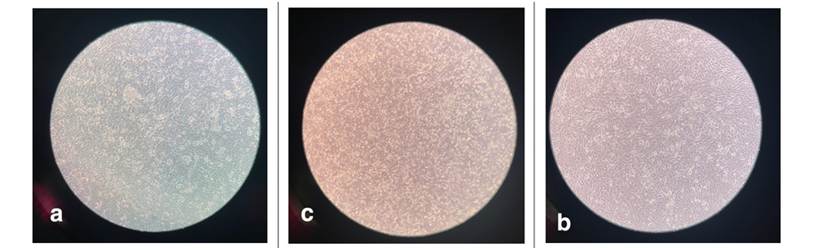
Figure 1 Microscopy images demonstrating the cell morphology at confluence of MG63, SAOS and TE85 Human Osteosarcoma cell lines.

In this study, human osteosarcoma cells were grown in the lab (Figure 1) and the liquid they grew in was collected. The ECM components from this liquid were isolated and analysed using Raman spectroscopy, which can detect differences in molecular composition. This found that the spectra (patterns) of the ECM from different osteosarcoma cell lines were distinct. This suggests that each cell line produces unique ECM molecules, particularly collagen. These results were then compared to previous analysis of human collagens to determine the differences in collagens produced by different cell lines.
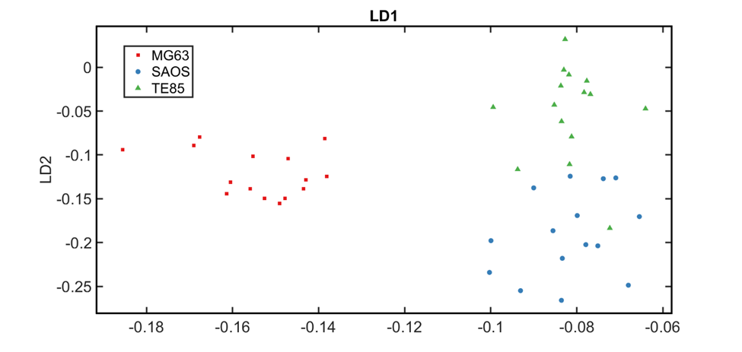
Figure 2 Principal Component - Linear Discriminant Analysis (PCA-LDA) of the Extracellular Matrix of human osteosarcoma cell lines, MG63, SAOS and TE85. The 2D scatter plots shows strong discrimination of the ECM of MG63s compared to SAOS and TE85.

Using statistical techniques, the differences in the ECM composition among the cell lines has been shown (Figure 2). This insight could help us understand how bone proteins change in cancer and how cancer cells move and behave. In the future, similar methods might be used to study tumour environments within the body.

Other comments: (no more than 300 words)

N/A

Data Protection/GDPR: I consent to the data included in this submission being collected, processed and stored by the Anatomical Society. Answer YES or NO in the Box below
YES

Graphical Images: If you include graphical images you must obtain consent from people appearing in any photos and confirm that you have consent. A consent statement from you must accompany each report if relevant. A short narrative should accompany the image. Answer N/A not applicable, YES or NO in the box below
YES

Copyright: If you submit images you must either own the copyright to the image or have gained the explicit permission of the copyright holder for the image to be submitted as part of the report for upload to the Society’s website, Newsletter, social media and so forth. A copyright statement must accompany each report if relevant. Answer N/A not applicable, YES or NO in the box below
YES

Signature of supervisor: Rebecca Shepherd Date: 29/01/24

END OF FORM
----------------------------------------------------------------------------------------------------------------------------------------

