UNDERGRADUATE SUMMER VACATION SCHOLARSHIP AWARDS – FINAL SUMMARY REPORT FORM 2021/22
NB: This whole report will be posted on the Society’s website therefore authors should NOT include sensitive material or data that they do not want disclosed at this time.

Name of student:
Niall Summers
Name of supervisor(s):
Laura Andreae
Project Title: (no more than 220 characters)
Mapping the anatomical substrate of impulsive behaviour in a mouse model for neurodevelopmental disorder
Project aims: (no more than 700 words)
Neurexin1α (NRXN1α) is a protein involved in synaptic adhesion and the formation of neural connections. Deletions of the NRXN1α gene have been strongly associated with neurodevelopmental disorders (NDDs) including autism, schizophrenia, and ADHD in humans (1,2). Mice with mutations in NDD risk genes have been extensively used to try and understand potential alterations in the brain that may relate to these NDDs, however, it has been difficult to translate effectively from mice to humans, in part due to a lack of clear, quantifiable similarities between mouse and human behaviour. Here, we chose to focus on a behavioural endophenotype where aspects of the underlying neural circuits are known, impulsivity, which is also seen across multiple NDDs. While there are many different kinds of impulsive behaviour and associated tests, we used a simple and robust test that is known to be dependent on the prefrontal cortex (PFC) - the cliff aversion test (3). Preliminary data from the lab has found that mice lacking Nrxn1α (Nrxn1α KO) show significantly increased jumping from an elevated platform (or ‘cliff’) in this test.

Loss of Nrxn1α may lead to a change in the connections in the brain, which may in turn alter activity in certain regions of the brain compared to others. For this study, we chose to focus on the medial prefrontal cortex (mPFC), as this region is known to be critical for cliff avoidance and has been previously implicated in connectivity changes seen in the Nrxn1α KOs (4). Therefore, this was chosen as a primary region of interest (ROI). Other ROIs included the striatum, hypothalamus, and amygdala as these have all been implicated in changes seen in either humans with NDDs or mice with Nrxn1α KOs (5-7). We also decided to have ROIs for the primary somatosensory cortex (S1), primary motor cortex (M1) and primary visual cortex (V1), as NDDs often lead to hypersensitivities in stimuli and activity, and this may lead to greater activities in these regions (8). We were able to choose 4 different coronal sections for each animal that included all 7 of these ROIs.

Our goal was to determine which cells and regions showed changes in activity levels following the cliff test, and how this may differ in the Nrxn1α KO mice. We used c-fos as a marker of neuronal activity, as expression of this immediate early gene is induced following neural activity. The brains were stained for DAPI (a nuclei marker), NeuN (a neuronal marker) and GABA (an inhibitory neuron marker). This is useful as it is known that changes in excitation/inhibition (E/I), or E/I balance, may be involved in the changes seen between WT and KO (9). Staining for GABA therefore would allow us to identify whether any changes in activity levels in individual cells were in inhibitory (GABA⁺ and NeuN⁺) or excitatory (GABA⁻ and NeuN⁺) neurons.

Project Outcomes and Experience Gained by the Student (no more than 700 words)
For the experiment, mice spent 10 minutes on the elevated platform (or 10 minutes in their home cage). 90 minutes after this, animals were perfused with paraformaldehyde, their brains extracted, then sectioned in 50µm coronal slices using a vibratome. The slices underwent antigen retrieval, permeabilization, blocking, and were then incubated with primary antibodies binding to the markers described in the aims. Secondary antibodies were then incubated, with the slices mounted and then imaged using a slidescanner. Each brain had 4 images each, one for each of the slices that was included. For each of these, ROIs were done for the specific areas. Each image was then analysed in MATLAB However, due to time constraints, only the deep layers of mPFC were analysed to completion. The results are shown in Figure 1.

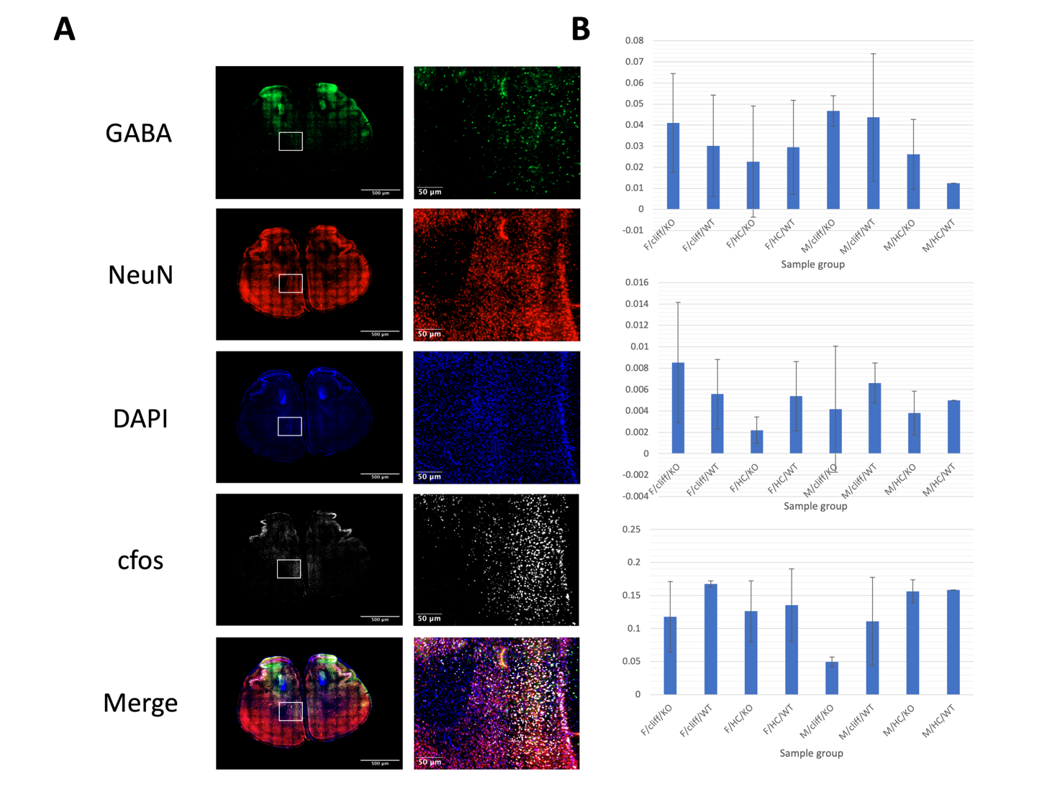
Figure 1. The analysed results for deep layer mPFC cells (A) A typical immunofluorescence image showing the presence of different markers in a slice of tissue: GABA (inhibitory neurons), NeuN (neurons), DAPI (nuclei), c-fos (active neurons), as well as a merged image of all the channels. On the right, there is a high-power view to show the individual cells that are nearby to the mPFC ROI, with having scale bars for size (500µm and 50µm respectively). (B) Graph showing changes in the density of c-fos positive cells (as a proportion of the total neurons, separated by each different group: F/M - female/male, cliff/HC - cliff tested/home caged (not tested), and KO/WT - knockout/wild-type. At least N=2 mice, except for M/HC/WT. (C) As for (B) but c-fos positive and GABA -cells out of the total neurons. (D) c-fos positive and GABA negative cells out of the total neurons.

The images produced from the project show successful antibody labelling, with the positive cells discernible from the background in all the different stains (figure 1A). The only major issue here was that certain antibody staining (such as NeuN and GABA) had quite high background, making the analysis more challenging. We also ended up having to use a slidescanner due to the number of images taken, which meant that some of the out-of-focus cells were difficult to place as either in or out of the image. So far, in terms of results obtained, it is difficult to make any conclusive statements due to the small number of biological replicates (figure 1B-D). The algorithm used also resulted in some increased variability. There were some issues that, if there was time, would ideally be fixed, such as identifying the threshold for the individual tissue slices rather than a threshold for all images that is the same. There were some artefacts on the images of certain slices, especially in some channels such as c-fos. At this early stage, there appeared to be a trend suggesting that, in KO male mice, the number of active excitatory neurons decreases in the cliff-tested mice compared to their home cage counterparts, but this will need to be verified with additional numbers. We also identified other brain regions with elevated activity which will be analysed in future work.

I have gained lots of experience during this project. The wet lab skills I have gained include a stronger ability to perform immunohistochemistry, tissue sectioning and both confocal and slidescanner fluorescent microscopy. I have also learned an enormous amount of neuroanatomy, including ways of identifying different regions of the brain, as well as how to use anatomical structures as reference (such as the corpus callosum, hippocampus and midline) to localise and identify my sections within the brain. In addition, I have learnt some new dry lab techniques. The main one I have learnt is how to use MATLAB, as I had to work on a program to identify the parts of images that were positive for certain stains. I have also been able to use programs such as Fiji in greater detail. Finally, I have gained other skills such as independent working, data analysis and better communication skills.

Please state which Society Winter or Summer Meeting the student is intending to present his/her poster at:
Winter

Proposed Poster Submission Details (within 12 months of the completion of the project) for an AS Winter/ Summer Meeting – (no more than 300 words)
I will use my poster to both display the data I obtained as well as explaining its value within a larger context. It will include figures such as the one displayed in the project outcomes with representative images of those that were produced from the experiments, as well as the final analysis results that were obtained. I will include details of the process by which the images are analysed, by showing the different stages involved and how they eventually led to the final stage. I will also include a section on the limitations of the work so far, potential future analysis with this dataset (including further optimisation of the analysis software) and future work.

Brief Resume of your Project’s outcomes: (no more than 200-250 words).
The title of your project and a brief 200-250 word description of the proposed/completed project. The description should include sufficient detail to be of general interest to a broad readership including scientists and non-specialists. Please also try to include 1-2 graphical images (minimum 75dpi). NB: Authors should NOT include sensitive material or data that they do not want disclosed at this time.
Mapping the anatomical substrate of impulsive behaviour in a mouse model for neurodevelopmental disorder

The aim of the project was to identify if there was a change in neural activity in different brain regions in mice with deletion of a neurodevelopmental disorder (such as autism, ADHD and schizophrenia) risk gene, and how this might be altered in the context of increased impulsive behaviour seen in the mutant animals. In order to determine changes in brain activity ex vivo, the levels were determined using immunofluorescent labelling of c-fos, an immediate early gene that is induced following neural activity. The tissue was imaged and then analysed using MATLAB in specific regions of interest (such as the medial prefrontal cortex). The tissue was segmented using an algorithm that was optimised based on the images produced. The data was then separated based on the coexpression of different stains, to determine the properties of c-fos positive (active) neurons. If c-fos was coexpressed with GABA, then those neurons were active and inhibitory, but if there was no GABA expression but positive c-fos, then it was seen to be an excitatory neuron. The changes in active excitatory and inhibitory neurons were used as changes in excitation and inhibition may have a role in the behaviours of neurodevelopmental disorder mice. The image below shows an example of an image produced from these experiments
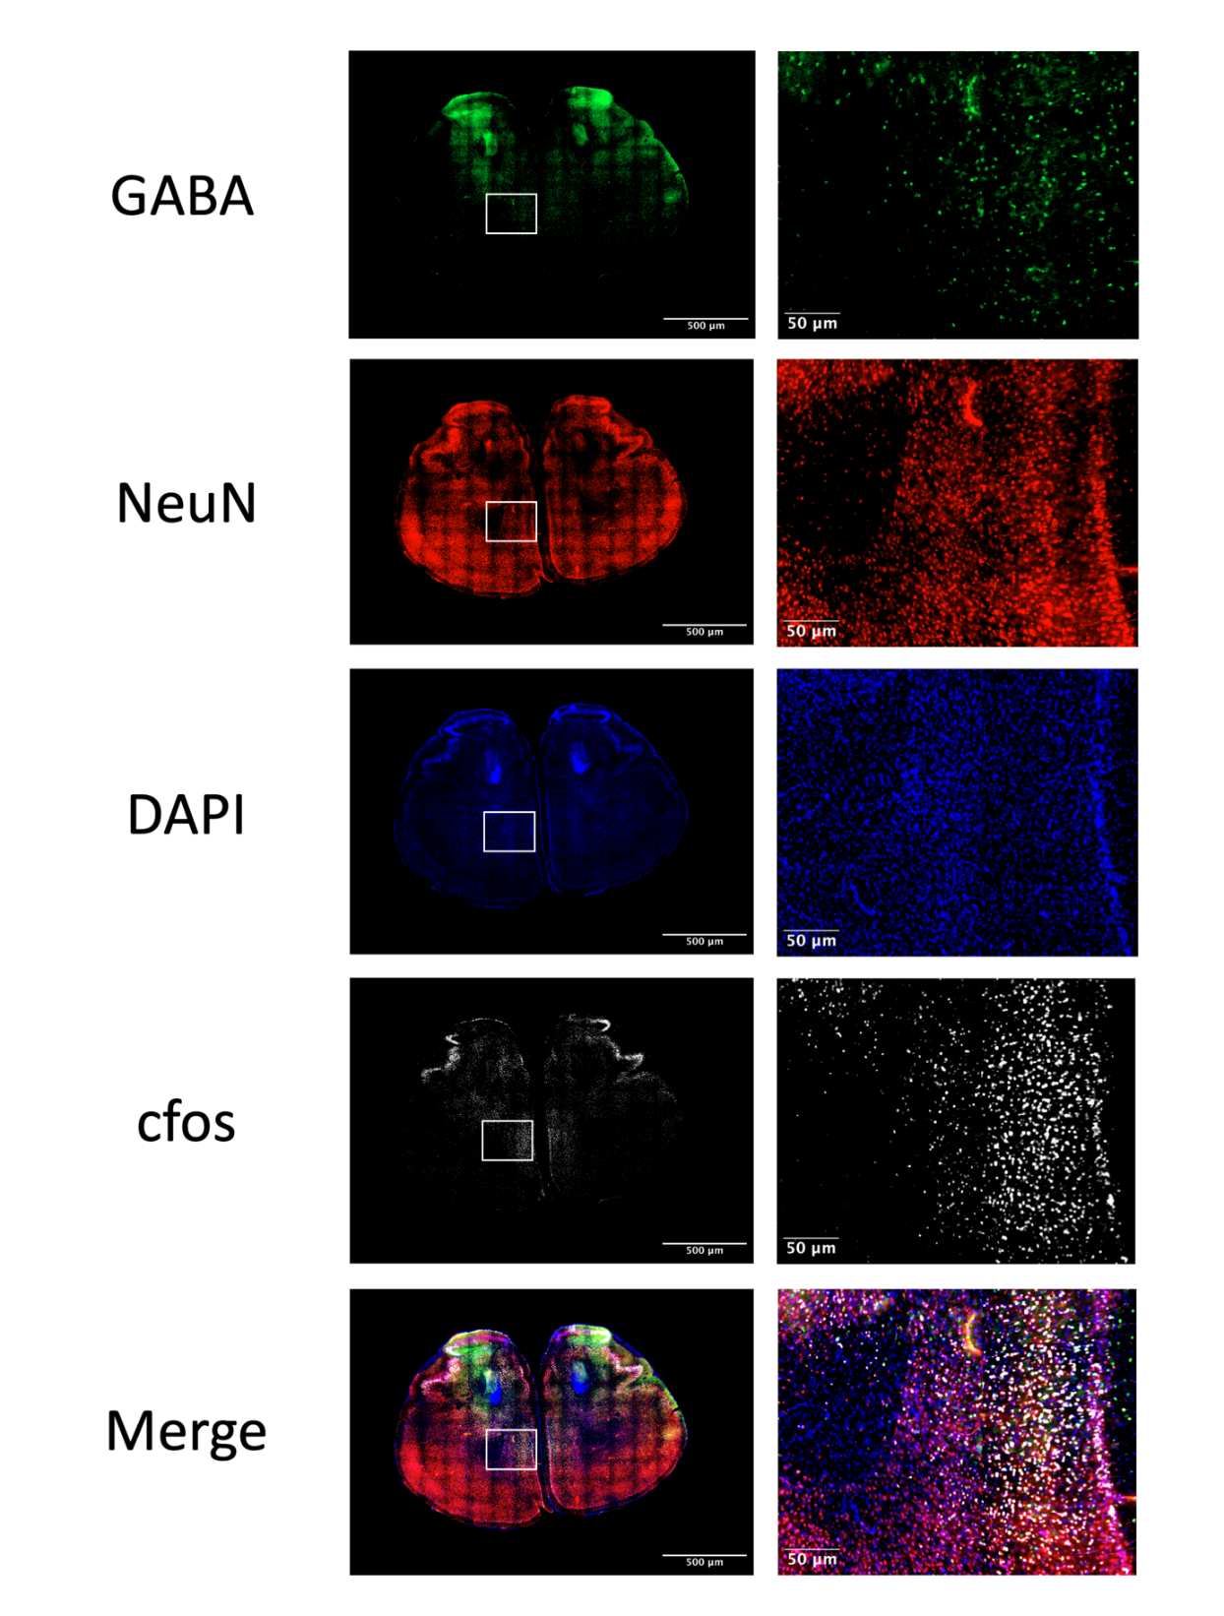
Other comments: (no more than 300 words)
Acknowledgements:

Thank you to my lab supervisor Laura Andreae, as well as Martyna Panasiuk, a PhD student who supervised and trained me in a large amount of the techniques used. I would also like to thank the other members of the Andreae lab and neighbouring labs for all their help.

References
(1) Tromp A, Mowry B, Giacomotto J. Neurexins in autism and schizophrenia—a review of patient mutations, mouse models and potential future directions. Springer Science and Business Media LLC; 2021.
(2) Zarrei M, Burton CL, Engchuan W, Young EJ, Higginbotham EJ, Macdonald JR, et al. A large data resource of genomic copy number variation across neurodevelopmental disorders. Springer Science and Business Media LLC; 2019.
(3) Xie L, Liu Y, Hu Y, Wang B, Zhu Z, Jiang Y, et al. Neonatal sevoflurane exposure induces impulsive behavioral deficit through disrupting excitatory neurons in the medial prefrontal cortex in mice. Springer Science and Business Media LLC; 2020.
(4) Gilbert SJ, Bird G, Brindley R, Frith CD, Burgess PW. Atypical recruitment of medial prefrontal cortex in autism spectrum disorders: An fMRI study of two executive function tasks. Elsevier BV; 2008.
(5) Li W, Pozzo‐Miller L. Dysfunction of the corticostriatal pathway in autism spectrum disorders. Journal of neuroscience research. 2020; 98 (11): 2130-2147. 10.1002/jnr.24560.
(6) Twining RC, Vantrease JE, Love S, Padival M, Rosenkranz JA. An intra-amygdala circuit specifically regulates social fear learning. Springer Science and Business Media LLC; 2017.
(7) Caria A, Ciringione L, De Falco S. Morphofunctional Alterations of the Hypothalamus and Social Behavior in Autism Spectrum Disorders. MDPI AG; 2020.
(8) Kazdoba TM, Leach PT, Crawley JN. Behavioral phenotypes of genetic mouse models of autism. Wiley; 2015.
(9) Uzunova G, Pallanti S, Hollander E. Excitatory/inhibitory imbalance in autism spectrum disorders: Implications for interventions and therapeutics. Informa UK Limited; 2016.

Data Protection/GDPR: I consent to the data included in this submission being collected, processed and stored by the Anatomical Society. Answer YES or NO in the Box below
YES
Graphical Images: If you include graphical images you must obtain consent from people appearing in any photos and confirm that you have consent. A consent statement from you must accompany each report if relevant. A short narrative should accompany the image. Answer N/A not applicable, YES or NO in the box below
YES
Copyright: If you submit images you must either own the copyright to the image or have gained the explicit permission of the copyright holder for the image to be submitted as part of the report for upload to the Society’s website, Newsletter, social media and so forth. A copyright statement must accompany each report if relevant. Answer N/A not applicable, YES or NO in the box below
YES

Signature of student Mr Niall Summers Date 20/10/22

Signature of supervisor Dr Laura Andrea Date 19/10/22

END OF FORM
----------------------------------------------------------------------------------------------------------------------------------------
File: USVRS-2021-22 Andrea Summers Report-Website Upl 271022

