

**­­­­­­­­­­­­­­­­**

**UNDERGRADUATE SUMMER VACATION SCHOLARSHIP AWARDS – FINAL SUMMARY REPORT FORM 2015/16**

*NB: This report will be posted on the Society’s website therefore authors should NOT include sensitive material or data that they do not want disclosed at this time.*

**Name of student:**

Miriam Graute

**Name of supervisor(s):**

Dr Jennifer Z. Paxton

**Project Title: (no more than 220 characters)**

**Engineering the enthesis using graded mineral hydrogels**

**Project aims: (no more than 700 words)**

The Paxton lab works to understand and replicate the bone/tendon interface (enthesis) *in vitro* for use in research on diseases and injury repair. *In vivo*, the mineral content of the tissue decreases gradually from the bone to the tendon, via mineralised and unmineralised fibrocartilage. This allows the smooth transmission of force from the yielding muscle to the rigid bone, thus enabling the key function of the tendon. Therefore, the Paxton lab aims to replicate unique anatomical structure of the bone/tendon interface in in vitro models, to better understand the formation and repair processes occurring at the tissue interface. The Paxton Lab uses an established in vitro model of a tendon/ligament to assess the bone-tendon interface formation. Previous studies have assessed the formation of a bone-tendon/ligament analogue using a cell-seeded hydrogel for the soft tissue and bone cement as the hard tissue. Although this model can form a multicomponent tissue analogue, the gradient of mineral content at the bone/tendon interface is not replicated and is therefore not a suitable with respect to the native anatomical structure.

The overall aim of this project was to investigate the use of a novel bone anchor design in the in vitro model. The bone anchor was designed to replace the original bone cements and construct a bone-tendon interface with a gradient of mineral between the soft and hard tissue regions. To this end, a novel bone anchor was manufactured by our collaborating laboratory (Pamula Lab, AGH University of Science and Technology in Krakow, Poland) and shipped under sterile conditions to our laboratory where we could assess the suitability in the existing in vitro model.

Our specific aims for this project were to;

1) Analyse the mineral gradient in the novel bone anchor design

2) Redesign the tissue culture methodology to engineer a more anatomically accurate bone-tendon interface

3) Assess the suitability of the novel bone anchor in the tendon/ligament in vitro model via gross digital imaging and histology.

Aim 1: We wanted to assess the mineral gradient present in the novel bone anchors provided to us by the collaborating laboratory (Pamula Lab, Krakow) and assess their suitability a new bone anchors in the established in vitro ligament model. For this, gross digital imaging and histology was employed.

Aim 2: The original in vitro model protocol used simple 6-well dishes coated in a Sylgard layer to fix the bone anchors to the bottom of the well. From our initial analysis of the novel graded bone anchors, it was clear that a primary task was to redesign the culture environment for the in vitro model to accommodate the new bone anchors. As well as re-evaluating the physical environment, the existing protocol would need to be evaluated for the new system. Previously, constructs have been grown in circular tissue culture wells coated in Sylgard 184 (Dow Corning), with insect pins and silk sutures providing attachment points for the chicken tendon fibroblasts (CTFs). The new culturing is to be a more accurate reflection of the conditions in vivo: instead of wrapping around the bone anchor, the CTFs share only one narrow interface with it. These bespoke culturing wells have the shape of a fish: the “tail” area precisely accommodates an anchor, while the “body” is the area seeded with CTFs. As the new shape was to significantly reduce the surface area on which the tendons are cultured, protocols currently used in the Paxton lab had to be adapted to this new environment.

Aim 3: Once the novel bone anchors had been assessed and the culture environment successfully redesigned, our aim was to assess the use of the novel graded bone anchors in the in vitro culture system. We were interested in whether the novel bone anchors would 1) attach to the soft tissue portion of the artificial construct and 2) whether tendon cells would infiltrate the bone anchor, forming a suitable transition between the artificial ‘tendon’ and ‘bone’ regions of the tissue construct. After embedding the constructs in paraffin, sections were cut, dewaxed and stained to visualize presence or absence of CTFs in the anchor region, as well as presence or absence of mineralisation outside the anchor. Gross digital imaging, too, was employed.

**Project Outcomes and Experience Gained by the Student (no more than 700 words)**

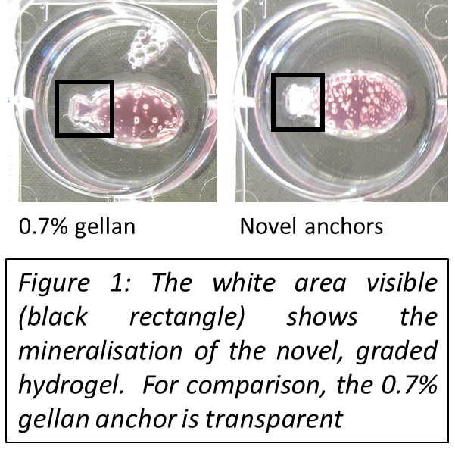Aim 1: Evaluating the novel graded bone anchors: Gross digital imaging showed the presence of mineralisation, and the colour difference to 0.7% gellan anchors (*Figure 1*) confirms this. Furthermore, microscope analysis of mineral stains confirmed the presence of a mineral gradient.

Aim 2: Redesigning the culture environment: This aim was successful, and the Paxton Lab is now using these bespoke wells. I have designed bespoke moulds that are used to form the voids for the bespoke wells. For this, I used the open access software Tinkercad (©2016 Autodesk, Inc.). These were then 3D printed. After evaluating three different loose shapes (i.e. widths) by making silicone moulds and culturing constructs, I designed a cohesive structure which combines six bespoke moulds onto a supporting structure (see *Figure 2*). This structure is tailor made for Greiner Bio One 6-well plates, as these are most commonly used in this lab. As the measurements of 6-well plates differ only very little between suppliers, the structure can also be used with others. The cohesive structure was chosen over the individual moulds, as it standardizes the orientation of the voids created, as well as the depth of the base silicone layer. To save ABS and funds, the moulds are designed to be hollow. With the individual moulds, this had led to some of the shapes tipping over while the silicone was curing. The construction features interlinking bars stable enough to support some weight to prevent floating in the future. As mentioned above, the construction standardizes the depth of the silicon base: it also makes it possible to cure the entire silicone bespoke well in one step, as the silicone base is no longer required to support the mould during void formation.

As the resolution of the 3D printer used was not high enough to produce a smooth surface, wrapping each fish in Parafilm® is recommended. Through trial and error, it was determined that leaving out the tail will better maintain the clearly defined connection between tail and body, while still maintaining a mostly transparent well for imaging analysis. Furthermore, existing protocols for setting up bone/tendon constructs had to be adapted to the new mould: Simply halving the volume of each reagent added, including CTF number, was found to be sufficient for the purpose of this project. It should be noted here that this led to higher depth of construct as previously produced, and investigations into the effects of this were recommended for future projects.



Aim 3: Assessing the suitability of the novel bone anchor *in vitro*: The trials with the bespoke, graded anchors revealed that the CTFs were able to attach to them and that full constructs were formed (*Figure 4*). When lifted up, the full construct stayed together. *Figure 3* shows nuclear red staining of a 0.7% gellan anchor in a d=14 construct. Normally, this stain would indicate the presence of nuclei around and perhaps inside the anchor. However, this was only seen in one anchor, and thus further assessments would be required to confirm or refute the migration of CTFs into the anchor. After my initial studies, the next tasks are to develop further the histology, dewaxing and staining protocols to optimize imaging in the presence of minerals. This will then allow a better evaluation of the migration of CTFs into the novel graded hydrogels and/or diffusion of minerals out of the anchor.

A formal partnership between the Paxton Laboratory, Edinburgh and the Pamula Lab, Krakow was established on the basis of the results produced.

Over the course of my project in the Paxton Lab, I have gained experience in the areas of animal cell culture, histology, computer aided design and analysis. I have furthermore presented the progress of my project in a lab meeting and will be preparing a poster for the next Summer Meeting. I have conducted my experiments in full, starting with thawing stocks of P1 CTFs from liquid nitrogen and followed with culturing methods of trypsinization, passaging and seeding bone tendon constructs. Furthermore, I am now trained in using formaldehyde (4%) for fixation and wax microtome for cutting sections. I am now able to stain these sections using H&E, alizarin red, as well as Von Kossa staining protocols.

Please state which Society Winter or Summer Meeting the student is intending to present his/her poster at:

Summer Meeting 2017

**Proposed Poster Submission Details (within 12 months of the completion of the project) for an AS Winter/ Summer Meeting – (no more than 300 words)**

The poster I intend to submit for the 2017 summer meeting will present the development of the new, fish-shaped culturing environment, the rationale behind the graded mineral hydrogels, as well as the results obtained from these initial experiments.

The importance of mimicking the physical native environment of the enthesis for in vitro studies will be introduced, including how both the fish-shaped void and the graded mineral hydrogels improve this compared to the previously used culturing system and protocols. The practical benefits of the combined structure as opposed to the individual fish will be highlighted. Images of the constructs as they contract, as well as histological images will be used to illustrate findings of CTF migration into the anchor. Various hurdles encountered during this project, and how they were overcome, will likely also feature on this poster.

As I will be conducting the research for my Honours Project in the Paxton Lab as well, I intent to use this opportunity to include relevant findings in this poster.

**Brief Resume of your Project’s outcomes**: **(no more than 200-250 words)**.

*The title of your project and a brief 200-250 word description of the proposed/completed project. The description should include sufficient detail to be of general interest to a broad readership including scientists and non-specialists. Please also try to include 1-2 graphical images (minimum 75dpi). NB: Authors should NOT include sensitive material or data that they do not want disclosed at this time.*

Engineering the enthesis using graded mineral hydrogels

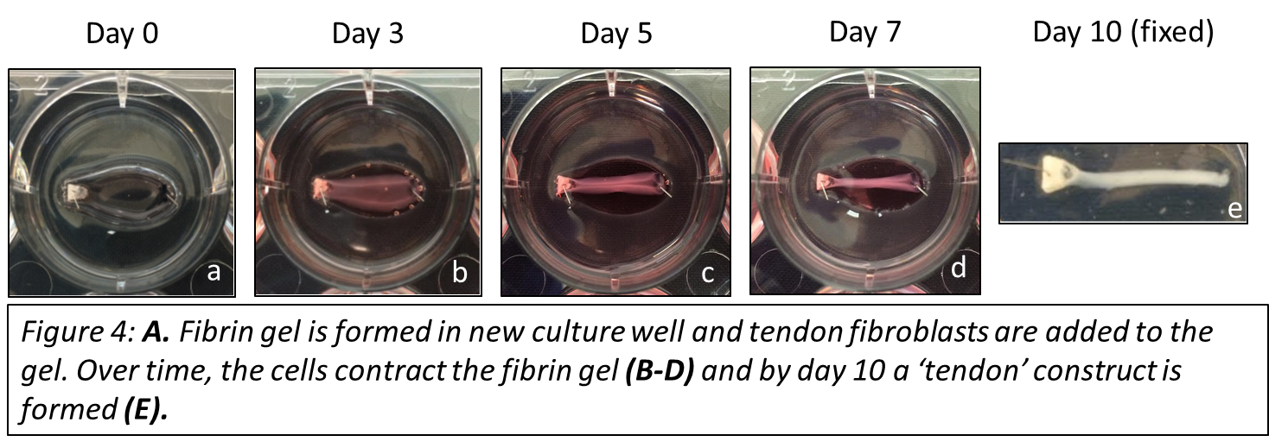In the human body, the transition from tendon to bone (the enthesis) is gradual, i.e. there are distinct areas with decreasing mineral density, the further away from the bone one looks. There are different approaches to engineering the enthesis. In this case, 0.7% gellan hydrogels were used as (control) bone anchors. Novel anchors, with a mineralisation gradient, where provided by the collaborating Pamula Lab, AGH University of Science and Technology in Krakow, Poland.

Aim 1: Using gross digital imagining, as well as histology, the presence of the mineralisation gradient was confirmed.

Aim 2: Before culture studies could commence, I designed a bespoke mould to create a bespoke well, which decreased the interphase between anchor and seeded tenocytes to one side of the anchor. Initially, the moulds were designed as individual pieces using computer assisted design software. I then improved the design to the construction shown in *Figure 2*, which aligns the bespoke wells and can support any weights required to for stabilisation while the silicone cures.

Aim 3: in order to assess the suitability of the novel, graded bone hydrogels, chicken tendon fibroblasts (CTFs) were cultured with the anchors using a cell seeding method. In *Figure 4*, the macroscopic development of a bone/tendon construct with the graded hydrogel as one anchor (left, white) can be observed over the course of 10 days. This shows how the CTFs were able to attach and form a tendon construct with this novel bone anchor.

**Other comments: (no more than 300 words)**

The original project timeline had to be revised due to bacterial infections in the tissue cultures. This delayed the start of the trials, as well as shortened the time over which the constructs could be cultured. Instead of the desired time points of day 7, day 14, day 21 and day 28, I was able to complete day 7 and 14.

Another problem was that for the majority of sections, the mineral deposition on the slides was damaged in the dewaxing, washing and staining process.

*Signature of student.......................................................Date*

*Signature of superviso Date…*

END OF FORM

--------------------------------------------------------------------------------------------------------------------------------------

*File: USVRS- Paxton and Graute Final Report no sig website version*