UNDERGRADUATE SUMMER VACATION SCHOLARSHIP AWARDS – FINAL SUMMARY REPORT FORM 2020/21
NB: This whole report will be posted on the Society’s website therefore authors should NOT include sensitive material or data that they do not want disclosed at this time.

Name of student:
Ellen Kelly
Name of supervisor(s):
Dr Jennifer Paxton
Project Title: (no more than 220 characters)
Exploring the use of 3D scanning technology to demonstrate anatomical variation
Project aims: (no more than 700 words)

In today’s technological world, the role of digital resources in anatomy education is steadily increasing – the importance and value of which has been reinforced by reduced teaching and laboratory time (Chapman et al., 2013). The COVID-19 pandemic has only served to exacerbate this reliance (Iwanaga et al., 2021). Unlike traditional textbooks, 3D virtual models enable students to interact with and gain spatial awareness of human anatomy, even when outside the laboratory (Azer and Azer, 2016). However, many of these resources rely on wholly computer-generated, idealised models and depict only one model of each anatomical region or bone. Thus, these educational tools do not enable students to appreciate the normal variation present between human anatomical specimens. This is an issue of increasing concerns for academics, medical professionals and students alike, as this lack of familiarity with anatomical variation may have serious consequences, such as a negative surgical outcome (Kowalczyk and Majewski, 2021).

Structured light scanning (SLS), a 3D scanning technique, presents a means by which this shortcoming may be addressed, and digital anatomy education resources improved. This scanning method creates a 3D virtual model of the desired object by projecting a repeated pattern of light onto the object’s surface. The scanner’s camera then detects the degree of distortion of this pattern and uses this information to determine the surface geometry of the subject (Gupta and Chaudhary, 2018).

This project therefore aimed to investigate the use of SLS to produce 3D interactive models of selected human bones/regions of skeletal anatomy. These virtual meshes were then compared using MeshLab, which provided quantitative (Hausdorff Distance - the farthest distance from each point on one model to the closest point on a second, superimposed model) and qualitative (coloured heat map on models) evaluation of the ability of SLS to capture, replicate and demonstrate anatomical variation. These analyses will provide insight into the ability of SLS to demonstrate anatomical variation, and hence, increase the educational value of digital anatomy learning resources.

Furthermore, as the first implementation of SLS technology with the host anatomy group, this project aimed to generate standard operating procedures, produce an instructional manual and train department staff in the use of the scanning equipment. This knowledge will ensure that this scanning technology is utilised optimally long after the conclusion of this project, supporting future research into the use of SLS within anatomy education at the University of Edinburgh.

Project aims:

- To use structured light scanning to produce 3D virtual models of human osteological specimens, contributing to an improved digital anatomy education tool which demonstrates anatomical variation.

- To determine best practices/techniques for scanning of human osteological specimens, promoting effective use of structured light scanning technology in future, as well as continued research into its value in anatomical education.

- To investigate demonstration of anatomical variation within the virtual models, evaluating the ability of SLS to represent this variation and contribute to the improvement of digital anatomy education tools.

Project Outcomes and Experience Gained by the Student (no more than 700 words)
Outcomes:

1. Producing 3D virtual models of osteological specimens using SLS.

Six different human bones/regions were chosen to be digitally replicated using SLS:
- Skull (with detachable/separated calvaria and, in all but one, mandibles)
- Scapula
- Humerus
- Ulna
- Radius
- Hand and wrist (whole)

In order to include anatomical variation within the virtual 3D model resource, three biological repeats of each bone/skeletal region were scanned (Figures 1 and 2). In total, 23 digital models were produced (skulls were scanned as isolated calvaria (x3), main skull portions (x3 – one with attached mandible) and mandibles (x2 – one not detachable).
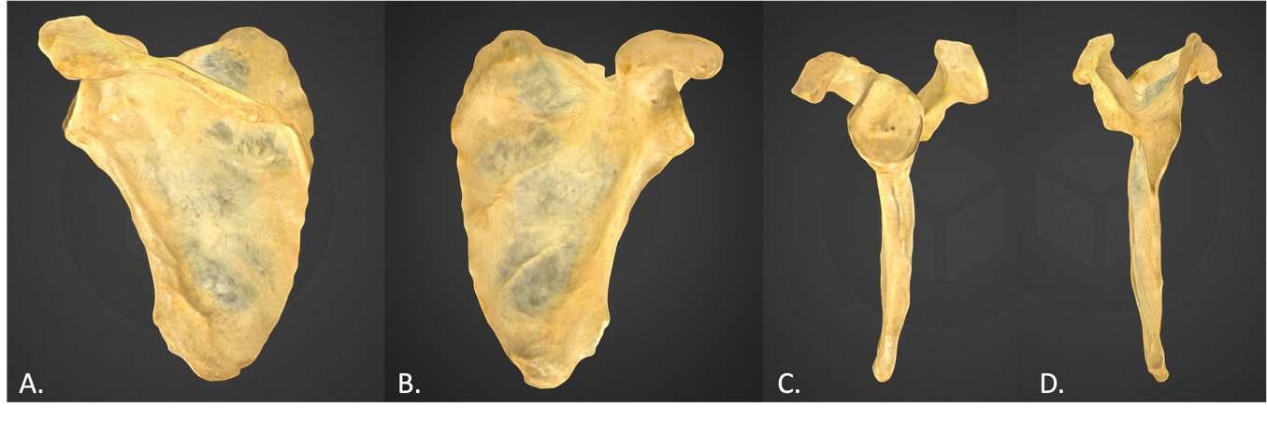
All models underwent graphics editing to enhance their appearance and resolve any issues (e.g. areas of overexposure), whilst remaining faithful to the appearance of the physical specimen. These models were then uploaded to a private SketchFab account, contributing to a library of anatomy education models.
Figure 1. Single model scan. Images of different angles in a 360° rotation of the scapula. A. Posterior B. Anterior C. Lateral and D. Medial aspects are shown

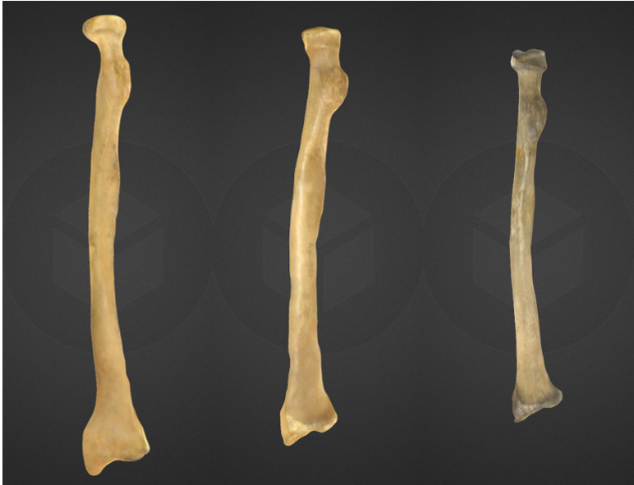

Figure 2. Images of 3D scans of 3 different radii. Anatomical variation in size, shape and colour can be seen.

2. Determining best scanning techniques/SOPs.

Throughout the project, various scanning techniques and set-ups (of both environment and the scan subject) were trialled. Meticulous records were kept, detailing approaches which did/did not work, and research into possible solutions to technical problems was undertaken.

Through this process of continuous improvement, optimal setup, scanning, model generation and editing approaches were determined. This knowledge was used to create an instructional manual, train a member of the anatomy staff and inform the construction of a dedicated scanning area within the anatomy laboratory. These efforts will ensure that this scanning technology may be used effectively in research and educational pursuits by staff and future students.

3. Investigating demonstration of anatomical variation.

MeshLab software was used to compare the meshed models (two at a time, within bone types i.e radii compared to radii etc). In total, 18 comparisons were carried out, with quantitative and qualitative data generated for each comparison. Unfortunately, the articulated hands could not be compared in this way, as differences in their posing resulted in the inclusion of irrelevant, non-anatomical variation. Although time constraints precluded this, future research may aim to scan and compare the isolated bones. However, these models still accurately replicate real human bones, and are a valuable addition to the digital resource.
Quantitative data was provided in the form of Hausdorff Distances (HD). The minimum and maximum mean HD were 0.965mm in the comparison of two radii and 6.103mm in comparison of two humerii, whilst the overall absolute minimum and maximum were 0.000mm and 27.397mm respectively. This indicates the presence of anatomical variation between the biological repeats of each bone, and that SLS is capable of capturing and replicating this variation.

Colour-coded heat maps visualised the variation present in each comparison further confirming the demonstration of anatomical variation in the SLS-generated models.

Figure 2. Example images of heat map comparisons made between different parts of the skull and between two biological examples. Variation is colour coded – from least to most: blue – cyan – green – yellow – red.

Experience:

This project has enabled me to gain valuable experience within an academic anatomy laboratory, allowing me to deepen my awareness of the conduct, respect and responsibility required when working with human remains. Furthermore, frequent handling of human osteological specimens has deepened my knowledge of human anatomy, particularly in relation to the skull and the upper limb, as well as enabling me to observe anatomical variation. This has increased my confidence in the identification, siding and orientation of isolated bones, compensating for some of the hands-on experience lost during the COVID-19 pandemic.

I have also gained extensive experience in the use of EinScan structured light scanning technology, as well as model generating and editing software. This has exponentially increased my computer literacy, as well as my confidence in my ability to quickly develop competency in new technologies and resolve issues, despite receiving limited training with this equipment. All of these skills will no doubt serve me well in future work and research, in an increasingly technology-reliant world.

Developing standard operating procedures and training staff enabled me to develop vital transferable skills such as teamwork, attention to detail and the ability to concisely explain technical procedures to a layperson through both oral and written communication.

Throughout this project, I have gained invaluable experience undertaking independent scientific research, working professionally and collaboratively within an academic laboratory and developing my confidence in the field of human anatomy. I believe that the experience gained through this scholarship project will prove invaluable to my future career.

Please state which Society Winter or Summer Meeting the student is intending to present his/her poster at:
Summer Meeting 2022

Proposed Poster Submission Details (within 12 months of the completion of the project) for an AS Winter/ Summer Meeting – (no more than 300 words)

Exploring the use of 3D scanning technology to demonstrate anatomical variation

Anatomy education relies increasingly heavily on digital resources, including 3D virtual anatomy models. The importance of these resources has been highlighted by the COVID-19 pandemic. However, most current digital tools depict only computer-generated, idealised models and only include one version of each specimen. Therefore, they do not expose students to the variation often seen in normal human anatomy, potentially negatively affecting their anatomical knowledge and competency (Kowalczyk and Majewski, 2021).

This project aimed to explore whether structured light scanning (SLS), a 3D scanning technique, could be used to create improved digital anatomy education tools which demonstrate normal anatomical variation.

Three biological repeats of six human bones/skeletal regions were scanned using SLS, resulting in a total of 23 virtual 3D models which were added to a private digital anatomy library on SketchFab. High quality models were produced, with quantitative analysis indicating that variation was present between all models to varying degrees. Qualitative analysis confirmed this, visualising these differences.

These results indicate that SLS is capable of capturing and replicating anatomical variation. This is a promising first step towards improving digital anatomy education resources, exposing students to the imperfect and varied realities of human anatomy, even when outside the laboratory. The knowledge gained in this project may help to inform future approaches in the use of SLS on human anatomical specimens.

Brief Resume of your Project’s outcomes: (no more than 200-250 words).
The title of your project and a brief 200-250 word description of the proposed/completed project. The description should include sufficient detail to be of general interest to a broad readership including scientists and non-specialists. Please also try to include 1-2 graphical images (minimum 75dpi). NB: Authors should NOT include sensitive material or data that they do not want disclosed at this time.

Exploring the use of 3D scanning technology to demonstrate anatomical variation

Technology continues to play an increasingly important role in anatomy education. In particular, the popularity of virtual 3D anatomy models is rising, enabling students to supplement their hands-on laboratory learning. However, many such resources include only one computer-generated, idealised depiction of each anatomical specimen. Thus, students are not exposed to the imperfect and varied realities of human anatomy.

This project aimed to explore whether structured light scanning (SLS), a 3D scanning technique, can be used to produce virtual models of real human anatomical specimens and create a learning resource which demonstrates anatomical variation. Multiple ‘versions’ of various bones/skeletal regions were scanned individually to produce individual models (example in Figure 1). Following this, models from the same region/bone were compared to each other in order to determine if differences in size/shape and features could be seen (Figure 2).
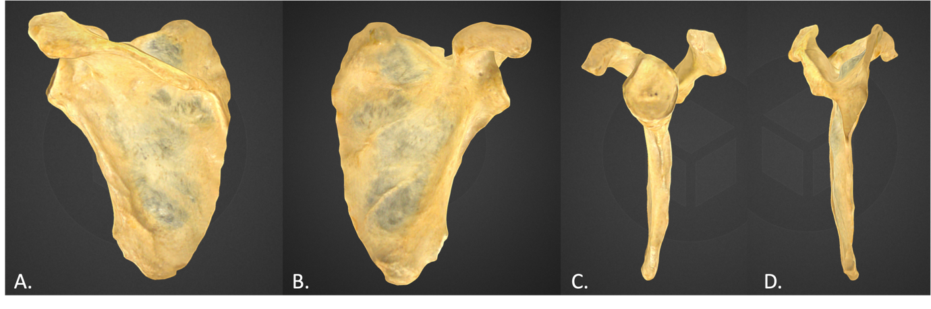
Figure 1. Single model scan. Images of different angles in a 360° rotation of the scapula. A. Posterior B. Anterior C. Lateral and D. Medial aspects are shown

Figure 2. Images of 3D scans of 3 different radii. Anatomical variation in size, shape and colour can be seen.

Analyses confirmed the presence of variation between models of the same bone type, indicating that SLS can replicate and demonstrate anatomical variation within its resultant models. Therefore, this project has found that SLS presents a promising means by which digital anatomy education resources may be improved, and the anatomical competency of students ameliorated. Furthermore, the knowledge gained through this project enabled the development of technical guidance for the use of SLS on human anatomical specimens and aided in the training of staff.

This is a promising first step towards the improvement of digital anatomy education tools, forming a foundation of knowledge to support future SLS research within the University of Edinburgh’s anatomy team.

Other comments: (no more than 300 words)

References

Azer, S. A. and Azer, S. (2016) ‘3D Anatomy Models and Impact on Learning: A Review of the Quality of the Literature’, Health Professions Education, 2(2), pp. 80–98. doi: 10.1016/j.hpe.2016.05.002.

Chapman, S. J. et al. (2013) ‘Anatomy in medical education: Perceptions of undergraduate medical students’, Annals of Anatomy - Anatomischer Anzeiger, 195(5), pp. 409–414. doi: 10.1016/j.aanat.2013.03.005.

Gupta, R. and Chaudhary, H. (2018) ‘Comparative analysis of low cost 3D scanning methods by evaluating its measuring capability’, International Journal of Innovative Research in Science, Engineering and Technology, 7(5), pp. 4849–4857. doi: 10.15680/IJIRSET.2018.0705063.

Iwanaga, J. et al. (2021) ‘A review of anatomy education during and after the <scp>COVID</scp> ‐19 pandemic: Revisiting traditional and modern methods to achieve future innovation’, Clinical Anatomy, 34(1), pp. 108–114. doi: 10.1002/ca.23655.

Kowalczyk, K. A. and Majewski, A. (2021) ‘Analysis of surgical errors associated with anatomical variations clinically relevant in general surgery. Review of the literature’, Translational Research in Anatomy, 23, p. 100107. doi: 10.1016/j.tria.2020.100107.

Data Protection/GDPR: I consent to the data included in this submission being collected, processed and stored by the Anatomical Society. Answer YES or NO in the Box below
YES
Graphical Images: If you include graphical images you must obtain consent from people appearing in any photos and confirm that you have consent. A consent statement from you must accompany each report if relevant. A short narrative should accompany the image. Answer N/A not applicable, YES or NO in the box below
N/A
Copyright: If you submit images you must either own the copyright to the image or have gained the explicit permission of the copyright holder for the image to be submitted as part of the report for upload to the Society’s website, Newsletter, social media and so forth. A copyright statement must accompany each report if relevant. Answer N/A not applicable, YES or NO in the box below
YES

Signature of student.......................................................Date…22/09/21………..

Signature of supervisor…………....... Date20/09/21

END OF FORM
----------------------------------------------------------------------------------------------------------------------------------------
File: USVRS- 2021 Report Website No sigs – Paxton and Kelly

