For Anatomical Society Website
Analysis of the distribution of α1 and α2-adrenergic receptors in the cerebral blood vessels. Relevance for Alzheimer’s disease
One of the major hallmarks of Alzheimer's disease (AD) is the presence of amyloid beta (Aβ) in the brain as plaques and in blood vessel walls. In the early stages of AD, Aβ is deposited in tiny membranes that are a millionth of the thickness of a human hair surrounding individual muscle cells in the arteries of the brain. Experimental work has indicated that the route by which fluid drains from the brain is along the membranes between smooth muscle cells in the artery walls. It is in smooth muscle cell basement membranes that Aβ is deposited in AD. For convenience, this pathway for elimination of waste including amyloid (Aβ), from the brain along basement membranes has been termed the “Intramural Peri-Arterial Drainage” (IPAD) pathway (figure 1).
From the observations in human AD and experimental studies we have proposed that failure of elimination of Aβ along IPAD pathways in the ageing brain could be a major factor that causes AD. Following this idea, we propose that enabling the elimination of soluble waste such as Aβ from the brain along IPAD pathways could be a strategy for the prevention of AD. For this to happen, the pump force that drives Aβ along IPAD needs to be enhanced.
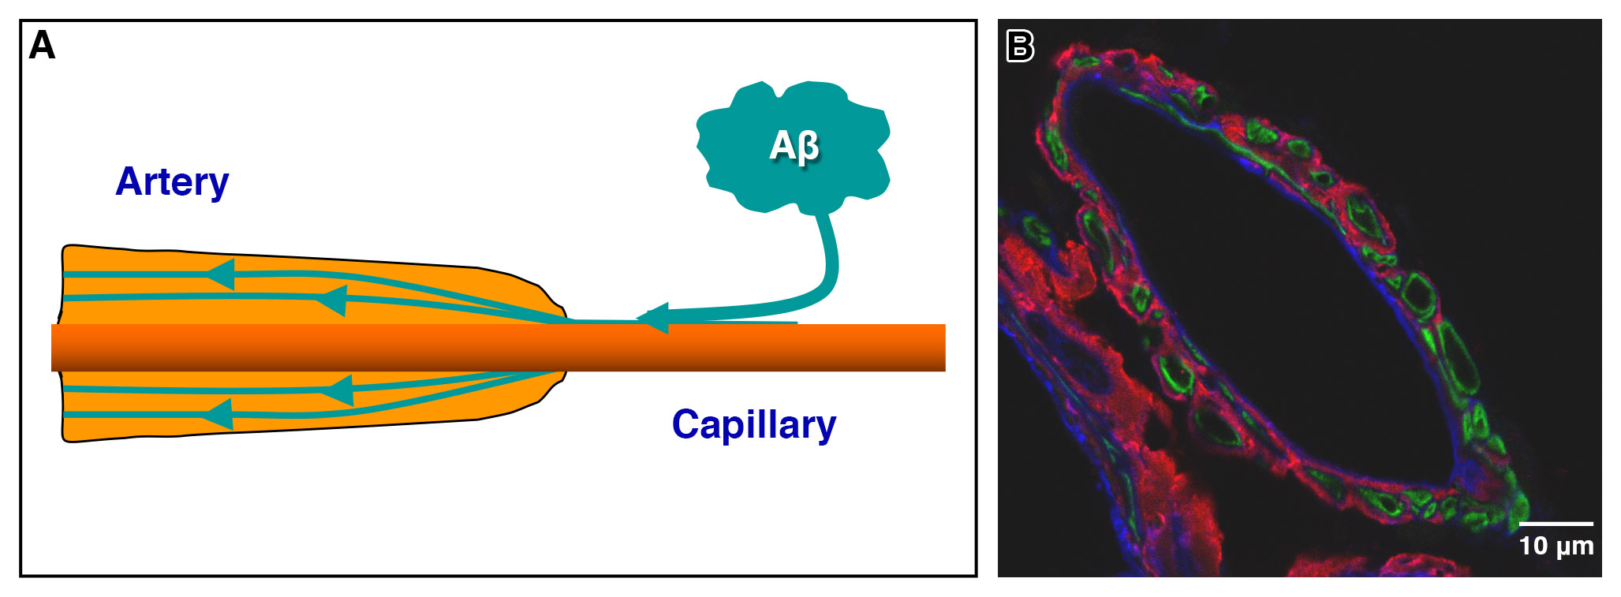
Figure 1: A) Diagrammatic representation of the elimination of waste including Aβ along the walls (basement membranes) of arteries. B) Cross section through a human artery at the surface of the brain showing basement membranes (IPAD) in blue, muscle cells in green and Aβ (red).
The nerves that end on sensors on the muscle cells represent an attractive target for improving IPAD. The muscle cells in the walls of arteries in the brain express “sensors” named adrenergic that receive adrenergic nerves that tighten the arteries. Despite studies showing a wide expression of these sensors in the brain, their distribution in the walls of arteries of the brain is not yet known. This project aims to analyse the distribution of α1 and α2-adrenergic sensors in the walls of blood vessels of the human brains. As AD appears to develop from a failure of elimination of Aβ along IPAD pathways, synchronising the pump force for IPAD promises to enhance the removal of Aβ in the treatment of AD.

