

**UNDERGRADUATE SUMMER VACATION SCHOLARSHIP AWARDS – FINAL SUMMARY REPORT FORM 2018/19**

***NB: This whole report will be posted on the Society’s website therefore authors should NOT include sensitive material or data that they do not want disclosed at this time.***

**Name of student:**

Simon Kershenbaum

**Name of supervisor(s):**

Dr Elia Benito-Gutierrez

**Project Title: (no more than 220 characters)**

Developmental Modularity in the Nervous System of Chordates: Challenging the ‘activation-transformation’ model of rostro-caudal regionalisation

**Project aims: (no more than 700 words)**

The main aim of the project was to understand the degree of homology between the vertebrate hindbrain and a middle region of the amphioxus neural tube that shows a particular proliferation pattern and a particular response to specific signalling cues during body axis elongation.

The specific objectives were:

1. To select a set of genes and markers that in vertebrates have a conserved role in hindbrain specification and differentiation.

2. To isolate these genes in amphioxus and characterise their expression during normal development and in embryos developing under perturbed conditions.

3. To investigate if there is modularity in response to signalling cues and, if there is, to set the boundaries of these putative modules either morphologically or molecularly.

**Project Outcomes and Experience Gained by the Student (no more than 700 words)**

In order to understand if a region in the amphioxus neural tube is homologous to the vertebrate hindbrain, I needed to first select a set of genes which function in vertebrates had been reported to be essential for the specification or differentiation of the hindbrain. I had the freedom to research the literature for genes that I thought would be good candidates for in situ hybridisation and visualisation. I would isolate the homologous genes in amphioxus with the objective of characterising their expression during development and compare it to that of vertebrates. To achieve this I first needed to retrieve the mRNA sequences of the genes of interest from the publicly available NCBI and ENSEMBL databases. In some cases, these sequences had been already reported for species of amphioxus other than the one used in the lab. Once compiled, I learnt to locally blast these sequences against the EGB lab’s transcriptome and genome databases built from the Mediterranean amphioxus *Branchiostoma laceolatum*. In cases where the transcriptome lacked the genes of interest, I had to reconstruct the predicted mRNA directly from the genome by isolating the exons in order to design probes. In this case the genomic regions were visualised with the Snap Gene Viewer software which I also learnt how to use and that helped me recognising the open reading frames within exons and the splice sites. I also learnt about sequence alignments and phylogeny as tools to identify the right orthologous genes.

After homology is established and a gene is isolated, DNA probes need to be designed for the in situ hybridisation chain reaction (HCR). This is a fluorescent in situ hybridisation technique which application in amphioxus has been pioneered by the EBG lab and that allows visualising gene expression and co-expression at a single-cell level in whole mount preparations of amphioxus embryos. While performing the HCR protocol in the lab I got to understand not only how to run an HCR, but also the reasons behind each step, as well as a broader understanding of “wet-lab” technique.

Once the HCR protocol is finished the samples need to be imaged via a confocal microscope. This gave me the opportunity to learn how to use a confocal microscope and understand how to optimise the imaging of whole embryos hybridised against multiple fluorescently labelled probes.

After the images are acquired, they must be analysed. To this end I was taught how to use ImageJ software which allowed me to look into the patterns in 3D and quantify the information contained within. The resolution in an HCR is much higher than in chromogenic in situs, and so I could use ImageJ to look at both single cell expression patterns and tissue level expression, each being useful for different questions. Additionally, I could perform simultaneous profiling of up to 4 different genes in the same embryo, thus I had to think about what combinations will maximise the amount and value of information obtained.

Part of my project was to understand how certain disruptions to signalling pathways can influence gene expression in the amphioxus putative hindbrain. I focused on the effects of Notch and the retinoic acid (RA) signalling pathway, as both signalling pathways have been reported to influence nervous system development in amphioxus. I reproduced treatments already published in other amphioxus species. This involved reviewing these papers and adapting the published protocols to the species I was using (*B.lanceolatum*). Once an appropriate protocol was found, I still needed optimise it for *B. lanceolatum* to ensure a reproducible, consistent phenotype. Gene expression patterns in these embryos were tested via HCR.

The effect of each treatment was tested at two different timepoints, one in the middle of elongation and one at the end of elongation, with the drug exposure taking place at the beginning of elongation. For genes of particular interest, a time sequence HCR was done to understand how relative gene expression changes over time.

The results of this research indicate that there is a widespread expansion of differentiation markers following notch inhibition. However, some neural markers are lost altogether from the putative hindbrain homologue. Additionally, some positional marker genes seem to be upregulated within their expression region following notch inhibition. These positional markers remain unchanged when the RA pathway is inhibited, suggesting that the Notch sensitive module is independent of the Hox code.

Please state which Society Winter or Summer Meeting the student is intending to present his/her poster at:

**Summer**

**Proposed Poster Submission Details (within 12 months of the completion of the project) for an AS Winter/ Summer Meeting – (no more than 300 words)**

**I will present something similar to the “Brief Resume of Project’s outcome” bellow, but in the format of a poster. However, I will add more specific information that may be best first present in the poster.**

*Understanding the evolutionary origin of the chordate hindbrain.*

Vertebrates can exhibit highly complex central nervous systems, and it is of great interest to understand which innovations are truly vertebrate and which were already in place in our chordate ancestor. One characteristic of the vertebrate neural tube is its high degree of regionalisation, with one of the regions being the segmented hindbrain.

To try and understand to what degree neural tube regionalisation is a vertebrate innovation, I looked into the degree of homology between the vertebrate hindbrain and the putative hindbrain of amphioxus, the chordate outgroup of vertebrates.

This included both characterising the gene expression pattern of the putative hindbrain, as well as testing how the gene expression and boundaries of this region change in response to perturbation of the retinoic acid and Notch signalling pathways.

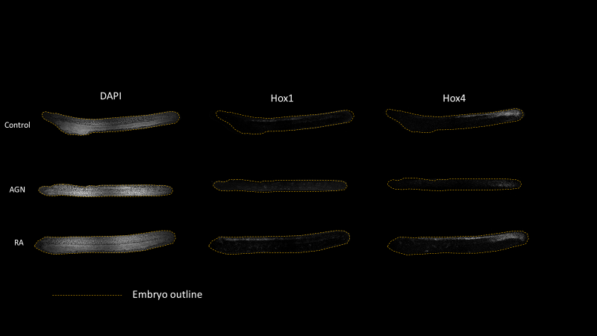

*Figure 1 – Effects of AGN and RA on Hox1 and Hox4 expression. A reproduction of similar experiments in order to test the effect of increased Hox1 and Hox4 overlap.*

My results indicate that the anterior limit of the putative hindbrain has previously unreported similarities to the vertebrate MHB. Additionally, I established that while the posterior limit of the putative hindbrain is coincident with the co-expression of Hox1 and Hox4, they do not regulate some of the posterior markers delimiting this region. Finally, I show that notch inhibition drives expansion of some differentiation markers, similar to what is seen in vertebrates.

In conclusion, the results strengthen the idea that the putative hindbrain amphioxus is in fact homologous to the vertebrate hindbrain and shows complex segmentation patterns, as well as a degree of similarity in its response to signalling cues. Overall, this may indicate that the ancestral chordate already possessed a genetically segmented hindbrain and that Notch signalling may have been important for regulating neuronal differentiation in this proto-hindbrain.

**Brief Resume of your Project’s outcomes**: **(no more than 200-250 words)**.

*The title of your project and a brief 200-250 word description of the proposed/completed project. The description should include sufficient detail to be of general interest to a broad readership including scientists and non-specialists. Please also try to include 1-2 graphical images (minimum 75dpi). NB: Authors should NOT include sensitive material or data that they do not want disclosed at this time.*

Vertebrates can exhibit highly complex central nervous systems, and it is of great interest to understand which innovations are truly vertebrate and which were already in place in our chordate ancestor. One characteristic of the vertebrate neural tube is its high degree of regionalisation, with one of the regions being the segmented hindbrain.

To try and understand to what degree neural tube regionalisation is a vertebrate innovation, I looked into the degree of homology between the vertebrate hindbrain and the putative hindbrain of amphioxus, the chordate outgroup of vertebrates.

This included both characterising the gene expression pattern of the putative hindbrain, as well as testing how the gene expression and boundaries of this region change in response to perturbation of the retinoic acid and Notch signalling pathways.



*Figure 1 – Effects of AGN and RA on Hox1 and Hox4 expression. A reproduction of similar experiments in order to test the effect of increased Hox1 and Hox4 overlap.*

My results indicate that the anterior limit of the putative hindbrain has previously unreported similarities to the vertebrate MHB. Additionally, I established that while the posterior limit of the putative hindbrain is coincident with the co-expression of Hox1 and Hox4, they do not regulate some of the posterior markers delimiting this region. Finally, I show that notch inhibition drives expansion of some differentiation markers, similar to what is seen in vertebrates.

In conclusion, the results strengthen the idea that the putative hindbrain amphioxus is in fact homologous to the vertebrate hindbrain and shows complex segmentation patterns, as well as a degree of similarity in its response to signalling cues. Overall, this may indicate that the ancestral chordate already possessed a genetically segmented hindbrain and that Notch signalling may have been important for regulating neuronal differentiation in this proto-hindbrain.

**Other comments: (no more than 300 words)**

I would like to thank the entire EBG lab for both the opportunity as a whole, and the support and positive attitude throughout the project.

Additionally, I would like to sincerely thank the Anatomical Society for this opportunity as it has been both extremely valuable and enjoyable. This experience has greatly increased my interest in pursuing an academic career, and the support from the Anatomical Society is greatly appreciated.

*Signature of student S. Kershenbaum Date 23.08.2019*

*Signature of supervisor Elia Benito-Gutierrez Date……23.08.2019*

*File: USSVRS 1819 Report BG and SK – no sigs web version - 100919*