**­­­­­­­­­­­­­­**

**UNDERGRADUATE SUMMER VACATION SCHOLARSHIP AWARDS – FINAL SUMMARY REPORT FORM 2016/17**

*NB: This report will be posted on the Society’s website therefore authors should NOT include sensitive material or data that they do not want disclosed at this time.*

**Name of student:**

Mr Yaroslav Shkanov

**Name of supervisor(s):**

Dr Stuart Morton, Dr Scott Border

**Project Title: (no more than 220 characters)**

Evaluating the impact of interactive histology educational videos: trendy hype or useful teaching tool?

**Project aims: (no more than 700 words)**

|  |
| --- |
| The delivery of medical education is changing in modern curriculums. There is a gradual decline in the hours dedicated to traditional basic science teaching in favour of greater clinically-relevant content. The same trends are witnessed in histology, despite being an important subject in the understanding of physiological, pathological and anatomical concepts. As a result, new teaching initiatives in histology have focussed on providing students access to material outside the laboratory, such as virtual microscopy and online multimedia resources. These resources have proven to be engaging, flexible and non-inferior to traditional didactic teaching with regards to exam performance. Currently, there is a paucity of research examining the impact of educational histology videos in medical curriculums. Our project aims were to:  (1) Create four themed histology teaching videos  (2) Create a simple online website to host these videos  (3) Run a pilot study with three experimental groups: traditional teaching vs. screencast vs. interactive video  (4) Examine knowledge gain / retention (using OBA-style MCQ quizzes) and student perceptions of teaching methods (using questionnaires) |

**Project Outcomes and Experience Gained by the Student (no more than 700 words)**

|  |
| --- |
| **Project Outcomes**:   1. Developed 4 histology videos, each lasting 7-8 minutes.   This randomised, cross-sectional study aimed to compare traditional teaching techniques versus two other forms of multimedia videos: screencasts and interactive videos. All three study resources had to be created from scratch for two histology topics, which were cartilage and respiratory. These resources included:   * **Screencast**: A type of video that begins with a blank screen and builds on content at the pace of the presenter, often employing handwritten annotations, similar to a whiteboard tutorial. * **Interactive Video**: A non-handwritten video that uses animations and quizzes to convey an educational narrative, similar to a recorded presentation. * **Traditional Teaching**: Scripts (4-5 pages) that were initially created for video narration ended up being used as surrogates for traditional teaching.   Interestingly, only 41.7% of students were aware of the differences between a screencast and educational video, despite greater than a third (37.5%) using YouTube videos as their ‘first port of call’ when learning something new in medicine or an allied healthcare subject.   1. Recruited 30 eligible study participants.   Before the study began, an ethics application was submitted to the local Ethics and Research Governance Committee at the University of Southampton to approve our recruitment process and data collection. After approval, despite most students being away for summer holidays, thirty participants were recruited into the study within a 2 to 3 week timespan. This fulfilled the recruitment target set out in my original AS application.   1. Students tended to find histology difficult to learn and used other resources in conjuction with traditional teaching.   The average perception for ‘I found histology difficult to learn’ was 7.2 / 10 (0 = strongly disagree, 10 = strongly agree), indicating that there was moderate agreement in our study sample. Equally, this moderately and negatively correlated with ‘I find using traditional teaching effective for histology (e.g. lectures, textbooks, microscopy, workshops)’ (R = -0.561, p = 0.001). These results suggest that students who agreed that histology was difficult to learn tended to disagree that traditional teaching was effective, eluding to the possibility that traditional resources may have not been enough in explaining difficult histological concepts. Further exemplifying this was the fact that 26 out of 30 students tended to use supplementary resources in conjuction with Faculty teaching (Figure 1).   1. Students tended to agree with the idea of videos being integrated into histology teaching and would find an educational channel dedicated to histology useful.   On average, students agreed on integrating videos into their learning (7.0/10, 0 = strongly disagree, 10 = strongly agree) and the benefits of an educational channel dedicated to histology learning (8.4/10, 0 = strongly disagree, 10 = strongly agree). Additionally, regardless of the teaching intervention, there were no statistically significant changes in the student’s perceptions of the benefits of an educational channel for histology, suggesting that students already felt quite strongly about the benefits of a histology channel before the study.   1. There was no statistically significant knowledge gain or knowledge retention between the 3 teaching modalities.   Our quantitative measures within this study included knowledge gain (immediately post-teaching sesson) and knowledge retained (4 weeks post-teaching session) as graded by an OBA-style MCQ quiz. A Kruskal Wallis test demonstrated there was no statistically significant difference in the knowledge gained and retained amongst the three groups (Figure 2A: n = 30, X2 = 0.08, p = 0.96 and Figure 2B: n = 27, X2 = 0.02, p = 0.93). This could be attributed to our small sample size, therefore it will be important to normalise knowledge gain for consistent analysis and more meaningful comparison between studies in the future.    **Experience Gained**:   1. Ethics procedure, liaising with ethics committee and implementing feedback from reviewers 2. Proficient use of photo, video and audio editing software (e.g. Pixelmator, ShowMe, Audacity) 3. Developing educational learning outcomes and writing OBA multiple choice questions 4. Development of questionnaires 5. Organisation and leadership of independent small group teaching sessions 6. Organisation and running focus groups 7. Use of statistical packages and analysis (e.g. GraphPad, SPSS) |

Please state which Society Winter or Summer Meeting the student is intending to present his/her poster at:

|  |
| --- |
| Society Summer Meeting 2018 (Oxford)  **Reason**: Attendance to a meeting where there is a greater educational theme would be preferable. |

**Proposed Poster Submission Details (within 12 months of the completion of the project) for an AS Winter/ Summer Meeting – (no more than 300 words)**

|  |
| --- |
| Evaluating the impact of interactive histology educational videos: trendy hype or useful teaching tool? |

**Poster Title**: Videos as an adjunct to traditional teaching: time to set a new standard in the histology multimedia realm?

**Poster Abstract:**

**Introduction**: In modern medical curriculums there has been a gradual decline in time allocated to basic science teaching and a greater emphasis on active, self-directed methods of teaching. The same trends are being seen in histology, with the introduction of virtual microscopy banks and online multimedia resources to aid self-study. This study aimed to assess the impact of different educational video formats versus traditional teaching techniques.

**Method**: A randomised, cross-sectional study was conducted with thirty medical students enrolled at the University of Southampton and free from one year of formal Faculty histology teaching. Participants were randomly assigned to either traditional teaching (n = 10), interactive video (n = 10) or screencast (n = 10). Outcomes measured were 1) knowledge gain and retention, assessed using OBA-style MCQ tests before and after the teaching sessions, as well as at week 4, and 2) student perceptions, assessed using Likert-scale questionnaires.

**Results**: A significant improvement in mean knowledge gain was observed for all teaching modalities: script (37.5%, P=0.002), interactive video (38.5%, P=0.002) and screencast (36.7%, P=0.008). There was no statistically significant differences between teaching modalities with respect to knowledge gain and knowledge retention. 73.3% of students agreed to consider integrating videos into their learning and suggested that the use of animations, clear layout and even humour proved to be important components in ensuring a strong engagement with the histology material.

**Conclusion**: This study is the first to assess different educational video modalities in the field of histology. The integration of histology videos provides an extra resource for contemporary students and makes a challenging subject more engaging, without affecting student assessment scores.

**Disclosures**: Funded by an Anatomical Society Undergraduate Studentship.

**Brief Resume of your Project’s outcomes**: **(no more than 200-250 words)**.

*The title of your project and a brief 200-250 word description of the completed project. The description should include sufficient detail to be of general interest to a broad readership including scientists and non-specialists. Please also try to include 1-2 graphical images (minimum 75dpi). NB: Authors should NOT include sensitive material or data that they do not want disclosed at this time.*

Videos as an adjunct to traditional teaching

The delivery of medical education is changing in modern curriculums with less time being assigned to the basic sciences. Histology still remains a fundamental topic in medical education and various online tools, such as virtual microscopy and multimedia resources, have been introduced to support curriculum changes. Our study aimed to examine the impact of different educational video formats on student learning.

The first phase of our study was to produce four themed histology videos (Figure 1); two interactive videos (a recorded presentation with a quiz) and two screencast videos (a handwritten whiteboard tutorial). The script for each video acted as our surrogate for traditional teaching. The second phase of the study involved recruitment and conducting the teaching sessions. Thirty clinical students were enrolled into the study and were allocated to either interactive video, screencast or script (Figure 2). Participants were subjected to a series of questionnaires and quizzes to assess our main study outcomes: knowledge gain, knowledge retention and student perceptions.

Our results showed that all teaching modalities had a positive impact on knowledge gain and retention, however, there was no major differences between teaching modalities. More positive feedback was associated with the videos, compared to script, since they were ‘succinct and simple’, ‘great for visual learners’ and ‘appealing to the eye’.

Our study suggests that videos could be integrated into modern medical curriculums without affecting exam performance and could increase student engagement within difficult topics, such as histology.

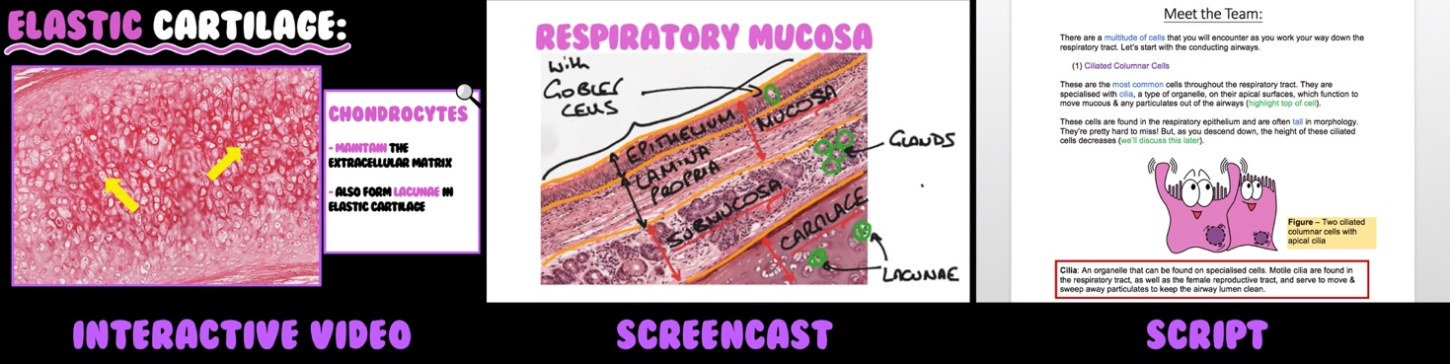

**Figure 1** – Segments of the interactive video, screencast and script.

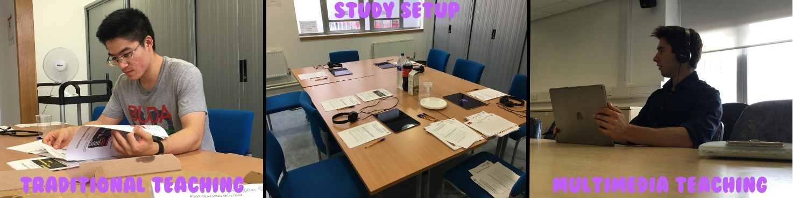

**Figure 2** – The teaching session and different teaching modalities.

**Other comments: (no more than 300 words)**

We would like to thank the Anatomical Society for the opportunity to undertake the above work and for sponsoring the study. The opportunity to explore the medical education field, particularly in anatomy, has broadened my horizon with regards to academic research and allowed me to connect with inspirational individuals who share my passion for medical education. All in all, this summer placement has provided a fantastic stepping stone towards an academic clinical career.

I wish to thank both my wonderful and experienced supervisors, Dr Stuart Morton and Dr Scott Border, who have both provided unrelenting support and imparting skills that have shaped my career. Working with these two innovators in the medical educational field has proven to be a very intellectual experience. Their mentoring has proven invaluable and without it, this project would have never come to fruition or completion.

Finally, I wish to extend a warm thank you to all the individuals associated with the Centre for Learning Anatomical Sciences (CLAS), University of Southampton, who provided me with a nurturing environment to work within and 24/7 support in completing this project.

*Signature of student* *Date*: 25/09/2017

*Signature of supervisor Date*: 13/09/2017

END OF FORM

----------------------------------------------------------------------------------------------------------------------------------------

UG 201617 ShkanovBorder Unsigned Report