Title: Investigating the role of the ubiquitously expressed thioesterase Ppt1- a multi organ morphological and molecular study to inform therapeutic targeting.

First Supervisor: Thomas Wishart, The Roslin Institute, University of Edinburgh

Second Supervisor: Gerard Thompson, Centre for Clinical Brain Sciences, University of Edinburgh

Third supervisor: Dominic Kurian, The Roslin Institute, University of Edinburgh

Overview: Ppt1 is a thioesterase. As with many other disease causing proteins such as SMN (in SMA), Ppt1 is ubiquitously expressed. However, perturbation in such a protein is capable of inducing a devastating postnatal neurodegenerative disorder (CLN1) in children, with PPT1-R151x being one of the most aggressive disease-causing lysosomal mutations. The relationship between the apparently ubiquitous 'housekeeping' activity of lysosome function and early neural dysfunction is unclear¹.

Investigations into patients confirms neurodegenerative progression is regional and other organ systems are also affected later in disease. Unfortunately, given this progression, patients are usually symptomatic by the time they come to the attention of a medical professional and the lifespan of such patients rarely exceeds ten years (i.e. 10%)¹. Thus, disease analysis is difficult and presymptomatic investigations nearly impossible.

This project seeks to address critical gaps in our biomedical understanding of the multisystemic nature of Ppt1 induced neurodegenerative conditions (and by inference, other ubiquitously expressed mutations presenting with a predominantly post-natal neurological phenotype).

We have generated the first ever CRISPR edited neurodegenerative model in sheep. We reproduced the PPT1 gene mutation (r151x) and thus recapitulated “CLN1” human disease phenotypic factors at end stages of disease including visual and motor deficits, the regional nature of neurodegenerative progression (according to MRI), and similar relative disease lifespan (15%). See figure 1 below.

By studying this model system in detail from presymptomatic stages at the morphological, histological and molecular level, and (where possible) in comparison with patient tissues and data we will improve our understanding of disease progression as a consequence of altered Ppt1 protein levels and the multisystemic nature of these conditions, as well as determining the utility of this model and informing considerations for targeting in pre-clinical therapeutic intervention trials¹

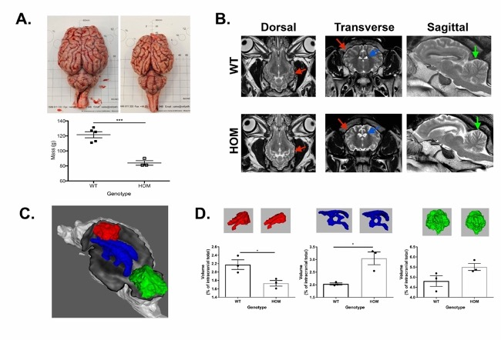
Figure 1: Pattern of neurodegeneration in ovine model mimics human disease - A. Total fresh brain weight – Wild type (WT) control (left) and PPT1 (CLN1 R151x) homozygote (Hom - right) at 17/18 months old (P=0.0006). B-D. motor cortex (red), cerebellum (green), and tri-ventricular cerebrospinal fluid (blue). B. Comparison of orthogonal T2-weighted spin echo imaging slices in example wild type (top row) and homozygous (bottom row) animals. C. Volumetric rendering. D. Volumetric data quantification. Error bars represent SEM. N=5(A),3(D) WT control; N=3 (A&D) PPT1 Homozygous sheep. Figure from Eaton et al 2017 Scientific Reports¹.

Reference:

- Eaton SL, Proudfoot C, Lillico SG, Skehel P, Kline RA, Hamer K, Rzechorzek NM, Clutton E, Gregson R, King T, O'Neill CA, Cooper JD, Thompson G, Whitelaw CB, Wishart TM. (2019) CRISPR/Cas9 mediated generation of an ovine model for infantile Neuronal Ceroid Lipofuscinosis (CLN1 disease). Scientific Reports 2019 Jul 9;9(1):9891. doi: 10.1038/s41598-019-45859-9. PMID: 31289301

File: Research Studentships Wishart Project Resume Website 090124

