Evolution of suckling: bone muscle interactions to create a novel structure in mammals

Supervisors:
Prof Abigail Tucker, Centre for Regenerative Biology, King’s College London
Prof Emily Rayfield, School of Earth Sciences, Bristol University.

Abstract:

One defining character of mammals is their ability to produce milk in order to feed their young. During mammalian evolution, this required changes to the mammary glands but also to the craniofacial complex. Suckling requires the tongue to create a seal anteriorly between the teat and the hard palate, and more posteriorly against the soft palate. The soft palate stretches between a structure known as the pterygoid hamulus, which provides anchorage for the tensor veli palatini (TVP) muscle. This connection is essential for control of the soft palate musculature and therefore for suckling. In this project we investigate how the muscles and bones of the palate interact during development using the mouse as a model. We will then compare the muscle-skeletal interactions in the forming palate in mammals that suckle from a teat (placentals and marsupials) with those that do not (egg laying mammals). Finally, we will map the dynamic changes in the palate and pterygoid region during mammalian evolution, using high resolution scans from fossils of early mammal-like reptiles. The project takes an interdisciplinary approach, combining knowledge from developmental biology, palaeontology, and computational modelling, and benefits from access to rare specimens, to address important questions about mammalian evolution, while providing new understanding about how force directs tissue development.
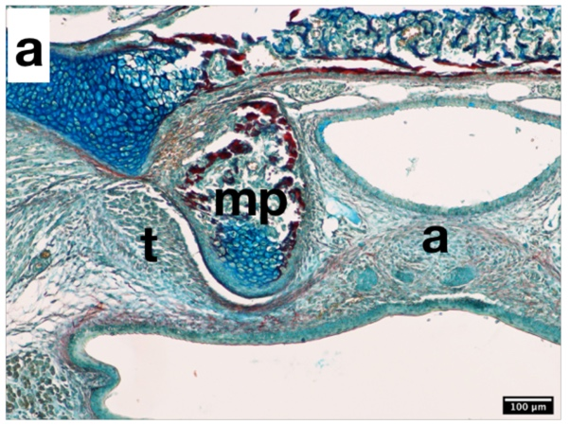
Mouse developing Pterygoid. Image shows histological section through a mouse embryo at embryonic day (E)17.5. A bursa (synovial space) has formed between the mp (medial pterygoid) and the t (tensor veli palatini).
Taken by Serena Sun, King's College London.

Echidna microCT scan. Images shows scan through a half head of a juvenile echidna.
Taken by James Rawson, Bristol University.

