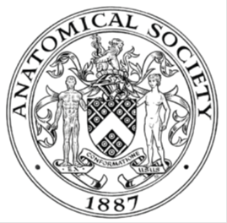
_______________________________________________________________________________________
AWARDEE REPORT FORM
_______________________________________________________________________________________

NAME |  | Matthew Parnall
UNIVERSITY |  | University of Nottingham
NAME OF AWARD |  | Symington Bequest Fund
PURPOSE OF AWARD conference attended (full name) with city and dates
European Society of Cardiology, Newcastle Cardiovascular Meeting, 15th to 17th November 2016, Newcastle, UK

REPORT: What were your anticipated benefits?
As I’m nearing the end of my PhD I hoped to network and find academics doing work that is close to the area of interest of my thesis. I also hoped to be able to discuss my work and gain valuable feedback. This was expected to enable me to look critically at what I and others have done and allow me to move forward to a new phase of my work.
COMMENTS: Describe your experience at the conference / lab visit / course / seminar.
The conference had a diverse array of speakers. The first day was focussed on the anatomy and development of the heart. It was interesting to hear new research and theories on the origin of heart structures and how these varied from former views. The next two days were a mixture of molecular and anatomical based work that could lead to therapies. I found this most interesting as it tied in with my research with many presentations using similar techniques and strategies to my own project. Over these two days I presented my poster and it was then that I had the chance to network and gain feedback on my work.

REPORT: In relation to skills, what were the most important things you gained? (does not apply to equipment grant)
The feedback from my presentation related to current and future projects. The former was particularly beneficial as my PhD viva is imminent. Feedback included advice on analysis of next generation sequencing and designing model systems to test cardiomyopathy and heart deformations. The information gained was so much more than I could ever get from researching alone.

REPORT: How do you think you will put this learning experience into practice in the future?
I am now using new analysis software as a direct result of conversations at the conference and have designed a new heart cell culture model to test effects of stress on the heart. In the future I will try to attend more conferences as I have found the information gained at this one invaluable. I would also encourage others to do so.

SIGNATURE | Matthew Parnall |  | DATE | 24/11/16
If submitted electronically, a type-written name is acceptable in place of a hand-written signature

File: AS-Award-Report-Form-BLANKCO-SEAL-date110216

