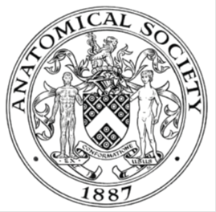
_______________________________________________________________________________________
AWARDEE REPORT FORM
_______________________________________________________________________________________

NAME |  | Claire Fitton
UNIVERSITY |  | University of Dundee
NAME OF AWARD |  | Barclay-Smith Travelling Award
PURPOSE OF AWARD conference attended (full name) with city and dates
To allow myself to travel to Galway, Ireland from 26-06-17 to 29-06-17 to attend the Anatomical Society’s Summer Meeting – Anatomists on the Edge from 27-06-17 to 29-06-17, to present a poster presentation.

REPORT: What were your anticipated benefits?
To network with like-minded academics, professionals and students, and to learn about current anatomical-related research.

To present my poster and gain experience in scientific communication.
COMMENTS: Describe your experience at the conference / lab visit / course / seminar.
I found the conference very enjoyable and informative, and was surprised at the variety of fields the conference had brought together. I was able to speak to both academics and business professionals and gained and insight into the future of anatomy education (virtual learning methods).

The talks were engaging, with particularly amazing use of imaging. I felt encouraged to create a professional twitter account and communicate with the academics I may otherwise have not had the opportunity to speak with.

I enjoyed presenting my poster and have felt encouraged to continue my scientific career with publications and oral presentations.

REPORT: In relation to skills, what were the most important things you gained? (does not apply to equipment grant)
I have learnt the importance of communication between academics and gained skills using social media (twitter) to gain knowledge and contacts with professionals.

I have also gained skills in poster design and effective presentation of information and knowledge.
REPORT: How do you think you will put this learning experience into practice in the future?
I would like to further my networking skills by attending future Anatomical Society conferences, as well as recommending the Society’s meetings to my peers.

I will further my learning experience in communication gained from presenting my own poster and listening to the oral presentations of others, by applying to present an oral presentation at the next Anatomical Society meeting.

SIGNATURE | Claire Fitton |  | DATE | 07-07-17
If submitted electronically, a type-written name is acceptable in place of a hand-written signature

File: AS-Award-Report-Form-BLANKCO-SEAL-date110216

