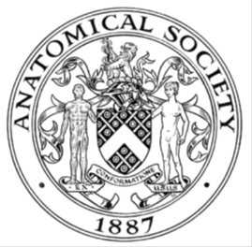
_______________________________________________________________________________________
AWARDEE REPORT FORM
_______________________________________________________________________________________

NAME |  | Janet Philp (with Joan Smith)
TWITTER HANDLE* optional |  | @anatomyfundamentals
UNIVERSITY |  | Edinburgh
NAME OF AWARD |  | Public Outreach
PURPOSE OF AWARD conference/event attended/organised (full name) with city and dates.
To partially fund the “I’ve got yer back” project encouraging hundreds of people to learn about the anatomy of their spine by making felt vertebrae which could all be assembled into an art piece. During National Back Week, the art piece will be displayed at the final event (04/10/2023) which will feature two talks on back anatomy and spine care.

REPORT: What were your anticipated benefits?
We anticipated people finding out more about their spinal anatomy by taking part in the felting activity and by attending the final event
COMMENTS: Describe your experience at the conference / lab visit / course / seminar/ event.
The event was launched at the Anatomical Society meeting with a preconference workshop (which was oversubscribed) with over 20 anatomists learning how to make felt vertebrae.
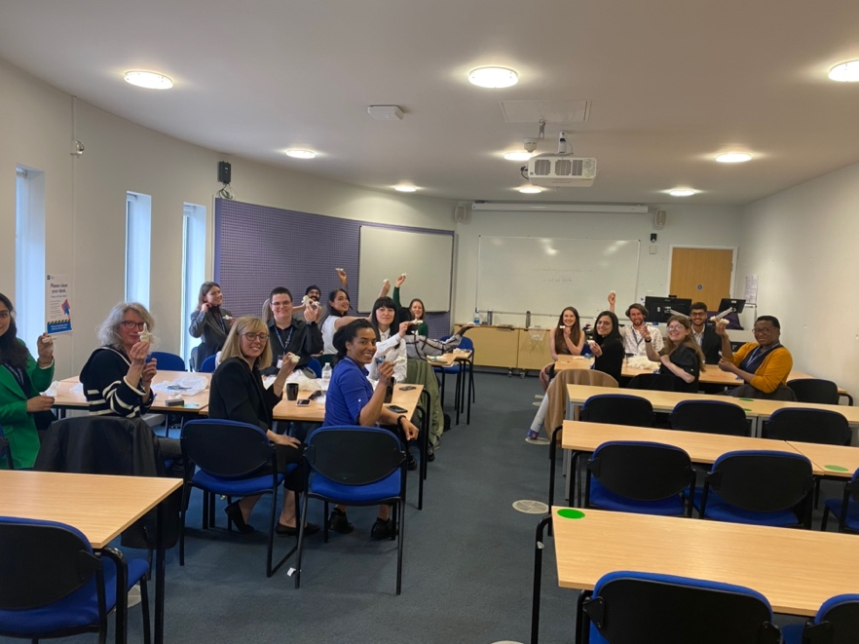

Preconference workshop at Nottingham conference 2023

At this point we started to get comments back from workshop participants about how they had never really appreciated the intricacies of the spinal anatomy even though they taught it regularly. The material for the workshop was converted into kits and taken away by attendees so that those who had not been able to attend in person could still participate in the project. The activity was advertised to the UK needle felters’ Facebook group and 3 days later we had to close the signup page because we were over-subscribed. We ran additional workshops for an Edinburgh Science/Art group and for a craft group for veterinary students and staff. A total of 140 felting kits were sent out and just under 100 felt vertebrae were returned. Each kit contained instructions and basic spinal anatomy sheets (attached to the email of this report). We asked each of the returning participants to provide us with some thoughts about the experience and what they had learned. A lot of the participants had experienced back surgery and we have collected many comments about how they had not really understood what had been done to their back until they under took this activity. We had comments back from several anatomical professional about how this was a much better activity for learning about spinal anatomy than simply reading or the 3D tech that is often used.
All of the returned vertebrae were mounted into an art installation. We are currently arranging professional pictures of the piece. The photo, along with a key allowed people to identify their felt and will be circulated to all participants.
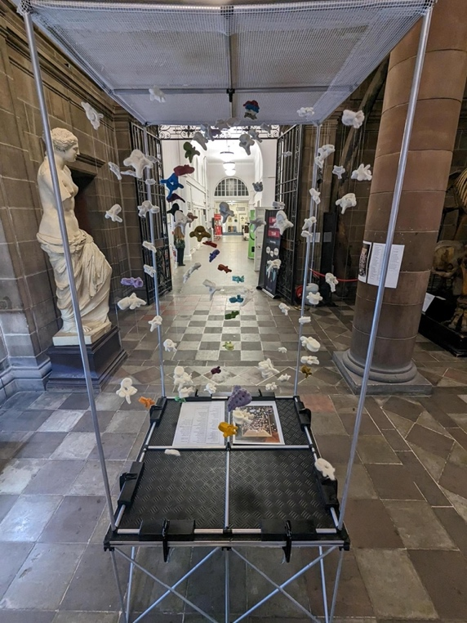
The final event had over 70 tickets booked. People learnt more about the evolution of the back and how to cope with, and avoid, back pain.
This project has further consequences than we anticipated. We were unprepared for the thankful emails we received from back pain suffers who felt they understood more about back anatomy through our simple activity than they had when medical professionals had explained their operations. We have been asked to consider writing up the activity for publication and have received requests to run further felted vertebrae workshops.

REPORT: In relation to skills, what were the most important things you gained? (does not apply to equipment grant. For public engagement/outreach awards what did your audience gain and how did you evaluate success?
Our audience gained an understanding of back anatomy and that ranged from the general public who knew very little about the subject, to anatomists who teach it every semester. The final event also gave those present an understanding of the evolution of the back and how to address back pain.
Some of the unanticipated benefits are that the University of Edinburgh is going to use the project as an example of ethical considerations around public engagement as it stirred strong emotions in some of the people who chose to undertake the activity as well as presenting us with some quite emotional emails which we were not anticipating.
The results of the project serve as additional evidence that there is a gap between the public understanding of their bodies and how much the medical profession think people understand. It appears that this gap needs to be addressed to improve health care.

REPORT: How do you think you will put this learning experience into practice in the future? For public engagement/outreach awards how with the materials/knowledge generated by this activity be used in the future?
This activity already has a number of future facing initiatives due to its adaptability to different academic specialisms and areas of interest. We have been asked to run a workshop for the post graduate osteology students. Joan Smith has, for many years, run drawing classes for these students where the activity of drawing heightens the students’ observation (both sight and touch) skills. The felting workshop will further develop these skills.
We are also exploring a project with the veterinary science students of needle-felting a sheep skeleton from the fleece of the flock on their farm. This will make interesting conceptual connections between the subject and the material from which it is made.

We have also been asked to consider writing up the project for publication in a scientific journal as a further development of our recently published book chapter, ‘Palpation, the art of felt anatomy’ (in Graphic Medicine, Humanizing Healthcare and Novel Approaches in Anatomical Education)

The plastic vertebrae will continue to the used in public engagement events with local schools where pupils will be encouraged to hold and feel the vertebrae to learn about the complexity of the human spine.

Data Protection/GDPR: I consent to the data included in this submission being collected, processed and stored by the Anatomical Society. Answer YES or NO in the Box below
yes
Graphical Images: If you include graphical images you must obtain consent from people appearing in any photos and confirm that you have consent. A consent statement from you must accompany each report if relevant. A short narrative should accompany the image. Answer N/A not applicable, YES or NO in the box below
Yes – people in images consented

Copyright: If you submit images you must either own the copyright to the image or have gained the explicit permission of the copyright holder for the image to be submitted as part of the report for upload to the Society’s website, Newsletter, social media and so forth. A copyright statement must accompany each report if relevant. Answer N/A not applicable, YES or NO in the box below
Yes – I hold copyright for all images

SIGNATURE | Janet Philp |  | DATE | 9th Oct 2023
If submitted electronically, a type-written name is acceptable in place of a hand-written signature

File: AS-Award-Report-Form-220922 – International Conference

