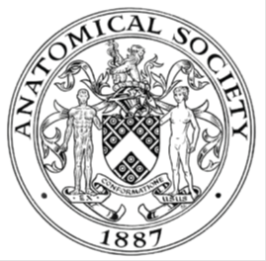
_______________________________________________________________________________________
AWARDEE REPORT FORM
_______________________________________________________________________________________

NAME |  | John Aplin
UNIVERSITY |  | Manchester
NAME OF AWARD |  | Departmental Seminar
PURPOSE OF AWARD conference attended (full name) with city and dates
To bring Dr Kathy Niakan, Francis Crick Institute, as a visiting speaker to Manchester.

REPORT: What were your anticipated benefits?
Dr Niakan is working at the forefront of research into early cell fate decisions in pre- and peri-implantation embryos. We wanted to hear about her most recent findings, and about her plans for gene editing on human pre-implantation embryos, which she has recently obtained permission to carry out for the first time.
COMMENTS: Describe your experience at the conference / lab visit / course / seminar.
She gave an outstanding lunchtime seminar to a large audience, and there was a lively question and answer session afterwards. One focus of her presentation was the intriguing differences between mouse and human embryos in terms of the control of early fate decisions by transcription factors. To a large extent the TF tool box is the same, but the timings of appearance of different factors and the cell compartments in which they operate show differences that might explain (for example) why it is more difficult to derive trophoblast stem cells from the human, and the different stages of development at which ES cells can be derived in the two species. Kathy disclosed that OCT4 will be the first gene to be targeted using CRISPR/CAS in human embryos, and suggested that the resulting phenotype may cause some surprises. In the afternoon she discussed work underway in Manchester particularly on embryonic stem cells and on implanting embryos, with Professors Sue Kimber, John Aplin, Daniel Brison, Neil Hanley and Melissa Westwood as well as Dr Peter Ruane and a postgraduate student, Stephane Berneau who was funded by the AS and has recently completed his viva successfully.

REPORT: In relation to skills, what were the most important things you gained? (does not apply to equipment grant)
N/a

REPORT: How do you think you will put this learning experience into practice in the future?
The seminar has informed us regarding future work on early embryos in our implantation model. We have agreed to exchange some antibody reagents. Collaborations on embryo research may follow.

SIGNATURE | John Aplin |  | DATE | 1/7/16
If submitted electronically, a type-written name is acceptable in place of a hand-written signature

File: AS-Award-Report-Form-BLANKCO-SEAL-date110216Final050716

