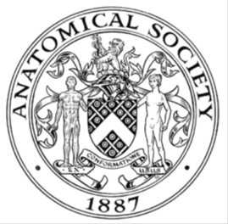
_______________________________________________________________________________________
AWARDEE REPORT FORM
_______________________________________________________________________________________

NAME |  | Mr Matyas Bubna-Litic
TWITTER HANDLE* optional |  | @YEN_community
UNIVERSITY |  | University College London, UK
NAME OF AWARD |  | Support for Student Societies 2022/23 Round 2 (deadline 19.01.23)
PURPOSE OF AWARD conference/event attended/organised (full name) with city and dates.
Young Embryologists Network Conference 2023, held in London on the 22nd May 2023

We are thankful to The Anatomical Society award which enabled us to invite Ms Agatha Ribeiro da Silva from MPI-HLR in Germany who presented a talk in person titled “Egr3 promotes endothelial cell migration during atrioventricular valve formation.”

REPORT: What were your anticipated benefits?
The Young Embryologists Network (YEN) conferences rely on our generous sponsors. Thanks to this the 15th iteration of the YEN meeting took place in May 2023 at The Francis Crick Institute in London in a hybrid event free-of-charge for all attendees from UK and abroad. Free and open participation an integral component of our ethos. Overall, more than 200 delegates from UK universities and across Europe travelled to attend the conference in person and around 100 attendees joined online.

On the day, we strived to create a relaxed environment that will bring together researchers across the field, sparking new ideas and collaborations, extending the Crick’s founding principle from “discovery without boundaries” to “exchange without boundaries”. We also aimed to promote scientific excellence and knowledge transmission. We invited high-profile speakers that should inspire our audience which represents the next generation of scientific leaders. Integral to their success is promoting the opportunities for networking and strengthening collaborative work between early-career-stage researchers (ERCs). Feedback so far highlighted the success of the conference.

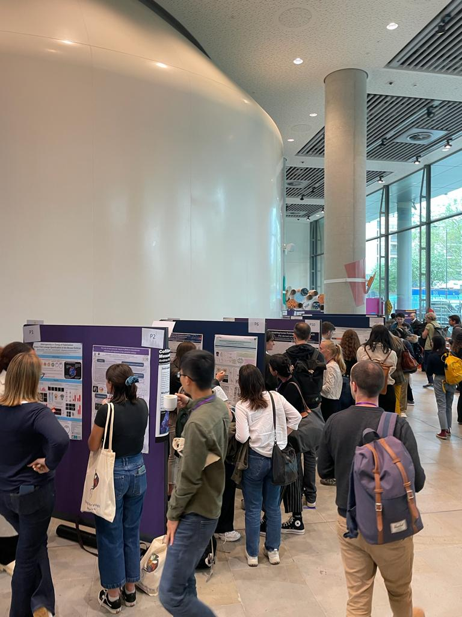
1. During our poster sessions delegates were discussing their research.

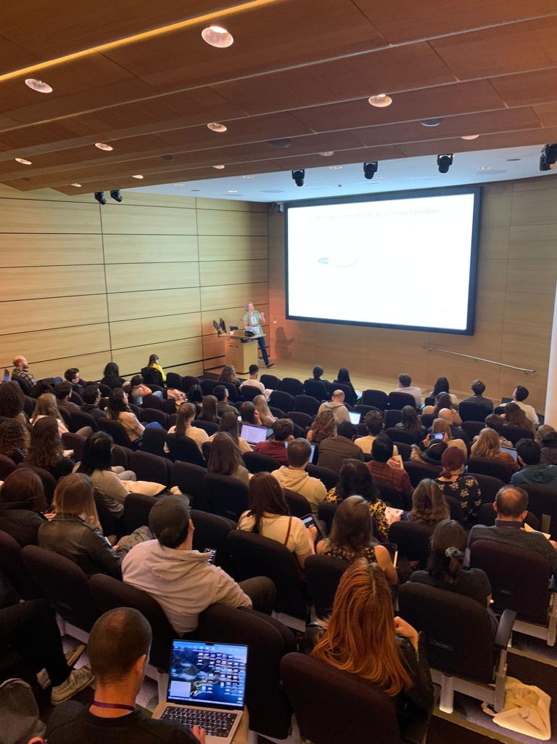
2. Dr Andrea Pauli from the Institute of Molecular Pathology in Austria sharing her exciting research in a talk about early zebrafish development.

Moreover, the scheduled perspective session on Equality, Diversity and Inclusion (EDI) in science was also a statement of YEN’s important commitment to raise awareness on key social issues that transcend science. EDI experts shed light on the current state of underrepresentation in science and offered practical strategies to foster inclusivity.

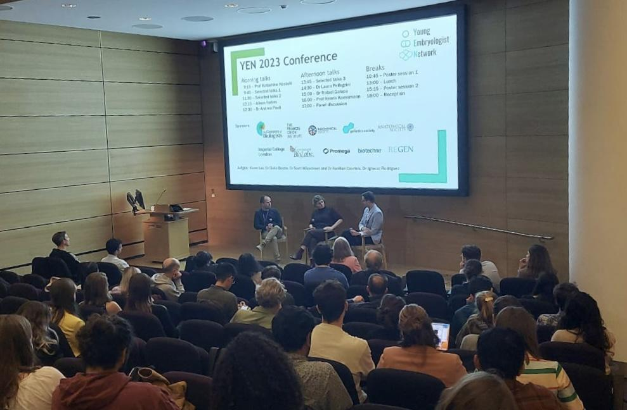
3. Scientific perspective panel discussion on Equality, Diversity, and Inclusion (EDI) in science with experts Alison Forbes (Inclusion Officer at Crick) and Dr Rafael Galupa (CBI Toulouse)

COMMENTS: Describe your experience at the conference / lab visit / course / seminar/ event.
Participating at the YEN 2023 Conference was a unique experience. The meeting created both a friendly and intellectually stimulating environment of peers to discuss our research and to nurture scientific thought. Participants presented either short talks or posters and during breaks we had the opportunity to interact, connect and network.

The line-up of keynote and invited speakers showcased outstanding science. Furthermore, the “Perspectives on Equality Diversity and Inclusion (EDI) in Science’ panel discussion drew our attention on an underdiscussed topic. Our communities and particularly science and research could be much better equipped in ensuring equal opportunities and access for people from all backgrounds.

REPORT: In relation to skills, what were the most important things you gained? (does not apply to equipment grant. For public engagement/outreach awards what did your audience gain and how did you evaluate success?
My active involvement in YEN 2023 committee offered me the opportunity to organise, plan and carry-out an international event in an academic setting. As a final year PhD student, being part of the organizing team was quite a challenge, but it was incredibly rewarding for my career, as well as a lot of fun. It offered me an excellent experience and opportunities for networking and soft skills development.

The most important soft skills I practised as a conference organizer were communication skills, negotiation skills and problem-solving skills. Particularly, I was involved in grant writing, contacting sponsors, web designing, and conference material preparation. During the day of the conference, I chaired scientific sessions and was involved in the smooth execution of the event.

During the day there were many inspiring talks from both senior academics and PhD students, this has helped me explore approaches outside my specific discipline and interact with other early career researchers.
REPORT: How do you think you will put this learning experience into practice in the future? For public engagement/outreach awards how with the materials/knowledge generated by this activity be used in the future?
Organising the YEN 2023 Conference has taught me a lot about how to plan a scientific meeting and discuss with other committee members how to best put our ideas into action. Overall, this has been a rewarding experience and I am certain that these soft skills will help me in any career path. Overcoming challenges that relate to grant writing and fulfilling the expectations of attendees have been valuable lessons that I can apply to any further grant/sponsorship applications. I aim to promote an interdisciplinary and collaborative working mindset during my career and maintain the connections and networks established during this past year of organising the event.

A further major objective of YEN 2023 was inclusivity and visibility of minority demographics in research. I believe that through this act we have drawn attention to important issues relating to diversity in science and I have learnt about how to address inclusivity in science on a practical level and ask about individuals can do to improve the system.

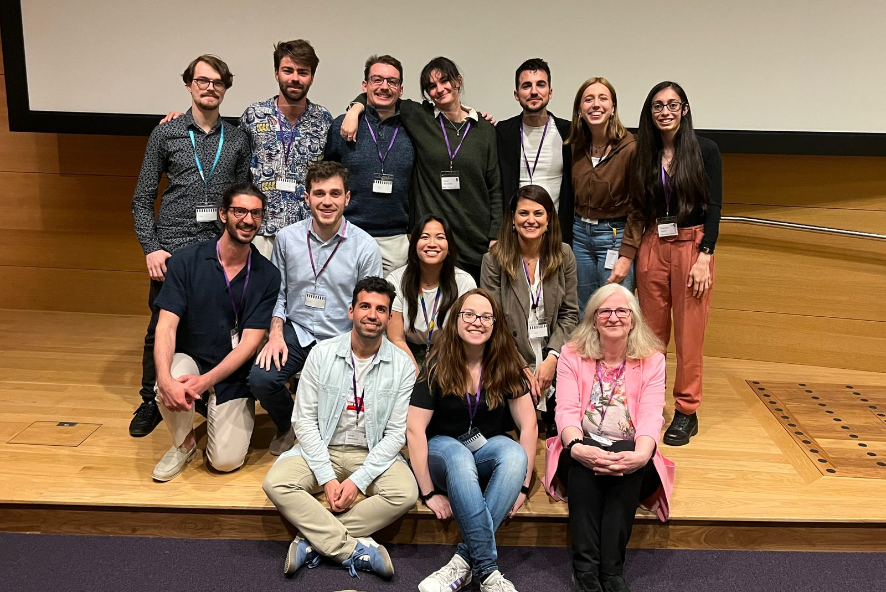
4. YEN committee 2023 and Dr Karen Lee (right bottom corner) founder of ReGen Charity in the memory of late Dr Sammy Lee. Names from top left to right, Matyas Bubna-Litic, Jeremie Subrini, Jack Morgan, Olivia Dinwoodie, Christos Kalaitzis, Irina Ballaguer Basells, Chantelle Spiteri, Luca Zanieri, Ferran Garcia Llagostera, Mint Htun, Foteini Papaleonidopoulou, Sergio Menchero, Cláudia Belém and Dr Karen Lee.

Data Protection/GDPR: I consent to the data included in this submission being collected, processed and stored by the Anatomical Society. Answer YES or NO in the Box below
YES
Graphical Images: If you include graphical images you must obtain consent from people appearing in any photos and confirm that you have consent. A consent statement from you must accompany each report if relevant. A short narrative should accompany the image. Answer N/A not applicable, YES or NO in the box below
YES
Copyright: If you submit images you must either own the copyright to the image or have gained the explicit permission of the copyright holder for the image to be submitted as part of the report for upload to the Society’s website, Newsletter, social media and so forth. A copyright statement must accompany each report if relevant. Answer N/A not applicable, YES or NO in the box below
YES
Copyright and permission: Foteini Papaleonidopoulou has taken these pictures and given permission to share
SIGNATURE | MATYAS BUBNA-LITIC |  | DATE | 10/07/2023
If submitted electronically, a type-written name is acceptable in place of a hand-written signature

File: AS-Award-Report-Form-220922 – International Conference

