

**­­­­­­­­­­­­­­­­**

**UNDERGRADUATE SUMMER VACATION SCHOLARSHIP AWARDS – FINAL SUMMARY REPORT FORM 2016/17**

*NB: This report will be posted on the Society’s website therefore authors should NOT include sensitive material or data that they do not want disclosed at this time.*

**Name of student:**

Matthew Lok Harvey

**Name of supervisor(s):**

Isabelle Miletich

**Project Title: (no more than 220 characters)**

Determining the Morphogenesis of the Submandibular and Sublingual Salivary Gland Main Excretory Ducts

**Project aims: (no more than 700 words)**

**Background of the project**

Saliva has a key role in the maintenance of healthy teeth and oral tissues and is instrumental for everyday physiological functions including eating, speaking and tasting food. 90% of the saliva is produced by three pairs of major salivary glands (SGs), the parotids, submandibular and sublingual glands that are located at a distance from the oral cavity and empty their secretions in the oral cavity through long ducts.

Although a wealth of information is available on how the SG secretory tissue develops, the formation of the main excretory duct (MED) is poorly understood. Saliva produced by acinar cells flows through a network of ducts of increasing diameters, eventually emptying into one main excretory duct, which opens into the oral cavity. When describing salivary gland embryonic development, Hamilton *et al.* (1945) are often cited regarding how the MED forms in embryonic stages. They report that the MED of the submandibular gland forms between the gland primordia, located proximal to the first molar tooth bud, and the sublingual papilla at the base of the tongue frenulum, through anteriorly advancing closure of gutter-like grooves in the buccal epithelium.

Matthew Harvey (the student to benefit from this summer vacation scholarship) produced 3D-reconstructions of the MED of the mouse submandibular and sublingual salivary glands at different time points of embryonic development during the lab project of the intercalated BSc he undertook in 2015-16. He showed the MEDs of these two glands form between embryonic days 12.5 and 17.5 on the buccal side of the medial paralingual groove by epithelial wrapping, and further confirmed this process takes place in a rostral direction, proximal to distal.

**Objectives**

The aim of the 4-week summer vacation research project was to further understand the formation of the MED of the submandibular salivary gland, as such we designed experiments to investigate the following questions:

1. Are cell shape, polarity, proliferation and death involved in MED development?

2. Is a lumen readily formed during the wrapping process or instead is a solid chord of epithelium initially formed, with cavitation at a later time point creating the duct lumen?

3. At what stage is MED formation completed?

In addition, it was intended that previous work, such as the 3D reconstruction of developing salivary glands and MEDs, be repeated to produce figures of higher quality.

**Experimental methods and design**

Cell proliferation was investigated by immunostaining for BrdU (in embryos to which BrdU had been administered 20 minutes prior to collection), as well as for Phospho-Histone H3 and Ki67. The ratio of proliferating / non-proliferating cells being compared in the forming duct epithelium and the adjacent epithelium of the paralingual groove.

Immunostaining for Atypical PKC ζ (apical marker), E-cadherin, Beta Catenin and ZO1 tight junction marker) was used to establish cell shapes and polarities during duct formation, as well as allowing for determination of the presence of a micro lumen immediately after wrapping.

Activated caspase 3 was used as a marker for apoptotic cell death, in immunostaining along the length of developing MEDs, to determine if cell death had a role in either lumen formation or MED wrapping.

These procedures were carried out on 8µm frontal sections of mouse heads collected at embryonic day (E) 13.5, E14.5, E15.5 and E16.5. Immunostainings were also attempted on whole mount salivary glands dissected from E14.5, E15.5 and E16.5 embryos.

Micro CT scanning of samples held in iodine solution or phosphotungstic acid was employed to produce increased fidelity 3d models of the MEDs, and determine lumen presence or size at various stages of development – E13.5, E14.5, E15.5 and E16.5.

**References**

HAMILTON W. J., BOYD J. D. AND MOSSMAN, H. W., 1945. *Human Embryology: (prenatal Development of Form and Function).* 2 edn. Cambridge: W. Heffer & Sons Ltd.

**Project Outcomes and Experience Gained by the Student (no more than 700 words)**

**Project outcome:**

We first determined the timing of development of the main excretory duct (MED) in the submandibular (SMG) and sublingual (SLG) salivary glands. Before the start of this summer project it had been identified the MEDs started to form between E (embryonic day) 12 and E13 in the mouse. Using haematoxylin and eosin staining on frontal sections of E15 and E16 heads, it was determined that MED formation is incomplete at E15 and complete by E16, with ducts converging at the sublingual caruncle at this latter time point.

We used immunostaining for E-cadherin or beta-catenin to visualise epithelial cell membranes during MED formation. Analysis of the data showed that both MEDs form from thickened areas of epithelium lateral to the medial paralingual grooves, but medial to the lateral paralingual grooves. Strikingly, the MED of the SMG (Fig 1 A-C) forms in a different way to that of the SLG (Fig. 1D,E), with the initial fold of epithelium giving rise to it being much larger and wider laterally than medially. Epithelial cell shape analysis revealed that the cells bounding the regions that fold into the MEDs constrict basally, while bounded cells constrict apically, during epithelial wrapping.

We used BrDU staining to label proliferating cells to investigate the role of cell proliferation in MED formation. While rare proliferating cells were identified in the developing SMG MED (Fig. 1A-C), numerous BrDU+ cells were observed in the developing SLG MED. These data strongly suggest that cell proliferation is is not a driving factor in the formation of the SMG MED, throughout all stages of SMG MED formation, from the initial epithelial thickening to the duct detaching from the medial para-lingual groove, while cell proliferation is abundant during the formation of the SLG MED and might be essential for the formation of this duct. However, cell proliferation was up-regulated in the SMG MED after completion of the duct, reaching similar levels of epithelial cell proliferation as those seen in the SLG MED (Fig. 1F).

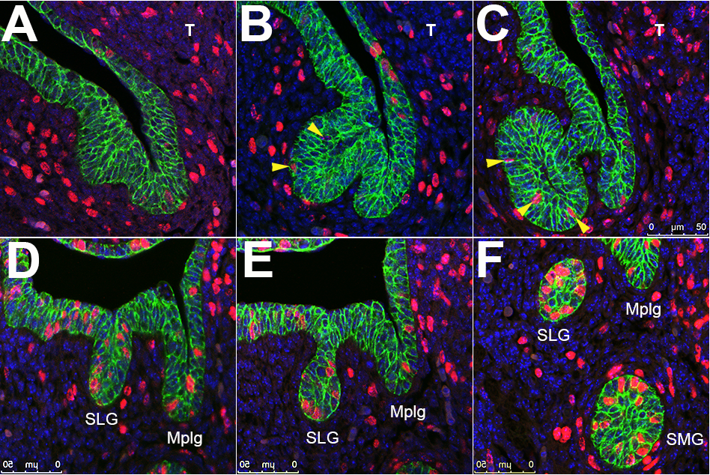

Figure 1. Formation of the submandibular and sublingual main excretory ducts. Immunohistofluorescence for E-cadherin (green) and BrDU (red) on frontal sections of E (embryonic day) 13 wild-type embryos injected with BrDU and sacrified 20 min. after BrDU injection. Labial is left and lingual (medial) right in all pictures. (A-C) Formation of the MED of the SMG starting with an epithelial thickening (A), budding (B) and thinning of the neck of the epithelial bud (C). Rare proliferating cells are observed in the developing SMG MED (yellow arrowheads). (D,E) Formation of the MED of the SLG including the formation of a solid chord of epithelium that displayed a greater width than length (D), followed by a thinning of the dorsal epithelium (E) eventually breaking off from the epithelium of the medial paralingual groove. Numerous proliferating cells can be observed in the forming SLG MED. (F) Interestingly, cell proliferation is restored in the SMG MED shortly after it has broken off from the epithelium of the medial paralingual groove. The scale bar represents 50 microns in all pictures. Mplg: Medial paralingual groove; SLG: Sublingual gland; SMG: Submandibular gland; T: Tongue.

We also investigated at what time point a central lumen formed in developing SMG and SLG MEDs. On H&E stained frontal sections of E13 wildtype heads, lumina were briefly observed after MED formation and were significantly absent in more proximal sections. This prompted us to investigate cell polarisation in the newly formed ducts as cell polarisation is necessary for lumen formation. We tested different antibodies to label distal cytoplasmic membranes, including an antibody directed against atypical PKC (from SantaCruz) and two antibodies directed against ZO-1 (respectively from Abcam and Santa Cruz). Only the ZO-1 antibody from Santa Cruz worked on wax sections and the preliminary data are presented in Figure 1 of the brief resume of this final report. We will use this antibody in the future to characterize epithelial cell polarity during MED formation, which will help us identify when the central lumen of the MED forms.

Finally, micro-CT scanning has been identified as a quick and efficient way to produce high quality 3D reconstructions of developing salivary glands (Fig. 2). MicroCT scans of developing salivary glands have been acquired at different time points of salivary gland development. The data will be processed to produce 3D reconstructions of the developing salivary glands. The student has gained the skills to do this analysis and is keen to pursue this project during his spare time.

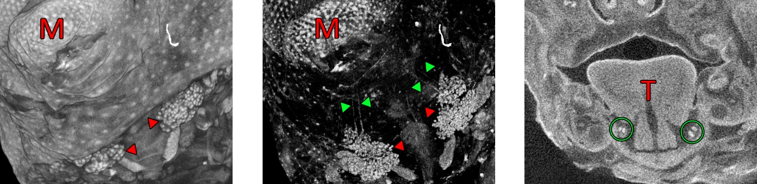Figure 2. Images produced by micro-CT showing an E15 wild type embryo head stained in phosphotungstic acid for 5 days. Left shows superficial structures including the SMG and SLG (red arrowheads) in 3D; centre shows more radiopaque structures, including the SMG and SLG (red arrowheads) and their respective MEDs (green arrowheads) in 3D; right shows a 2D slice with MEDs (circled) well defined and more radiopaque than adjacent structures, which will allow for future refinement of 3D reconstructions. M labels mental protuberance, T labels the tongue.

The data obtained during the course of this research project are currently being drafted into a research paper that will be submitted to a peer-reviewed journal, which will enhance the career prospects of the Student.

**Experience gained by the student:**

The laboratory techniques learnt by the student include dissection of embryos, generating tissue sections from paraffin-embedded samples and frozen samples with a microtome or cryostat, mounting sections onto glass slides, performing double fluorescent immunostainings, imaging with a confocal microscope, preparation of materials for micro-CT scanning and interpretation and analysis of micro-CT data.

The transferable skills taught comprise using the Adobe Photoshop program to make montages with the pictures obtained, using PowerPoint to make slides to present the data obtained, getting training into how to give an efficient oral presentation and write a research article.

The Undergraduate Research Fellow also participated in other lab research activities, collaborating on other lab projects in related fields of research. The Undergraduate Research Fellow also interacted with a number of PhD students within the Department of Craniofacial Development and Stem Cell Biology, which deepened his understanding of what is a PhD and more specifically what is expected from a PhD student.

Please state which Society Winter or Summer Meeting the student is intending to present his/her poster at:

Winter 2017 Dundee

**Proposed Poster Submission Details (within 12 months of the completion of the project) for an AS Winter/ Summer Meeting – (no more than 300 words)**

Investigating the formation of the main excretory ducts of the submandibular and sublingual salivary glands in the mouse

**Brief Resume of your Project’s outcomes**: **(no more than 200-250 words)**.

*The title of your project and a brief 200-250 word description of the proposed/completed project. The description should include sufficient detail to be of general interest to a broad readership including scientists and non-specialists. Please also try to include 1-2 graphical images (minimum 75dpi). NB: Authors should NOT include sensitive material or data that they do not want disclosed at this time.*

Located at a distance from the mouth, the submandibular gland is a large salivary gland that empties its secretions in the mouth through a long duct. In the embryo, the main body of this gland, which gives rise to all saliva-secreting cells, develops first at the back of the mouth. Subsequently, the main excretory duct (MED) forms anteriorly and opens in the oral cavity at the base of the tongue. While a wealth of information is available on how the secretory tissue of this gland develops, the formation of the main excretory duct is poorly understood.

The project has investigated the embryonic origin and cellular mechanisms involved in the formation of the MED of the submandibular and sublingual salivary glands in the mouse. Although these two ducts form from a similar anatomical region, we have found the mechanisms involved are strikingly different for these two salivary glands. This initial work will constitute the basis of a molecular analysis to identify the genes involved in these processes.

This research constitutes an important step on the way to engineering salivary gland tissue to help patients with irreversible salivary gland dysfunction, who include patients who have undergone radiation therapy for head and neck cancer as well as patients affected with Sjögren's syndrome, an autoimmune disease that targets the salivary glands. Crucially, we expect this research not only to benefit the salivary gland field, but also other areas of research interested in the formation of biological tubes to regenerate diseased or injured tubular organs.

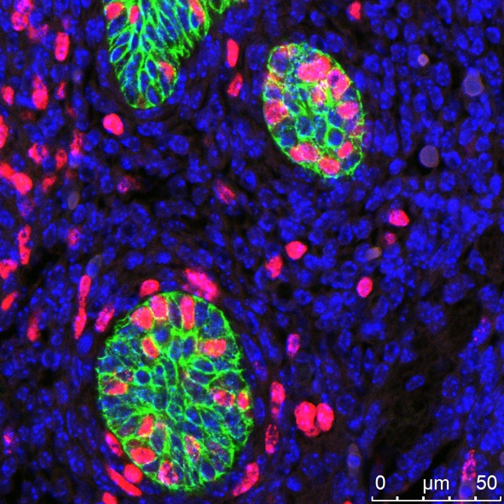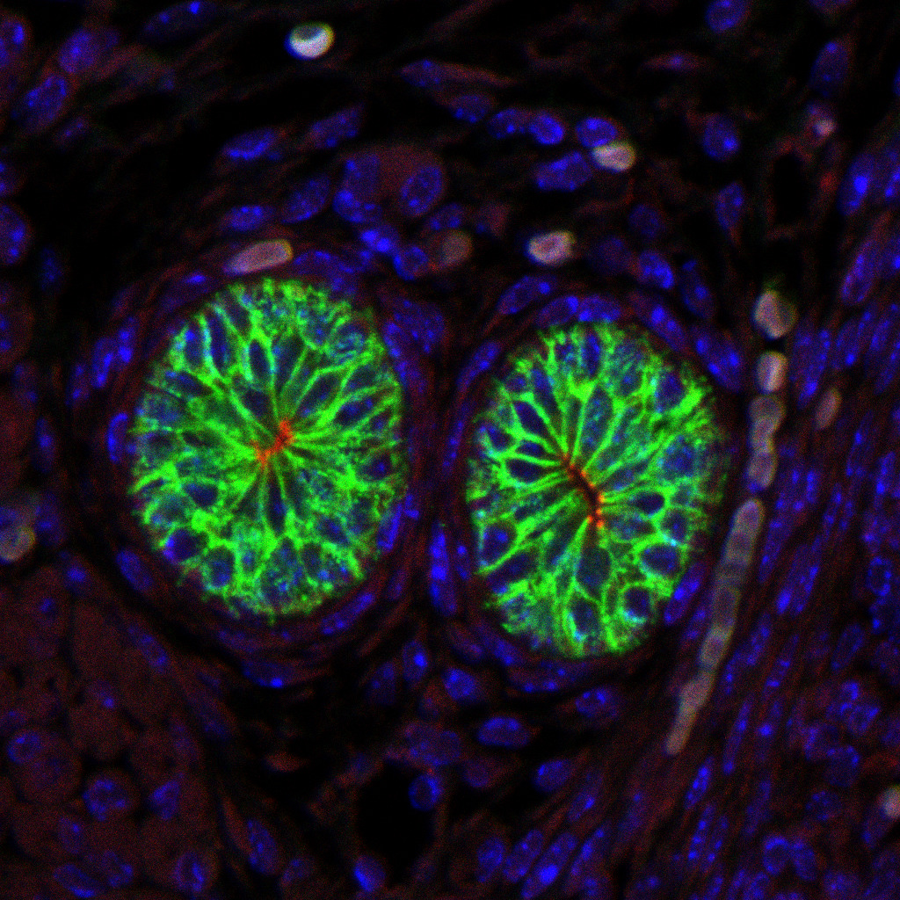Figure 1: Left image – Proliferating cells (red, BrDU staining) in the submandibular (left) and sublingual (right) gland main excretory ducts at embryonic day 13. Right image – Showing lumen formation (red, ZO1 staining) in the submandibular (right) and sublingual (left) gland main excretory ducts at embryonic day 16. Epithelial cell shapes are stained in green for beta-catenin (left image) and E-cadherin (right image).

**Other comments: (no more than 300 words)**

*Signature of student.......................Date…12/10/17*

*Signature of supervisor Date……12/10/17*

END OF FORM

----------------------------------------------------------------------------------------------------------------------------------------

*File: USVRS-AwardandBursaryTemplateLetter 2017-v3FINAL 120517- Dr Isabelle Miletich*