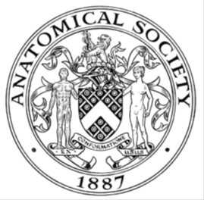
_______________________________________________________________________________________
AWARDEE REPORT FORM
_______________________________________________________________________________________

NAME |  | CLAIRE FITTON
UNIVERSITY |  | UNIVERSITY OF DUNDEE
NAME OF AWARD |  | BARCLAY-SMITH TRAVEL AWARD
PURPOSE OF AWARD conference attended (full name) with city and dates
To attend the AnatSoc Summer Meeting 2018 in Oxford 23-25.07.18 to present my oral presentation on “measuring compliance in Thiel-embalmed human cadaveric arteries: a novel model for endovascular device development”.

REPORT: What were your anticipated benefits?
I wished to gain practice and confidence in oral presentations to an academic audience, and in particular, to an audience with anatomical knowledge given the topic of my presentation. I also wished to liaise and network with this community.
COMMENTS: Describe your experience at the conference / lab visit / course / seminar.
This conference was held in the beautiful setting of St John’s College at Oxford University (photo) and was a pleasure to attend. I was able to network with both professionals and students and it was great to catch up on the progression everyone is making with their work and research. The first session on the use of radiography in medical education was a great introduction, and I had previously not been aware of the lack of it in many medicine courses. It was clear from the response of the audience inclusion of radiology early in the programmes is an aim of many educationalists. On the final day I presented my current research in an oral presentation. It felt very rewarding speaking in front of this audience and it was excellent practice to perfect my presentation skills. I also felt very comfortable answering the questions the audience gave – something I was not expecting!

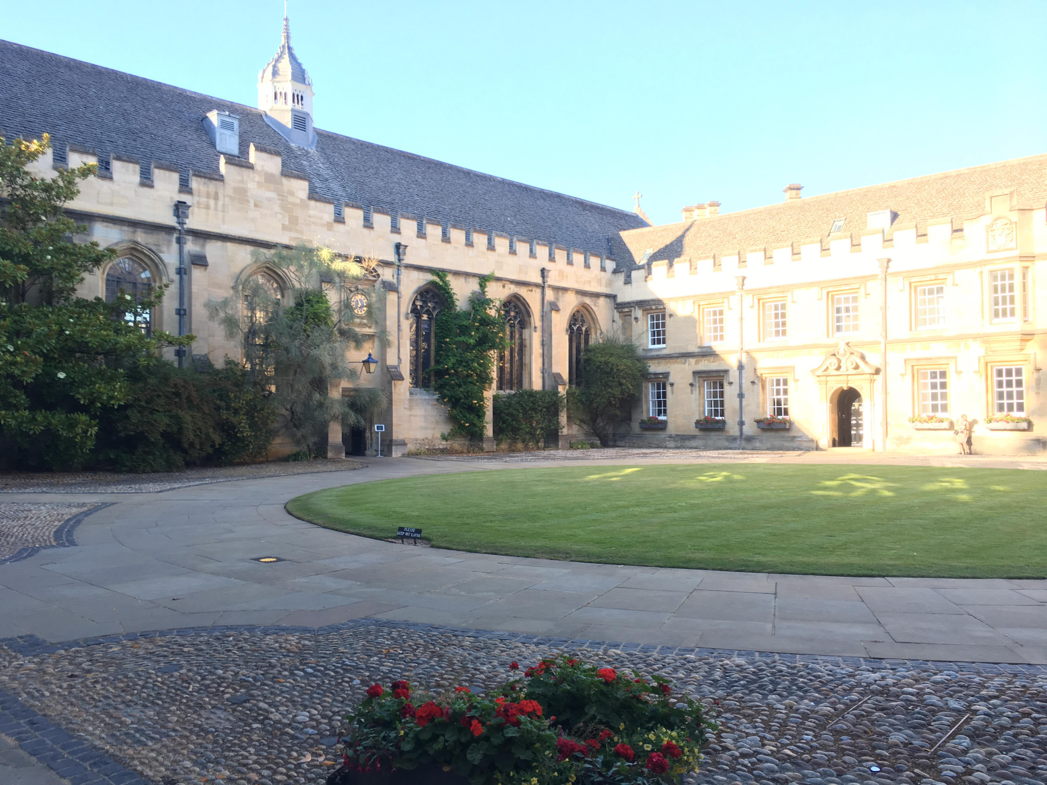

REPORT: In relation to skills, what were the most important things you gained? (does not apply to equipment grant)
I feel the most important thing I have gained from this conference is confidence in presentation skills. Listening to others and their styles, and reflecting on my own presentation I now understand how I can improve for future talks, and I know where I excel. Speaking to an academic audience with anatomical knowledge, the questions I replied to were aimed more at the methodology This contrasted with the emphasis on the concept of body donation which in my experience gives rise to proportionally more questions from those with less professional anatomical knowledge.

REPORT: How do you think you will put this learning experience into practice in the future?
Learning from this will undoubtedly help me with future presentations to academic audiences. It also allows me to understand where confusion or questions may arise in my research so I can address this, and gives me the confidence to apply to further conferences for oral presentation opportunities.
SIGNATURE | Claire Fitton |  | DATE | 27.07.18
If submitted electronically, a type-written name is acceptable in place of a hand-written signature

File: AS-Award-Report-Form-BLANKCO-SEAL-date110216

