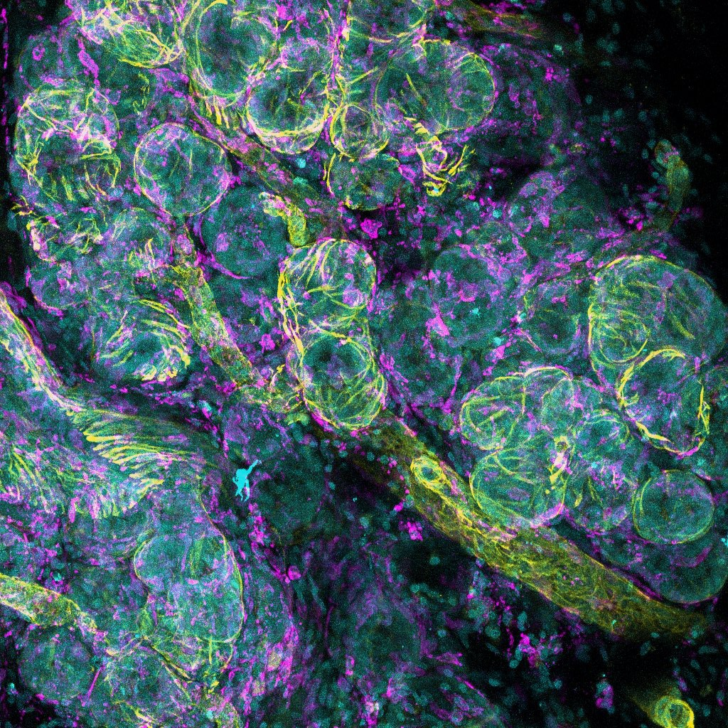

File: 3-D Mammary Macrophages – website upload 190723

