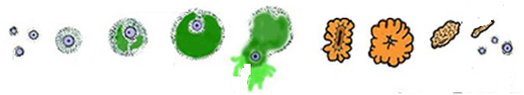
Follicle Stickers (Menstrual cycle)

