Building a model of the Eye Muscles

In this Resource we will provide the tools to build your very own working eye muscles model. This will help your understanding of how the eye moves at how each muscle can interact to represent full eye movement.

Lets Get Started........
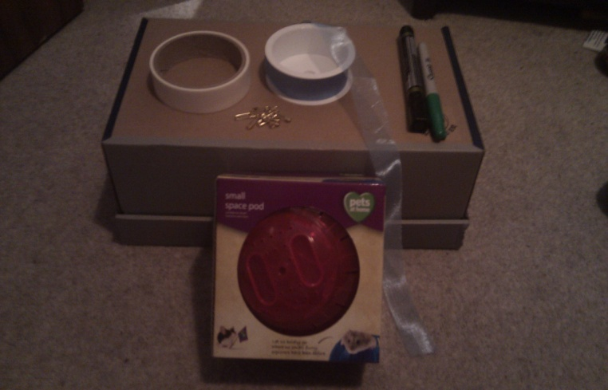

Equipment needed

- Hamster ball or plastic football
- Cardboard box
- Ribbon
- Sellotape
- White tape
- Coloured Pens
- Safety Pins
- 4 yoghurt cups (washed)

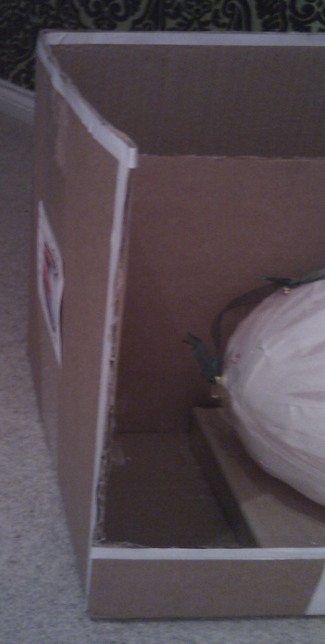

The following guide is to be used as a teaching aid for anatomy teaching for ages 12-16. The level of detail and knowledge required can be adjusted accordingly.

Firstly, cut out two sides of the box, preferably the top and the front panel. On the front panel, leave around a 1/6 of the panel remaining at the bottom.

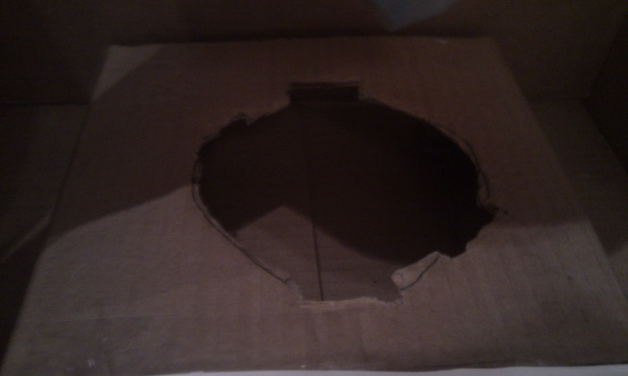
Using one of the cut panels, cut a circle ¾ the diameter of the hamster ball into the card. This will form the holder for the eyeball.

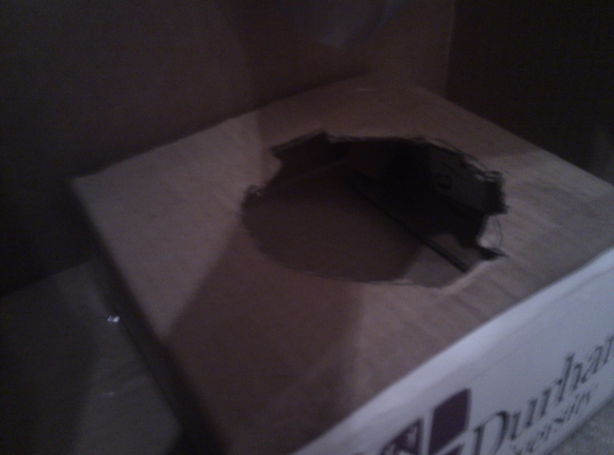

Place the four yoghurt cups in the bottom of the box, so that it supports the card mentioned above. Selltape these into place.

Place the card on top of the yoghurt pots so that each pot is in the corner of the card. Sellotape into place.

Cut 5 holes into the back panel for the muscles and one into the lateral aspect for another.

The Box is now complete

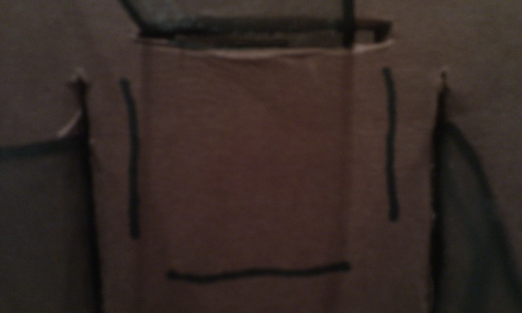

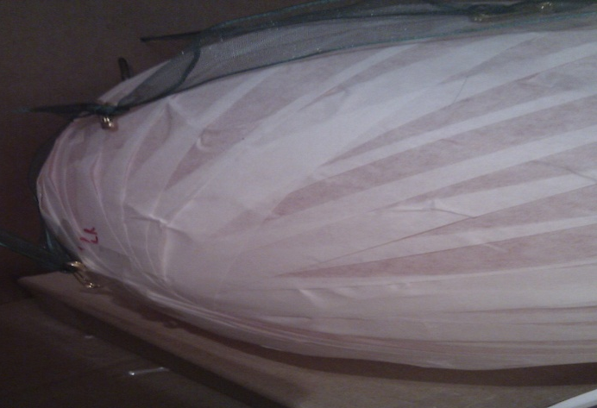
For the eye, wrap the ball in white tape, ensuring it is covered entirely, forming the eyeball.

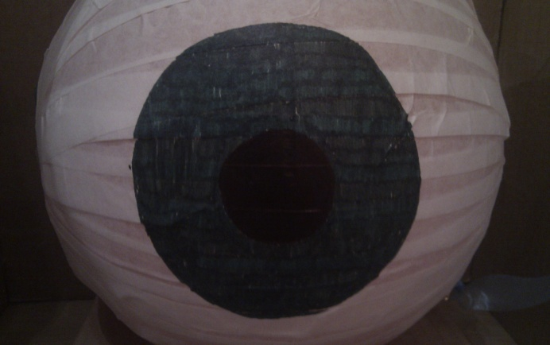

Draw the iris and the lens on the ball.

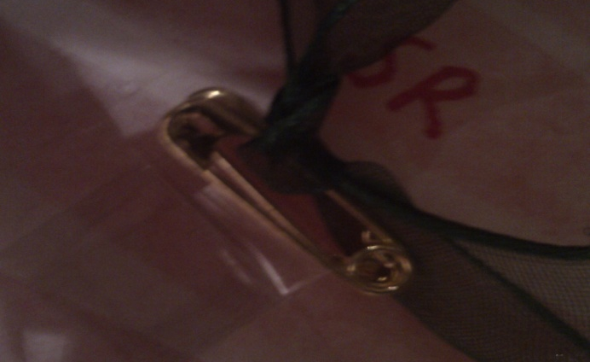

Using closed saftey pins, sellotape two pins together.

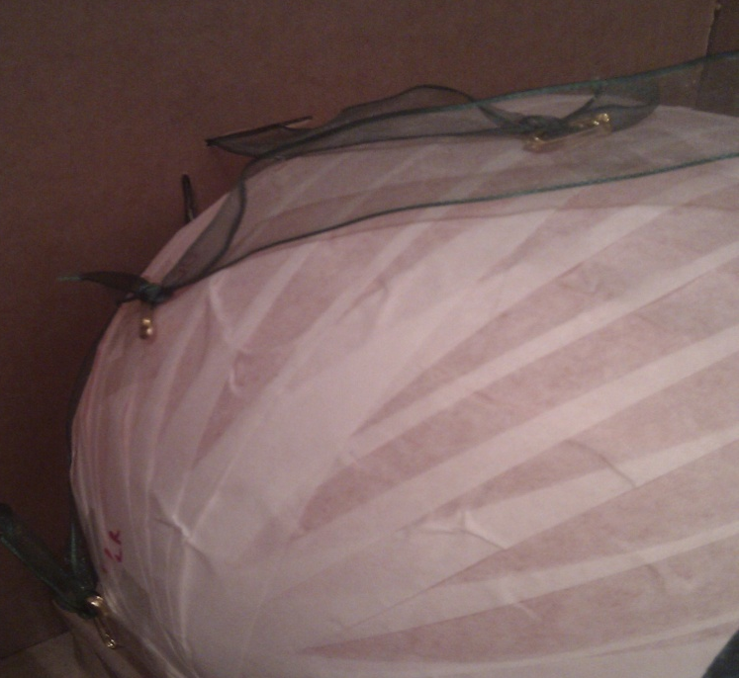

With the iris facing forward, sellotape these pins to the top and bottom of the eye, as well as either side. These will give you the attachments for the eye muscles.

For more advanced eye movement muscle levels, attach pins between the superior rectus and the lateral rectus (superior oblique), and attach pins between the inferior rectus and the medial rectus (inferior oblique).

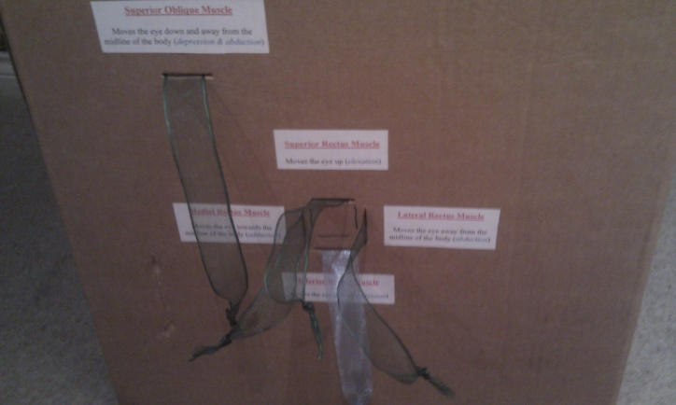

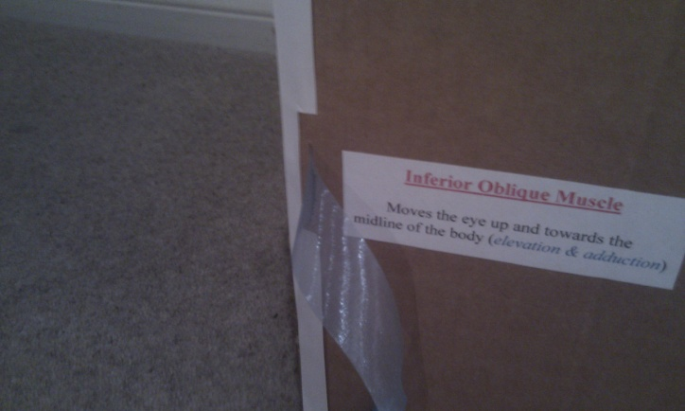
Attach the ribbons the pins and place through the corresponding holes in the back of the box and to the side.

On completion, label your ribbons and the eye movements should be complete.
