YEAR 2014/15: PROFESSOR ROGER KEYNES
STUDENT: MS ELLIE WALDER
INSTITUTION: CAMBRIDGE UNIVERSITY
PROJECT TITLE: AN EXPERIMENTAL TEST IN VIVO OF THE MOLECULAR BASIS OF SPINAL NERVE SEGMENTATION

Brief Resume of your Project’s outcomes for the Society’s Website: (no more than 200-250 words).
The title of your project and a brief 200-250 word description of the proposed/completed project. The description should include sufficient detail to be of general interest to a broad readership including scientists and non-specialists. Please also try to include 1-2 graphical images (minimum 75dpi). NB: Authors should NOT include sensitive material or data that they do not want disclosed at this time.

Title: An experimental test in vivo of the molecular basis of spinal nerve segmentation

Our laboratory has identified a protein that plays a key role in generating the anatomical repeat pattern of spinal nerves during development. This molecule is expressed selectively by cells in one half of each of the embryonic 'somites' that form the vertebrae of birds and mammals. Several lines of evidence indicate that it repels the growing tips of spinal (motor and sensory) nerve fibres growing away from the spinal cord, forcing them to traverse the other half of each somite, so ensuring that they reach their targets in the body without obstruction by the vertebral column.

Spinal nerve fibres in a 3-day chick embryo 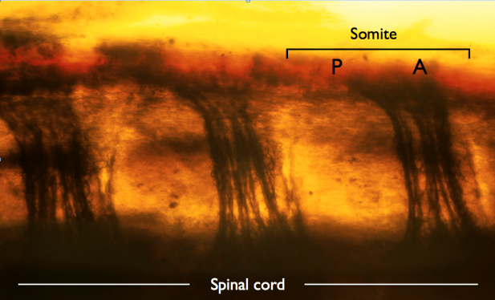

The aim of Ellie Walder's project was to carry out a functional test of this protein in vivo during spinal nerve development in the chick embryo. She injected a chemical (siRNA), designed to reduce expression of the gene encoding the protein, into the somites via a glass micropipette. Two days later she processed and stained the somites to visualize the pattern of spinal nerve outgrowth into them. She worked out a new way to record the complex outgrowth patterns, and her preliminary results after 6 weeks were consistent with the nerve-repulsion hypothesis.

File: UGProjectOutcomes201415KeynesWalder

