YEAR 2014/15

SUPERVISOR: DR DARA CANNON

STUDENT: MS GRÁINNE NIELSEN

INSTITUTION: NUI, GALWAY

PROJECT TITLE: INVESTIGATION OF WHITE MATTER TRACTS IN FAMILIAL BIPOLAR DISORDER

Brief Resume of your Project's outcomes for the Society's Website: (no more than 200-250 words).
The title of your project and a brief 200-250 word description of the proposed/completed project. The description should include sufficient detail to be of general interest to a broad readership including scientists and non-specialists. Please also try to include 1-2 graphical images (minimum 75dpi). NB: Authors should NOT include sensitive material or data that they do not want disclosed at this time.
We found that subjects with bipolar disorder who have a family member also with bipolar disorder had a marked decrease in white matter organization (fractional anisotropy, FA) in the cingulum compared to subjects with bipolar disorder who do not have a family member with the disorder (non-familial BD). This is an area of the brain that is involved in emotional regulation. More of the brain showed these reductions when compared to a psychiatrically healthy comparison group, with regions including the corpus callosum, right anterior thalamic radiation, right superior longitudinal fasciculus, right corticospinal tract, and left uncinate fasciculus. In contrast, non-familial BD did not differ relative to the healthy group.
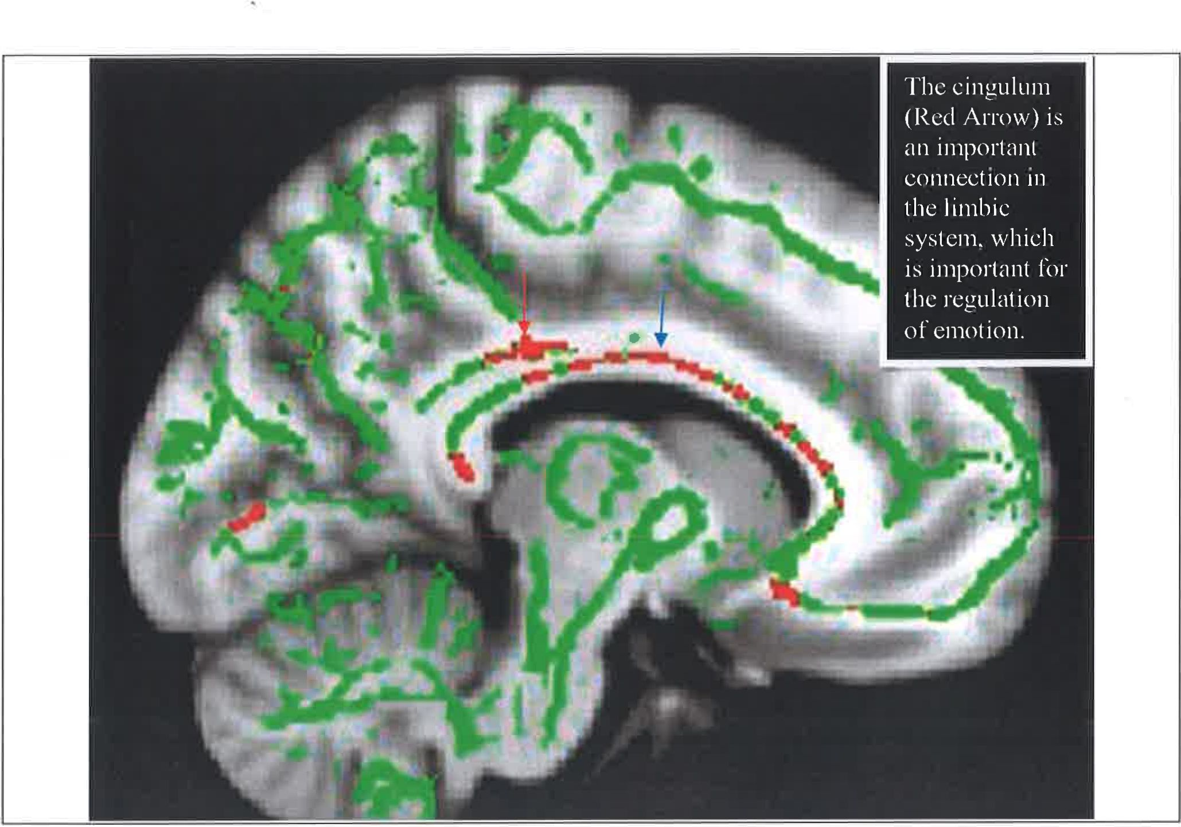
Figure 1: This image shows a sagittal section of the brain. The FA skeleton is in green, and the areas of reduced FA are shown in red. The cingulum is marked by the red arrow, and the corpus callosum is marked by the blue
arrow.

These data suggest that white matter alterations are more pronounced in the disorder when a family history is present. The extent of the deficits observed does not appear to be related to the age that the illness began at, or the medication that an individual was administered. Finally we were unable to detect a relationship between the extent of the deficit and the number of affected relatives, though we believe this to be due to the low statistical power of our relatively small sample.
We concluded that bipolar disorder in those with a family member with the disorder is marked by differences in the cingulum. The importance of this finding is that the cingulum provides crucial connections between elements of the limbic system that are involved in emotional regulation.

File: UGProjectOutcomes201415CannonNielsenFINAL

