YEAR 2014/15
SUPERVISOR: DR FLORA GROENING
STUDENT: MS KENNA ROBERTSON
INSTITUTION: ABERDEEN UNIVERSITY
PROJECT TITLE: THREE-DIMENSIONAL ARRANGEMENT OF COLLAGEN FIBRES IN THE HUMAN ZYGOMATICOTEMPORAL SUTURE

Brief Resume of your Project's outcomes for the Society's Website: (no more than 200-250 words).
The title of your project and a brief 200-250 word description of the proposed/completed project. The description should include sufficient detail to be of general interest to a broad readership including scientists and non-specialists. Please also try to include 1-2 graphical images (minimum 75dpi). NB: Authors should NOT include sensitive material or data that they do not want disclosed at this time.
The human skull is made up of thin and irregular bones which are held together by sutures. Sutures are fibrous joints that are composed of densely packed collagen fibres. They have an important role in facilitating the deformation of the skull during birth, accommodating the development of the expanding brain during infancy and allowing flexibility of the skull under load. The collagen fibres within sutures prevent dislocation of the bones when subjected to high forces such as those that occur during biting and chewing. Their mechanical function of sutures is directly related to the arrangement of these collagen fibres.
This project used confocal microscopy to visualise and analyse the 3D arrangement of collagen fibres within the human zygomaticotemporal suture. In the individual we studied, we found a consistent pattern of long parallel fibres that are arranged obliquely, almost parallel to the bone surface, rather than short fibres that run straight across the suture. The consistency was surprising as our previous work showed large variations in the bone morphology between different parts of the suture. To our knowledge, this study is the first that has visualised the 3D arrangement of collagen fibre orientation in the human zygomaticotemporal suture. These data are a first step towards a better understanding of the forces that act on this suture in vivo.

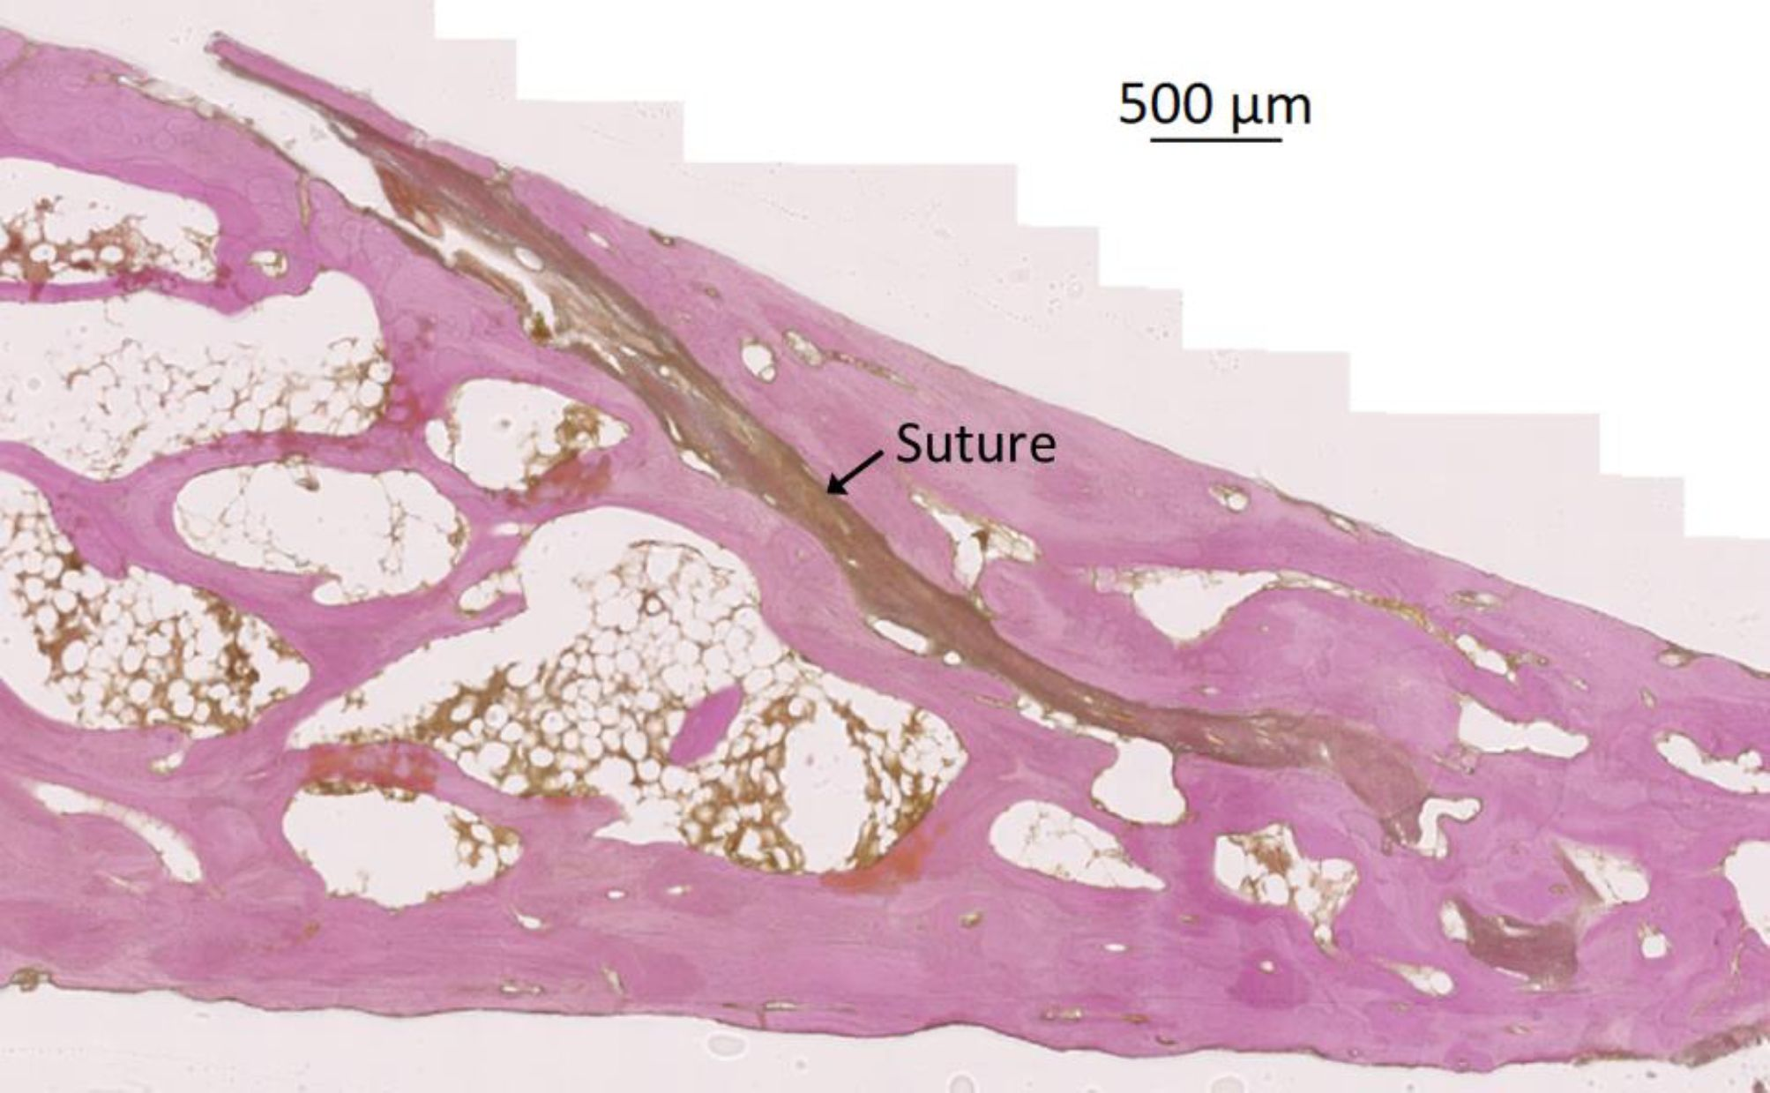
Fig. 1. Transverse section of the zygomatic arch showing the zygomaticotemporal suture. Bone is stained purple.

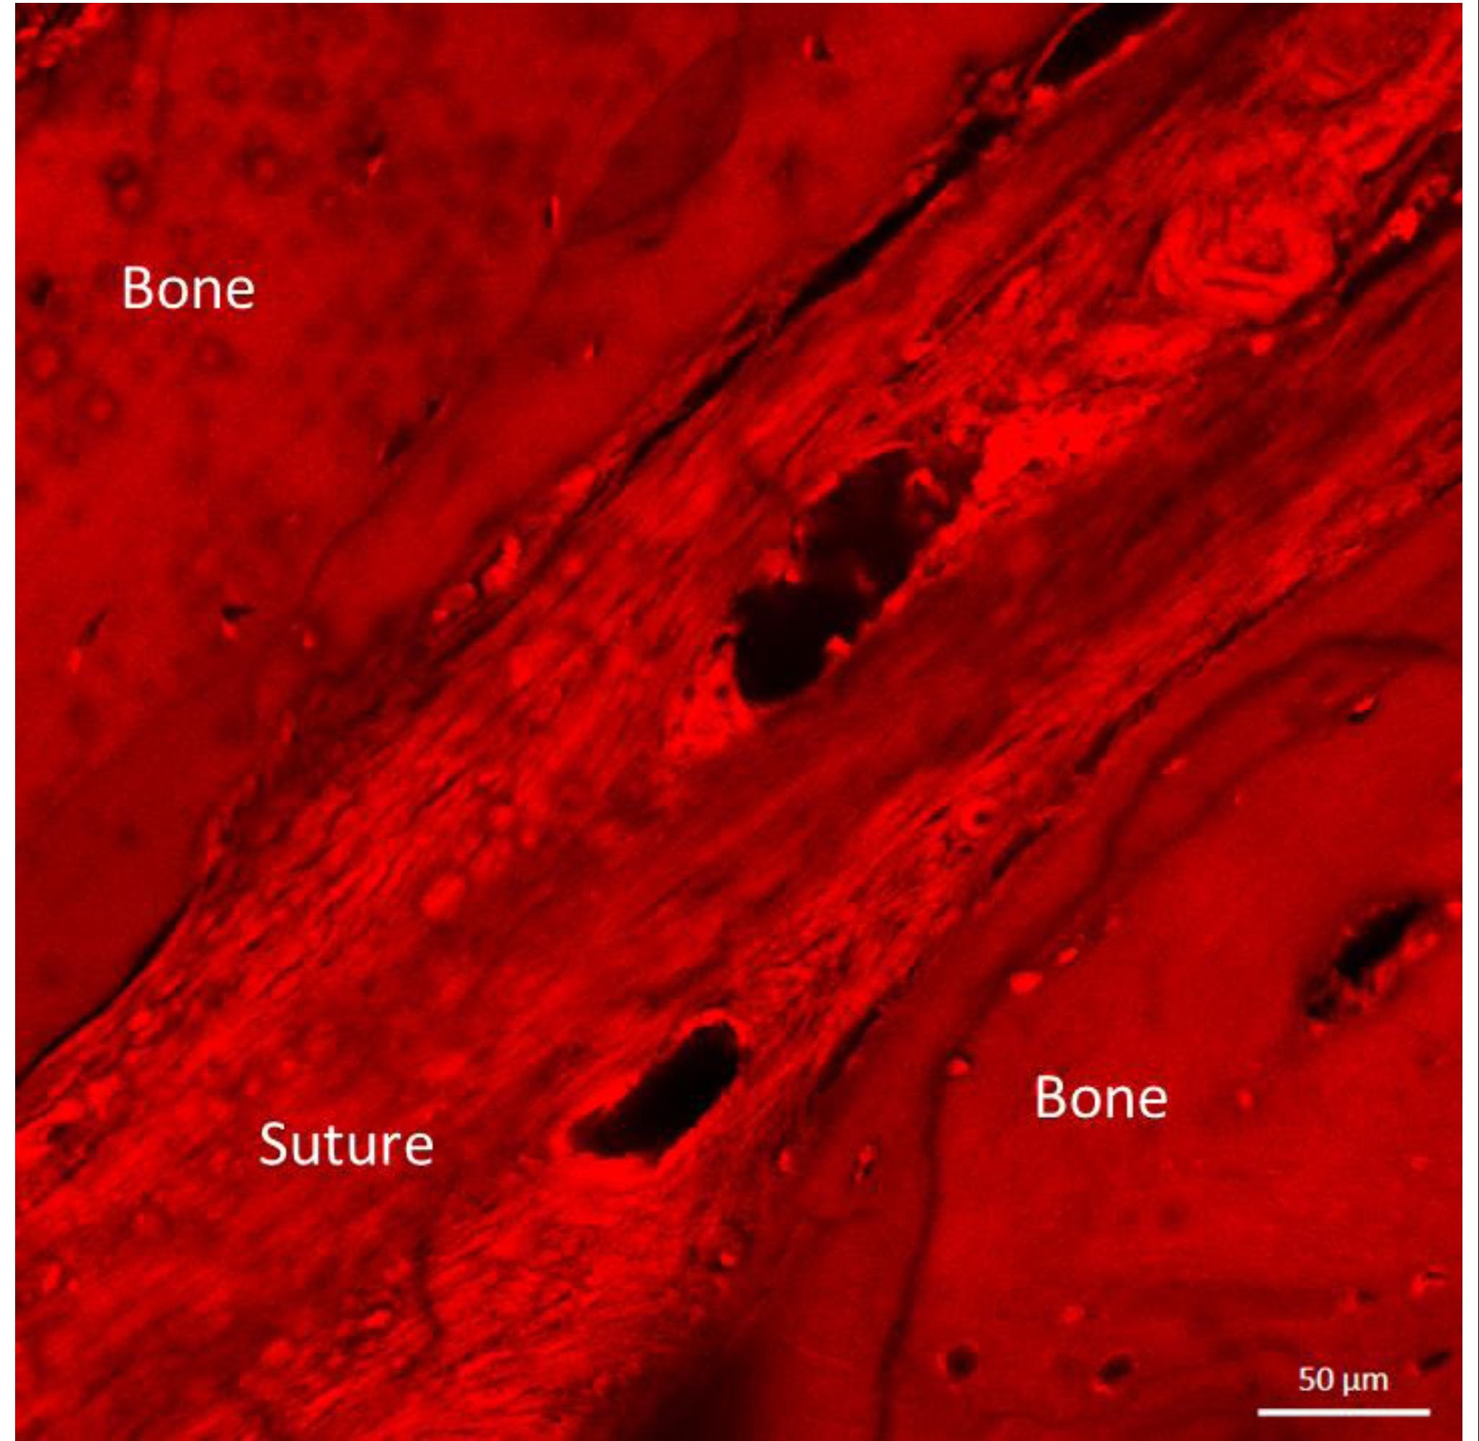
Fig. 2. Confocal microscopy image showing the collagen fibre orientation within the human zygomaticotemporal suture.

Fig. 3. Confocal microscopy imagehowing a site where suture fibttach to the bone.

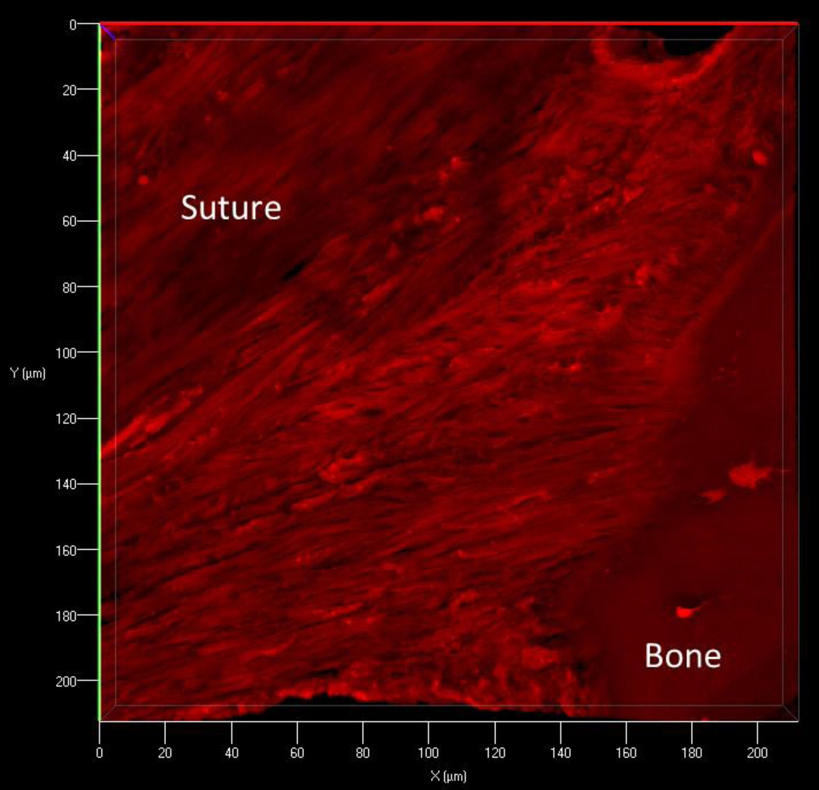

Fig. 3. Confocal microscopy image showing a site where suture fibres attach to the bone.

File: UGProjectOUtcomesGroening201415FINAL

