YEAR: 2013/14
SUPERVISOR: PROFESSOR ANDREW PITSILLIDES
STUDENT: MS BETHANY CHARLTON
PROJECT TITLE: DOES EMBRYO MOTILITY INFLUENCE LONGITUDINAL GROWTH OF SKELETAL ELEMENTS TO ALTER LIMB FORM IN DEVELOPING CROCODILIANS?

Brief Resume of your Project’s outcomes for the Society’s Website: (no more than 200-250 words).
The title of your project and a brief 200-250 word description of the proposed/completed project. The description should include sufficient detail to be of general interest to a broad readership including scientists and non-specialists. Please also try to include 1-2 graphical images (minimum 75dpi). NB: Authors should NOT include sensitive material or data that they do not want disclosed at this time.

Does embryo motility influence longitudinal growth of skeletal elements to alter limb form
in developing crocodilians?

The project aimed to answer this question in West African Dwarf crocodiles. The effect was examined by manipulating the mechanical input acting on limbs by altering embryo motility with incubation temperature. Previous studies in developing chicks have examined the effect of immobilisation on limb form at a range of developmental time points: and results have shown that incubation temperature and pharmacological manipulation of embryonic movement can exert profound influences on longitudinal limb growth as a function of body size in developing avians.

Crocodiles are an oviparous species which are not incubated by a parent - and may therefore experience intra-species variation in incubation conditions, level of embryonic motility and subsequent limb growth. They may therefore provide details into the epigenetic effect mechanical input may have on embryonic physiology in tetrapods.

16 West African Dwarf crocodile eggs were incubated at three temperatures (28°C, 30°C and 32°C) from E10 to E74 (euthanised at near hatching age; with major groupings concentrated at the extremes, as these are known to yield female offspring). Frequency of embryonic movement was found to be positively influenced by raised incubation temperature; especially at earlier embryonic time points (Figure 1). Results also relayed that experimental groups 28°C and 32°C, below and exceeding the optimal temperature of 30°C for incubation in captivity, respectively, showed a statistically significant difference in limb length: producing a 1.6 fold increase at higher temperatures (Figure 2). These differences are likely to influence gait and behaviour post-hatching; ancient crocodilian ancestors with longer, robust limbs showed a tendency to favour terrestrial, rather than aquatic, locomotion.

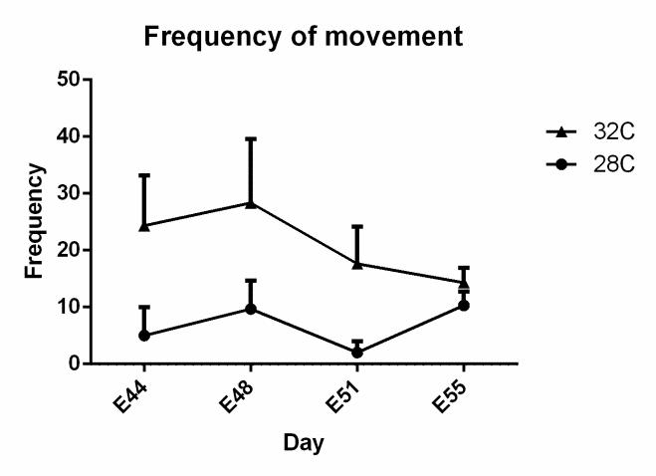
Figure 1. Graph to show effect of temperature on mechanical input at different embryonic time points of incubation: measured as frequency of movement in a 3 minute interval.

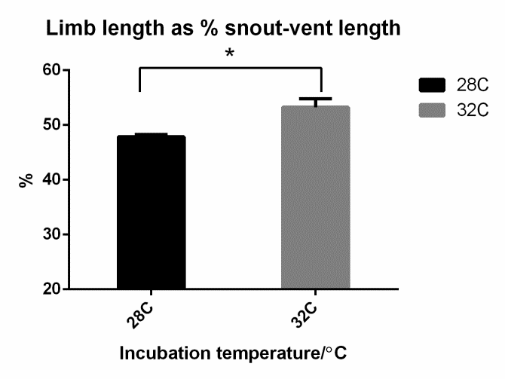
Figure 2. Graph to show the positive correlation between limb length as a percentage of total body length at higher temperatures.

File: UGProjectOutcomes201314-AndrewPitsillidesandBethanyCharlton

