YEAR: 2013/14
SUPERVISOR: DR ABIGAIL TUCKER
STUDENT: MR DEAN MALIK
PROJECT TITLE: UNDERSTANDING THE DEVELOPMENT OF THE EXTERNAL EAR:INSIGHTS FROM MOUSE MODELS

Brief Resume of your Project’s outcomes for the Society’s Website: (no more than 200-250 words). The title of your project and a brief 200-250 word description of the proposed/completed project. The description should include sufficient detail to be of general interest to a broad readership including scientists and non-specialists. Please also try to include 1-2 graphical images (minimum 75dpi). NB: Authors should NOT include sensitive material or data that they do not want disclosed at this time.

Understanding the development of the external ear: insights from mouse models
In this project we have investigated how the external ear (ear canal and pinna) form during normal development using the mouse as a model. We have concentrated on the development of the external ear canal, which we have shown is much more complex then previously described. Defects in the external ear canal (loss or stenosis) lead to conductive hearing loss as sound waves fail to travel to the middle ear. The canal initially forms as an invagination of the surface ectoderm and extends as an open tube towards the middle ear. The tube then collapses before birth to form a thin sheet, which we show involves changes in cell dynamics, cell adhesion and cell survival. This sheet then re-cavitates to form an open tube in later development, with the cells in the presumptive lumen dying by programmed cell death to create the canal. In addition to characterising these events in normal mice we have also investigated defects in this process in mouse models for human syndromes associated with external ear defects. These results will aid our understanding of the mechanisms behind external ear defects, and may help with devising new treatment options.

Figure Legend: Programmed cell death (black spots) in the forming murine external ear canal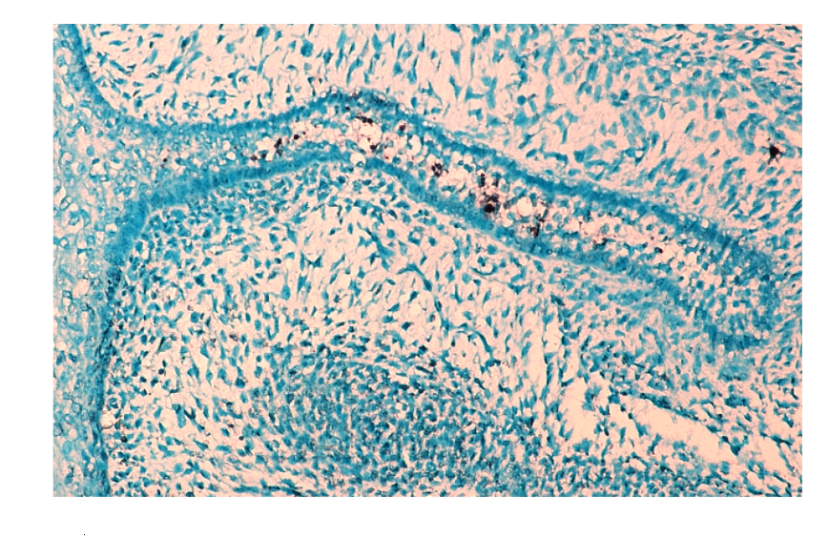

END

File: UGProjectOutcomes201314ATuckerandDMalikimage

