Dear Mary-Anne

Symington Bequest Report

I would like to thank the society for the award of £1,000 from the Symington Bequest Fund Awards 2013/14 – Round 2, to enable me to attend The International Federation of Associations of Anatomists (IFAA) Meeting, 8th to 10th August 2014, Beijing, China.

I was an invited symposium speaker in the session ‘Medical Education in Europe’ with a talk titled: The Secrets of Anatomy Pedagogy: the who, what, why, where and when. Other speakers in this session included Professor Moxham and Dr Bockers. I also gave a talk on the results of the Delphi process titled: A Validated Anatomy Syllabus for Medical Students (C.Smith, G.Finn, J. Stewart and S.McHanwell). I also presented three posters: Transforming Anatomy Educational Landscapes (C.F. Smith, T. Cecot and S. Border), Predicting academic achievement and shaping future medical careers: Is it dependent on our visuo-spatial ability? (Deniz Hassan, Christopher Schulz, Claire F Smith) and a taxonomy for anatomical education (V.Nyamse and C.F. Smith).

The symposium talk was very well received to a full audience and the questions afterwards reflected that the UK is certainly a leader in Anatomical Educational Research. The talk on the core curriculum was also very well attended and I am in no doubt that the results and publication of the revised core syllabus will prove to be adopted internationally and will be well cited in the Journal of Anatomy. The posters were viewed by many, although not many individuals stood by their posters at the required time, I had heard this informally beforehand, so whilst I was there at the required time I also took mini hand-outs of the posters and pinned them to the board, all were taken by lunchtime. The combination of talks and posters has highlighted the ongoing work in the UK to the IFAA Education Committee and it is hoped that further collaborations will take place as a result of this.

To show support for the society I attended the general meeting of the IFAA as an observer. One thing that struck me was the governance of the IFAA not allowing proxy voting for countries that were not present, and this is something I would recommend that the society push for through the IFAA representatives. I also watched the fantastic presentation given by Professor Davies for the Anatomical Society bidding for the next IFAA meeting.

Cont’d….

Mary-Anne Piggott -2- 14th August 2014

Whilst the result was not favourable to the UK the presentation was certainly the best and was the only one to contain any information on potential scientific content, from which the more cynical side says that the voting of this is again not valid as societies who were not present could not vote and it seems to be chosen more based on a good holiday location than the academic content. My overall opinion of the IFAA meeting was very positive as a place for the joining on anatomy research and matters and this should be focused on, for example on the ethics and process of body donation, however the governance raises lots of questions and it is hoped that as a society, and with the new IFAA president changes will occur from within.

I am grateful to the Anatomical Society for their support; I ensured the Anatomical Society was acknowledged appropriately in all talks and posters.

Yours sincerely
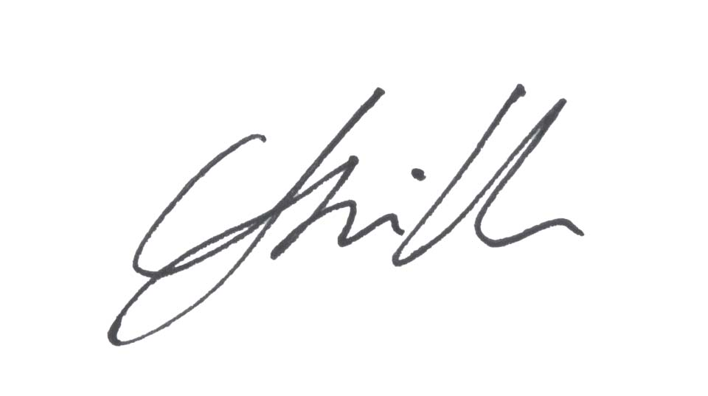
Dr Claire Smith
Head of Anatomy
Reader in Anatomy

