Kerry Thompson, Centre for Microscopy and Imaging, Anatomy, NUI Galway



A preliminary Investigation of the fine structure of the Actin Cytoskeleton in epithelial cell lines using advanced electron microscopy methods

Lab visit with Prof. Dorit Hanein in Sanford Burnham Medical Research Institute, La Jolla, California, February 2014

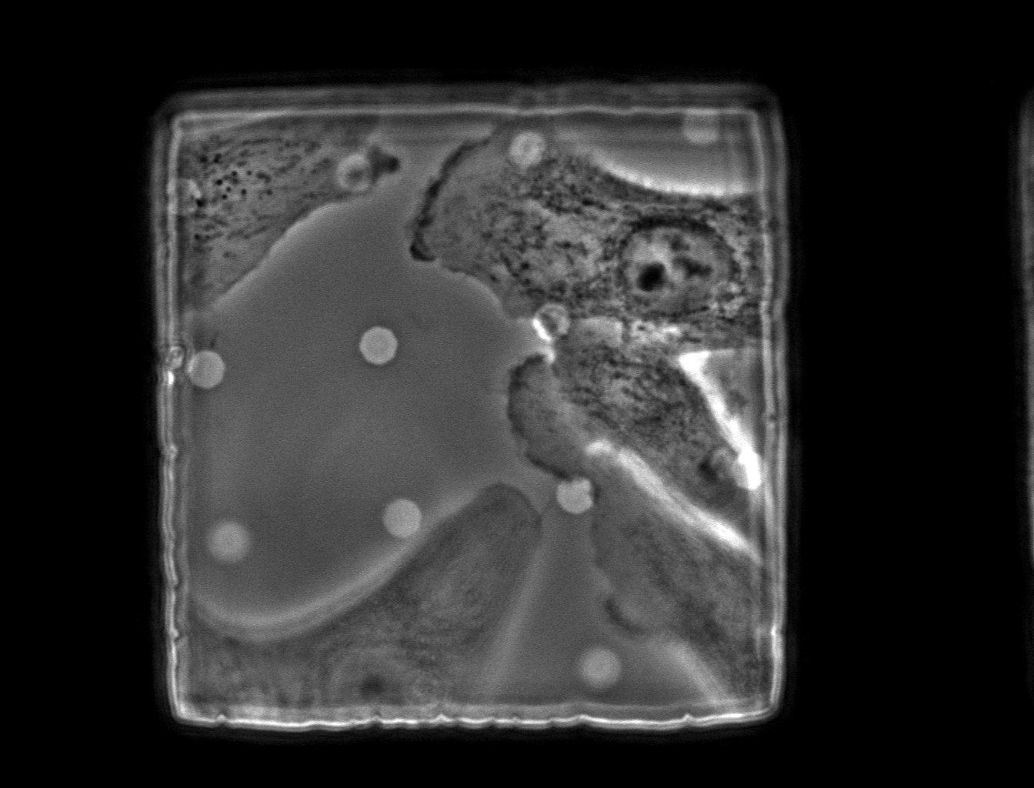
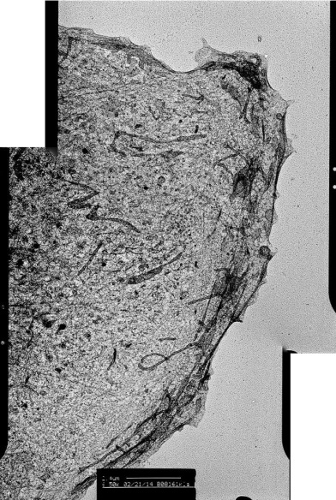
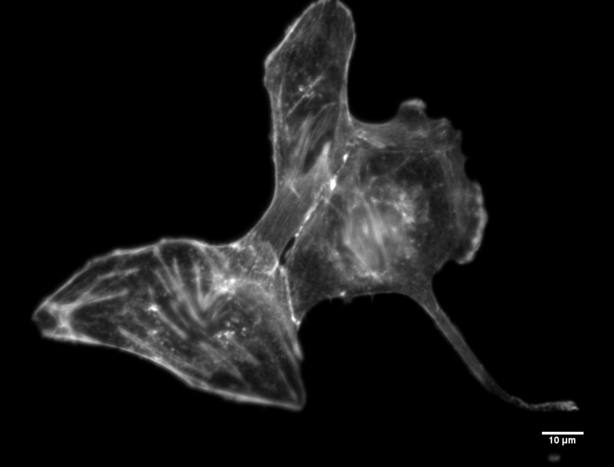
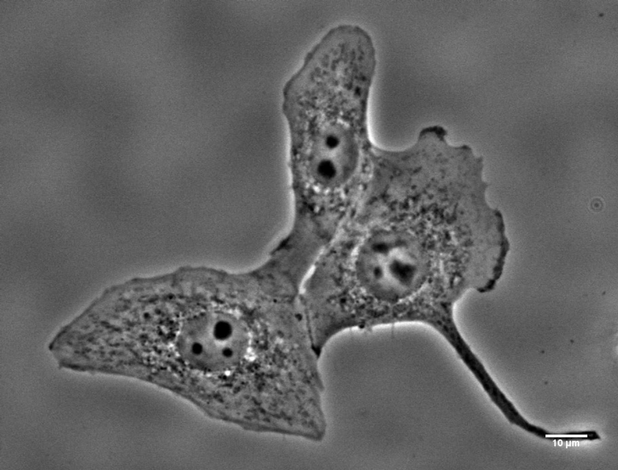
1
2
3

Figure 1: Phase contrast and fluorescence image (594nm Phalloidin) of KLE cells (scale bar 10µm) – cells were cultured on carbon coated MatTec dishes. Figure 2: Phase contrast image of KLE cells cultured on carbon coated TEM grids (scale bar 10µm). Figure 3: A TEM image of the same cell (leading edge) that is highlighted in Figure 2 at higher magnification and resolution (scale bar 2.4µm)

On hearing Prof. Hanein speak at an EMBO meeting in France in 2012, I quickly realized the specialized EM techniques used in her presentation were currently unavailable in NUI Galway and also to be best of my knowledge, perhaps throughout the UK. From this initial meeting, further contact was made with the Hanein lab in 2013 and it was agreed that a visit for research and training purposes would be scheduled for February 2014. From the literature it is known that after short term exposure to Endocrine disrupting Chemicals or EDC’s, rapid structural alterations manifest within many tissues under study. In recent years, our group has been focused on structure function relations in the female reproductive tract, after exposure to EDC’s and other estrogenic compounds. My approach for this work was from a number of backgrounds, as an anatomist, a cell biologist and a microscopist. This pilot study aimed to investigate alterations to patterning of the fine structure of the cytoskeleton in epithelial cell lines through the use of high resolution, high magnification techniques after treatment with estrogen like compounds.
After arriving I was introduced to the lab members and given a tour of the facility. I was assigned a day to day supervisor, Karen Anderson (Senior Electron Microscopy Specialist), and the experimental work started that week. Many conditions must be optimized for these types of correlative light and electron microscopy (CLEM) studies – cell density/concentration, cell spreading, interaction with transmission electron microscopy grids etc. This method of CLEM is referred to as “whole mount” TEM as cells are cultured actually on top of the grids used for imaging. Over the course of my visit, I was given guidance and advice about how best to achieve good results for each stage of the protocol. As is the case with other correlative studies, cells are first located at the light microscopy level and then again with electron microscopy. Using high resolution, high magnification images, ultrastructure and cytoskeletal components can be clearly identified in the cellular peripheries where the electrons can pass easily through the thinner contents. This may aid in the anatomical and histological classification of these structural alterations. Through this collaboration and training with the Hanein lab, we hope to better understand the structural and functional actin cytoskeletal alterations that may occur in epithelial cell lines after exposure to EDC’s.
This visit to Prof Hanein’s lab helped facilitate the collection of data sets through experimental techniques not currently used in NUI Galway. This in turn aids in developing research methods and protocols within National University of Ireland, Galway. This project also establishes transatlantic international collaborative links for potentially both NUI Galway and the Anatomical Society. I would like to thank the Hanein lab for making this trip possible and providing me with a new skill set, and finally I am also most grateful to the Society for their support of this training.
(The Hanein lab is supported by National Institute of General Sciences (NIGMS) Grant Number P01 GM098412 (DH))

