NAME |  | Susan Morgan
UNIVERSITY |  | Cardiff University
NAME OF AWARD |  | Symington Bequest Fund Award 2014/15 Round 5
PURPOSE OF AWARD conference attended (full name) with city and dates
XXIV International Symposium on Morphological Sciences 2-6 September 2015 at Istanbul, Turkey
REPORT: What were your anticipated benefits?
I am conducting interdisciplinary research within the Cardiff School of Biosciences and the Cardiff School of English, Communication and Philosophy into cultural aspects of the anatomical sciences. I have earlier presented my work at a humanities conference, so I looked forward to presenting and receiving feedback on my work at a high profile international symposium of anatomists, clinicians and biologists. I also hoped to capture qualitative data for my research by conducting and recording key interviews with conference delegates.
COMMENTS: Describe your experience at the conference / lab visit / course / seminar.
I am extremely grateful to have been given the opportunity to attend the XXIV International Symposium on Morphological Sciences. It was rewarding in terms of giving me the experience of presenting my work (and receiving feedback) at a high profile scientific conference. Hearing papers by and attending panel sessions with other delegates, who included academics and clinicians, was stimulating in that it widened my knowledge of the field and of the art of giving presentations.

Attending the symposium also gave me the opportunity to conduct interviews with six anatomists, all of whom are long term members of key terminological committees. This helped me to capture important qualitative data for my research. My discussions with them on cultural aspects of the anatomical sciences also helped to clarify some of the questions I am exploring, which relate to gender balance in nomenclature (historical and contemporary), textbooks and teaching.

The symposium was also an excellent way to network and to share ideas with those working in the morphological sciences who are actively involved in research, committee work and teaching.

REPORT: In relation to skills, what were the most important things you gained? (does not apply to equipment grant)
The oral presentation was a challenge as we were asked to restrict our talks to eight minutes. As well as learning to select the most relevant images and diagrams for my slides, I endeavoured to summarise our work: to describe our methods, our hypothesis and how that was contradicted by our findings.

From the interviews I conducted I feel I have gained a far greater understanding of the history of terminology and of the role of nomenclature associations and committees in questions relating to gender balance in anatomy.

REPORT: How do you think you will put this learning experience into practice in the future?
In future presentations, depending on time constraints, I intend to include more data in my slides in order to provide more of a context for our work. We are complementing our study with analyses of the reactions of professional anatomists and clinicians to anatomical imagery, so this learning experience has been invaluable in terms of providing feedback. It has also enabled me to capture empirical data through providing opportunities for interviews. Such data will inform the paper we have started to write, that develops and complements work published in Morgan et. al., 2014, J. Anat. 224, 352-365.

SIGNATURE | 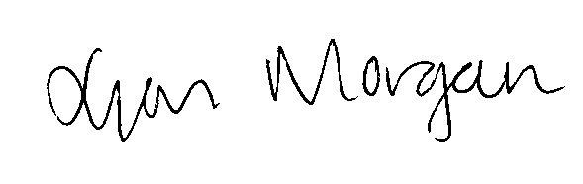 |  | DATE | 09/09/2015
If submitted electronically, a type-written name is acceptable in place of a hand-written signature

