Mechanoadaptation of Developing Limbs: “Shaking a Leg”

Supervisor
Professor Andrew Pitsillides
Royal Veterinary College

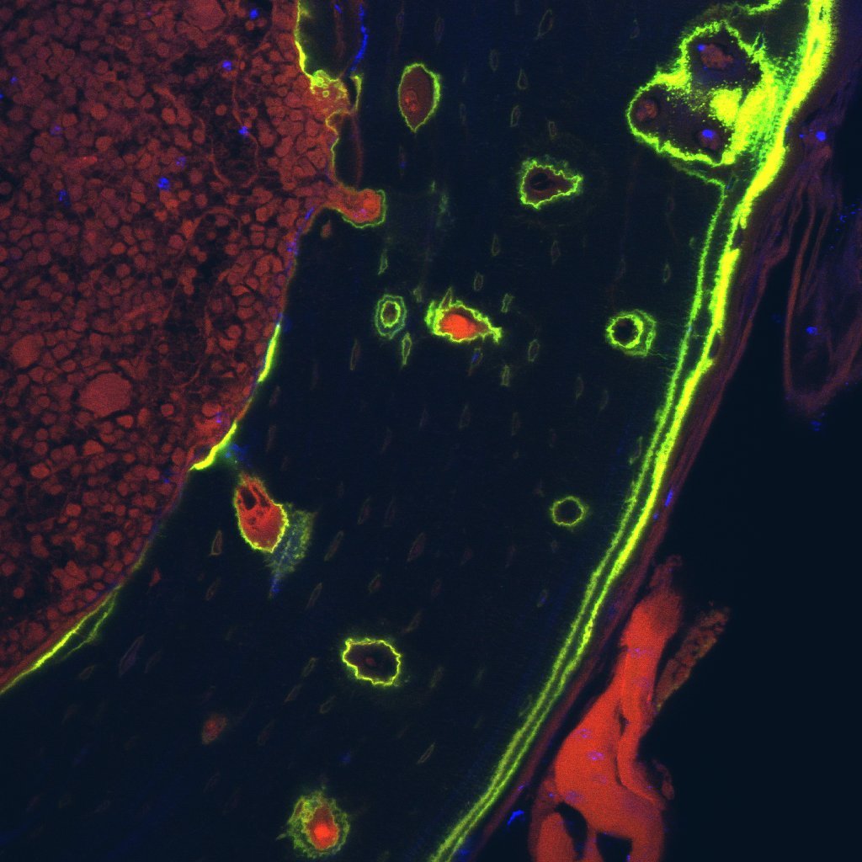
Skeletal tissues function in a changing mechanical environment, and adult bone shape and size are adapted to this input. These mechanoadaptive inputs are likely to alter radically during limb development, yet their role in attainment of the skeletal proportionality necessary for locomotion is undefined. Embryo limbs move spontaneously before osteogenesis and these movements may either impact on the initial stages of bone development or mechanoadaptation may be an acquired characteristic, arising only later in development. We find that the contribution made by movement to skeletal architecture has late onset and that distal bones are more sensitive. This project addresses whether skeletal proportionality relies partly upon specific genes that regulate bone mechanoadaptation.

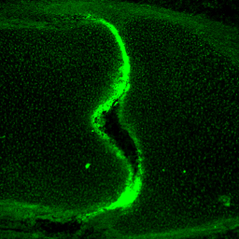
Differential skeletal proportions match to divergent locomotory habits. Relative limb bone size differs between (mice vs. avian) and within classes (chicken vs. ostrich). One distinguishing feature is the relative length of distal elements; longer in ostrich than chicken, which in turn are longer than in mice. The role of mechanoadaptation in these diverse anatomies is unexplored, and it is possible that elongated distal ostrich elements have greater reliance on embryo movement for the marked differential in their growth. This project evaluates the extent to which movement contributes to proportionality of bones along the limb’s proximal-distal axis.

Foetal programming is essential for correct bone function. We have identified a bone gene signature and several candidates associated with acquisition of mechanoadaptation late in foetal development. Work in this project will also aim to pinpoint roles for candidate mechanoadaptive genes in bone development and thus link gene function to anatomical form.

