Expression of autism susceptibility genes in the earliest stages of human cerebral cortex development

Supervisors
Dr Gavin Clowry, Institute of Neuroscience, Newcastle University. http://www.ncl.ac.uk/ion/staff/profile/gavin.clowry

Professor Susan Lindsay, Institute of Genetic Medicine, Newcastle University.
http://www.ncl.ac.uk/igm/staff/profile/susan.lindsay

Our previous work, including microarray, quantitative PCR, histological and cell culture studies demonstrated that area specific gene expression is a feature of the earliest stages of human cortical development. A re-analysis of our microarray findings found that more than 50% of the top autistic spectrum disorder (ASD) susceptibility genes show significant expression at the onset of human cerebral cortex development and many show rostro-caudal expression gradients. This was unexpected as ASD susceptibility genes are usually implicated in synaptogenesis and synapse stabilisation at later stages of development. They could, however, be involved in earlier developmental processes such as neurogenesis and cell migration which, if perturbed, might contribute to ASD symptoms. This hypothesis can be tested by mapping patterns of susceptibility gene expression, in both space and time. when these events are occurring.

Therefore, we propose, using human fetal brain specimens provided by the Human Developmental Biology resource in Newcastle (http://hdbr.org), to study the expression patterns of a group of related ASD susceptibility genes at early developmental stages by,
1) Confirming expression by quantitative PCR.
2) Localizing expression in tissue sections using immunohistochemistry and in situ hybridization.
3) Studying regulation of expression in primary cell cultures from different regions of fetal human neocortex.

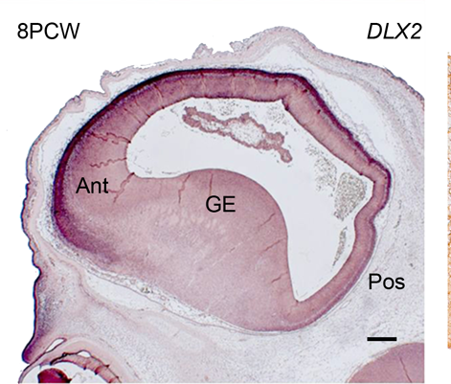
In situ hybridisation study of the expression of the GABA interneuron specifying transcription factor DLX2 in a section from human fetal forebrain at 8 weeks post conception. Expression was high (darker) in the anterior cortex and low posteriorly, as predicted by our microarray study.
Double-immunolabelling of a primary culture of cells from early fetal human cortex. Cells expressing either a radial glial marker or a neuronal marker were observed.

