Centre for Biomedical Sciences Education
School of Medicine, Dentistry and Biomedical Sciences
Queen’s University Belfast
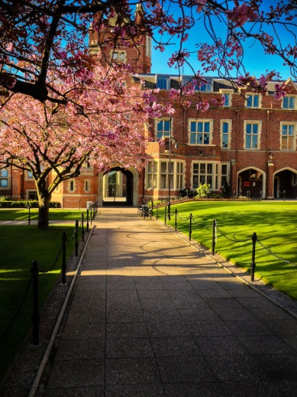
The teaching of anatomy in Belfast has a long and rich history and dates back to 1819 when James Lawson Drummond – Chair of Anatomy and Physiology – introduced the subject within the Faculty of Arts, at the Royal Belfast Academical Institution (Inst.). The Medical Faculty (located at Inst.) was formed in 1835 and housed a dissecting room, lecture room and museum where medical students received their training in anatomy.

In 1849, when Queen’s College Belfast opened, the Medical Faculty moved to the University Road site where lectures in anatomy were held, however, dissection continued at Inst. until 1863 when a new medical building opened in the University Quadrangle. In 1968, the Medical Biology centre (MBC) opened where the current dissecting rooms are located, within the Anatomy Licensed Area (12113) that is regulated by the Human Tissue Authority (HTA).

Cadaveric dissection is undertaken by students across a range of undergraduate degree programmes within the School:
- First and second year Medicine
- First year Dentistry
- BSc (Hons) Intercalated Medical Science
Students studying for a degree in Biomedical Science, Human Biology, Medicine, Dentistry and Intercalated Medical Science also have the opportunity to study histology within the purpose-built Virtual Histology Suite, using PathXL software.
Postgraduate Programmes
Postgraduate students enrolled for the Certificate, Diploma or Masters in Clinical Anatomy have the option of studying gross anatomy across a range of applied anatomy modules, using prosected anatomical specimens. These modules allow students to advance their knowledge of human anatomy and develop the skills associated with teaching; the programmes therefore offer students an excellent foundation for a future career in teaching anatomy as well as developing their knowledge of the subject.
In September 2015, the first intake of students on the new blended learning programmes in Clinical Anatomy commenced their studies. Students enrolled on these programmes have the option of choosing from a range of modules and their learning will take place virtually through access to a series of anatomy web-apps and face-to-face interaction with teaching staff.

Re-development of Anatomy Teaching Facilities
During the summer months of 2015, a major refurbishment programme took place within the Anatomy Licensed Area, including development of a new mortuary and bespoke Surgical Skills Training Area. The programme also included full modernisation of the Main Dissecting Room facility to include advanced interactive touch-screen technology. These major re-development works are part of a major capital investment programme in the University and will provide students with the opportunity to study in a modern and dynamic environment. Clinical colleagues will also have the opportunity to develop their knowledge of anatomy and develop surgical skills within the dedicated Surgical Skills Training Area.

For contact details please refer to our website http://www.qub.ac.uk/schools/mdbs/bms/

