Dr Frank Schubert
University of Portsmouth

Student: M. Ware

Comparative analysis of early axon tracts in the embryonic vertebrate brain

The first neurones differentiating in the embryonic vertebrate brain set up a scaffold of longitudinal, transversal and commissural axons tracts. These tracts were already noted in anatomical studies in the early 20th century, and were revisited from the 1990’s using advanced morphological techniques like immunohistochemistry. This work initially focussed on zebrafish and mouse and led to the term ‘early axon scaffold’ to describe the early tracts. Already the characterisation of the zebrafish and mouse tracts showed remarkable similarities, indicating that at least some features of the early axon scaffold are highly conserved among vertebrates. More species have been described since, but a direct comparison of the tracts between different vertebrates is lacking. Moreover, the early axon scaffold in the chick, a major model species, has not been analysed in any detail. This study aims (1) to describe the development of the early axon scaffold in the chick, (2) to directly compare the early axon scaffold in chick, mouse, frog and shark, and (3) to analyse molecular mechanisms involved in the development of the first neurones and the outgrowth of their axons. Using immunofluorescence and axon tracing, we have determined time and place of origin for the early tracts in the chick embryonic brain. The comparison of the different vertebrates showed that the longitudinal tracts made up of medial longitudinal fascicle (MLF) and tract of the postoptic commissure (tpoc), along with the posterior commissure and its associated transversal tract (TPC) are strictly conserved in all species, and hence can be regarded as stereotype components of the vertebrate early axon scaffold. Following our finding that the first neurones in the chick brain (MLF neurones) differentiate at very early stages, prior to the known expression of most patterning transcription factors in the brain, we employed microarray analysis to search for genes that could be involved in the differentiation and fate determination of the MLF neurones. Expression analysis of candidates identified genes with either region- or cell-specific expression, which hints at a possible role in the development of the MLF. Furthermore, we found that at later stages the expression of the axon guidance molecule Netrin2 suggested a possible role in channelling the TPC into a narrow path. Ectopic expression of Netrin2 in the chick brain interfered with the development of the TPC, indicating that Netrin2 is indeed involved in the formation of the TPC.

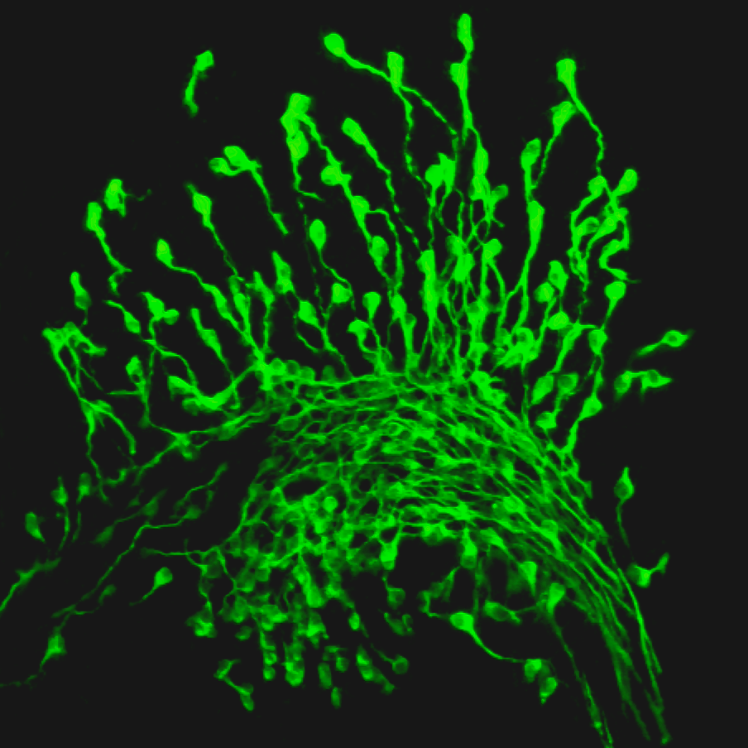

MLF neurones in the brain of a HH14 chick embryo, stained with the anti betaIII-tubulin antibody Tuj1

Presentations resulting from this studentship:

- Poster presentation at Anatomical Society Summer Meeting (Nottingham, Jul 08)
- Poster presentation at Young Neuroscientist’s Day (Cardiff, Oct 08)
- Oral presentation at Biosciences Postgraduate Symposium (Brighton, Dec 08)
- Poster presentation at Anatomical Society Winter Meeting (Oxford, Jan 09)
- Poster Presentation at AAA Experimental Biology conference (New Orleans, Apr 09)
- Poster presentation at ISDB meeting (Edinburgh, Sep 09)
- Oral presentation at Head Group Meeting (London, Jan 10)
- Poster presentation at FENS Forum of European Neuroscience(Amsterdam, Jul 10)
- Oral presentation at Anatomical Society Summer Meeting (Portsmouth, Jul 10)
- Poster presentation at EMBO meeting (Barcelona, Sep 10)

