Dr J. Taylor and Dr Z. Molnar
University of Oxford

Student: T. Lickiss

Axon Outgrowth in the Developing Cerebral Cortex

During the development of the mammalian cerebral cortex, neurons are required to migrate to their final destinations within the developed brain, connect with other neurons through their axons and dendrites, and integrate functionally to produce the mature nervous system. One essential aspect in this is the growth and guidance of the axon.
Using a diverse range of experimental approaches, this project aimed to answer the following three main questions about this process.
- At what point in neuronal migration and development does significant axon growth begin?
- What are the main transcription factors that determine the direction of this growth, and how do these overlap?
- Do non-coding RNA transcripts in close genomic association with these transcription factors have any role in this process?
Using visualization of cortical neurons through electroporation and organotypic slice culture, it was identified that significant axon growth begins a long time prior to the end of radial migration during neuronal development. Combining this method with retrograde tracing and immunohistochemistry it was found that previously identified transcription factors of opposing function, Satb2 and Ctip2, are co-expressed in a subset of cortical neurons, and it is likely that these neurons extend axon branches in diametrically opposed directions as a result. Finally, using in situ hybridization and an array of molecular techniques, it was discovered that proximal non-coding transcripts were expressed in strikingly similar temporal and spatial patterns to their transcription factors, and that these are likely to play a role in regulating the activity of these transcription factors underlying axon growth during development.

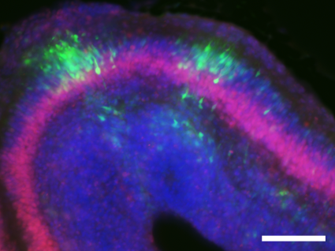
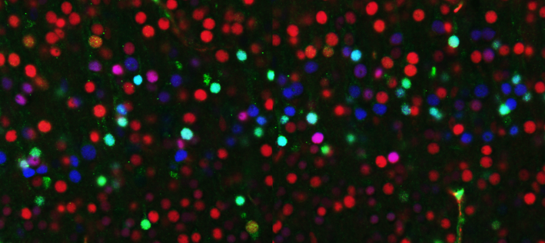

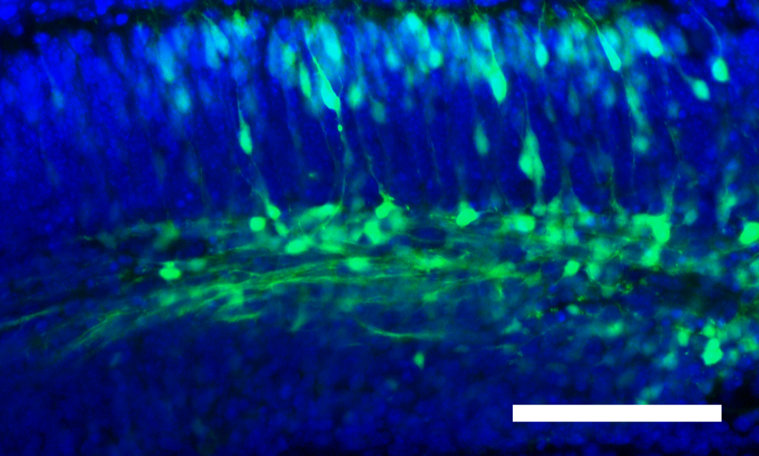

Presentations resulting from this studentship:

- "Long Noncoding RNA Partners of the Transcription Factor Satb2 in Callosal Projection Neurons of the Mouse Cerebral Cortex" Abstract presented at Anatomical Society Conference, January 2010.

- "Directed Axon Growth Begins During Radial Migration through the Intermediate Zone in Mouse Cerebral Cortical Development" - Abstract presented at Anatomical Society Conference, January 2009.

- "EARLIEST PROJECTIONS FROM DEVELOPING NEOCORTICAL LAYER V PYRAMIDAL NEURONS" - Abstract presented at Axon Guidance, Synaptogenesis & Neural Plasticity Meeting, Cold Spring Harbor, 2008.

- "Development of Differential Axon Growth from Layer V of the Cerebral Cortex" - Abstract presented at Anatomical Society Meeting January 2008.

