The National Undergraduate Neuroanatomy Competition 2016
On Saturday 9th April, the Faculty of Medicine at the University of Southampton, in association with The Anatomical Society hosted its fourth annual National Undergraduate Neuroanatomy Competition. Ninety eight medical students from across the UK and Ireland attended the one day conference that was designed to inspire and enhance the skills of budding neurologists and neuroscientists. Taking place at Southampton General Hospital, competitors sat both a multiple choice exam and a neuroanatomy spotter. The overall winner for the day was Theron Ng Sir Yuan (Dundee University) obtaining the highest score ever recorded at the competition. We were honoured to have with us special guest speakers Professor Ceri Davies (Imperial College London) and Dr Roxana Carare (University of Southampton) who gave exhilarating lectures in the afternoon. The formal welcome address this year was given by our newly appointed Associate Dean for Education, Professor Karen Morrison.
The event was led by final year medical student, Ellie Seaby, who collaborated with a dedicated team of students, faculty staff and clinicians. The competition continues to go from strength to strength each year, attracting an increasing number of competitors. We would like to thank everyone who has supported and helped the event become a success particularly The Centre for Learning Anatomical Sciences, The Anatomical Society and The Royal College of Surgeons Edinburgh.

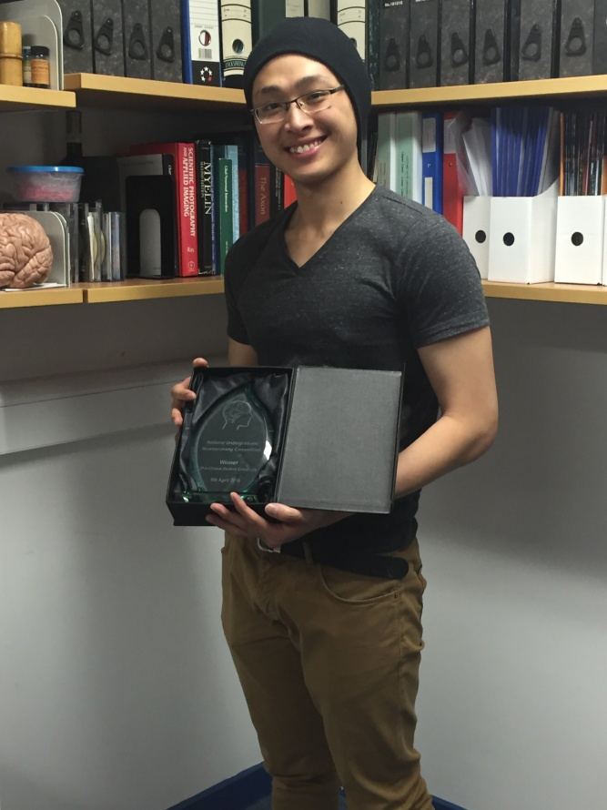
Overall Winner Pre-clinical: Theron Ng Sir Yuan (Dundee)

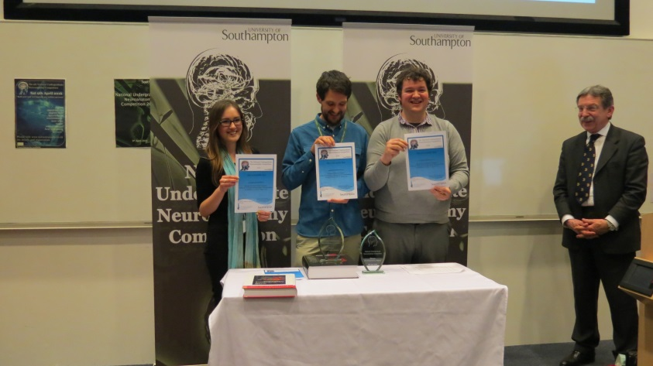
Runner-up Pre-clinical: Emma Jane Norton (St George’s)Winner clinical: Felix Gill (St George’s)Runner-up Pre-clinical: Edward Droscher (Manchester)
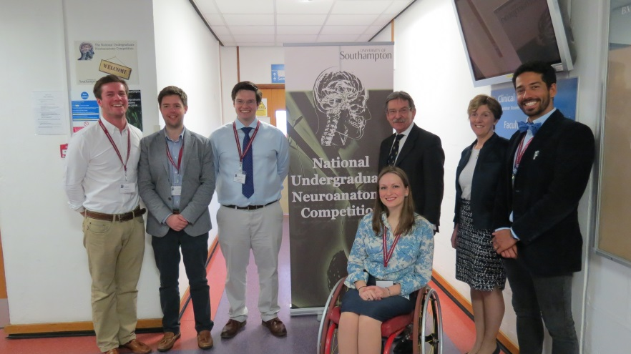
Committee members Jonny Stephens, Andrew Lowry, Sam Hall, Teu Andrade and Ellie Seaby with Professor Ceri Davies and the Associate Dean for Education at Southampton Professor Karen Morrison

