
A partnership between the Universities of Brighton and Sussex with the NHS
Brighton and Sussex Medical School, established in 2003, is an equal partnership between the Universities of Sussex and Brighton together with NHS organisations throughout the South East region. The arrangements for the School's governance reflect this approach and students are awarded joint BM BS degrees of both Universities.

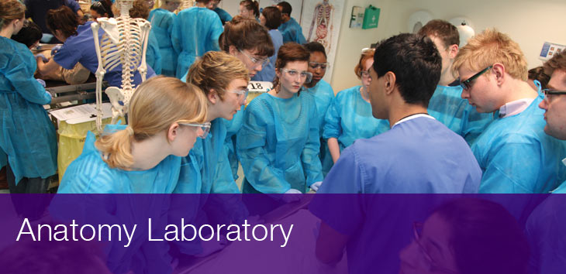
The Anatomy Department was established by Professor Di Lawrence-Watt in 2003. It is a very popular part of the curriculum and is one of the reasons so many students decide to come to BSMS.
“Being able to dissect from a very early stage is one of the greatest things about being at BSMS. It really helps your understanding of medicine being able to see and touch the different structures for real, supporting the knowledge that has been taught previously in lectures”. Will Whyte, 1st year student.

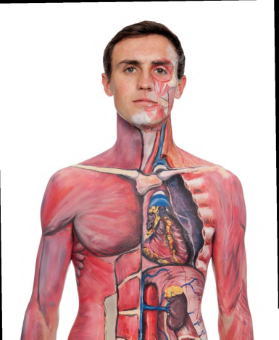
Anatomy is an integral part of the undergraduate medical course and is widely recognised as one of the selling points of the programme. Anatomy at BSMS is designed to be an exciting and varied theme within the course. There is a strong focus on multidisciplinary teaching and all aspects of anatomical teaching and learning are reinforced by functional and clinical input.
The Anatomy Laboratory is located in the Medical Teaching Building on the University of Sussex campus and was opened in 2003. The facility includes a fully equipped state-of-the-art anatomy dissecting room. Although the focus of the Laboratory's use is the undergraduate medical curriculum, where dissection is the corner stone of anatomical teaching, we also help to deliver anatomy teaching as part of a number of other undergraduate and postgraduate courses as well as professional training programmes.
The Anatomy Laboratory is licensed under The Human Tissue Act 2004, regulated by the Human Tissue Authority. The licence holder is the Registrar of the University of Sussex and the day-to-day responsibilities for the licence reside with the 'Designated Individual' (DI).

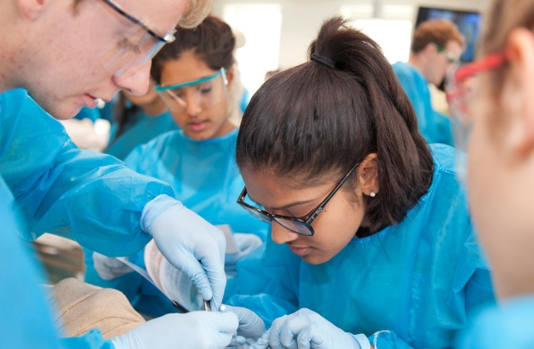
Undergraduate
At BSMS anatomy is taught using a full range of teaching and learning skills. Within years 1 and 2 undergraduate students dissect specified regions of the human body aided by structured notes which are designed to ensure students gain a complete understanding of how structure and function within the body are so closely related and how such knowledge forms the basis of clinical medicine.
Throughout the teaching of anatomy, physicians, surgeons and radiologists all participate in lectures, tutorials, clinical symposia and practical classes alongside the anatomy team, enabling the students to observe the strong underpinning of clinical medicine with the basic medical sciences.
Demonstrators in Anatomy, all of whom are surgical SHOs work with the students both within the dissecting room and in module tutorials bringing to the course their everyday clinical experiences as junior house doctors. In year 2 of the course some dissection is still undertaken, with students also studying structure and function from prepared prosected specimens.
Living anatomy is a very important part of the course, with students learning the basis of clinical examination from the knowledge they gain of important surface landmarks of thoracic and pelvic viscera. In living anatomy sessions students also study joint structure and movement which introduces them to biomechanics as a first introduction to the discipline of orthopaedics.
A particular strength in the teaching of anatomy at BSMS is the linking of anatomy with modern day medical imaging with students undertaking self directed interactive imaging sessions in the IT suite to enhance and strengthen the knowledge gained in the anatomy practical classes, tutorials and lectures.

Postgraduate
Postgraduate anatomy also has a very high profile at BSMS. The anatomists contribute to the MSc degree in Orthopaedics and Trauma with candidates for the degree spending valuable time within the dissecting room studying surgical anatomy relevant to their level of study as well as the MSc in Cardiology. Many of the orthopaedic surgeons from the Trust Hospitals also utilise the BSMS dissecting facility both for the running of surgical courses and undertaking research projects related to anatomical examination to confirm, or even refute, dogma in surgical practice.
'The anatomy teaching is one of the best aspects of the course. Our lecturers are amazing and dissections help you to appreciate what you are learning in a way that no text-book can teach. Regular imaging practicals also give us a taster of anatomy's relevance.' Mark Abel
The Team
Dr Claire Smith
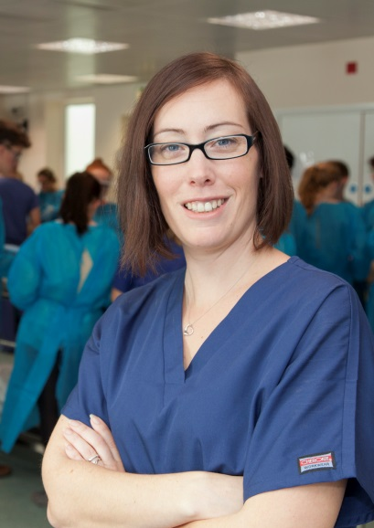
Dr Smith is Head of Anatomy and joined the team in 2013. Dr Smith’s research focuses on understanding the student learning experience so that the learning can be improved. Her seminal research has led the field in understanding how students learn. Her recent focus has been on student psychometrics including; approaches to learning, learning styles, personality and spatial ability. Dr Smith has also published in the areas of assessment, standard setting and e-learning. She has also contributed quirky and creative papers to the literature, including; Comforting Cadavers, exploring the use of fabric condition in dessicated specimens, Felxor Pollis Action, investigating students perceptions and use of demonstration videos and Histology Slides into the 21st Century. Dr Smith is Chair of the Education Committee Anatomical Society as well as a member of council. Dr Smith is also a member of the Court of Examiners for the Royal College of Surgeons and holds numerous External Examining Appointments at other Medical Schools. Internationally Dr Smith is the Anatomical Society representative for the European Federation Experimental Morphologists and the Trans European Research Anatomy Pedagogy Group.
Dr Andrew Dilley
Dr Andrew Dilley is Senior Lecturer in Anatomy and joined BSMS in 2007. His research focuses on the neurobiology of nociception (pain) and the mechanisms of painful peripheral neuropathies. Dr Dilley’s research is aimed at understanding the pathophysiology of conditions such as repetitive strain injury (RSI) and complex regional pain syndrome. Specifically, the laboratory is focused on determining the physiological mechanisms that cause inflamed nociceptors to become hyperexcitable. His research employs highly skilled single unit electrophysiological techniques to examine the properties of nociceptors. As part of a two-pronged approach, Dr Dilley also conducts human studies that employ a range of imaging techniques (MRI and ultrasound) to identify signs of neuritis (nerve inflammation) and pathology in patients. A major focus of his work has been the development of ultrasound motion tracking software to enable investigations into soft tissue biomechanics. Dr Dilley has published extensively in the field of pain.
Dr Ricardo Governo
Dr Governo is a lecturer in Anatomy and joined BSMS in 2008, affiliated into the Clinical and Laboratory Investigation unit. Awarded a PhD in Neuroscience in 2003 Dr Governo’s research interest since then has been to investigate the transmission, processing and modulation of pain. These include researching the effect of analgesic, antidepressant or antiemetic compounds on noxious stimuli, resulting in several publications in research journals related to the field of pain or NMR imaging. His research experience includes immunocytochemistry, immunofluorescence, electron microscopy, behavior testing, patch-clamp recording and fMRI imaging. Dr Governo’s latest focus is to develop collaborative links to investigate the impact of sexual-specific hormones in the processing of acute and chronic pain.Dr Governo also leads numerous large or small-group sessions to first or second year medical students, as a means of promoting the GMC’s directive of encouraging medical students to become more involved in research. These sessions provide a detailed insight into scientific research including the development of study paradigms, the pitfalls of ethics applications, data analysis and statistics, plus data dissemination and presentation.
Ms Tracy Young
Tracy has been the Prosector at BSMS since 2007. Tracy oversees the day to day running of the DR and also teaches anatomy to first and second year students and also supervises SSCs and Individual Research Projects.
In her role as Person Designate, Tracy maintains the paperwork in relation to the donation of human cadavers. Tracy also maintains all records regarding the cadaveric material held by BSMS and facilitates the arrival and disposal of all material. As the main Prosector, Tracy directs the production of all dissected specimens and leads on the preparation of samples for each teaching session. Tracy also leads on all technical aspects of the facility including the overseeing of operating procedures and is responsible for Health and Safety matters.
DR Technician
This is a new post. The post holder will support Tracy in the day to day running of the DR, preparing specimens and cadavers for teaching sessions and maintaining the DR to a high level.
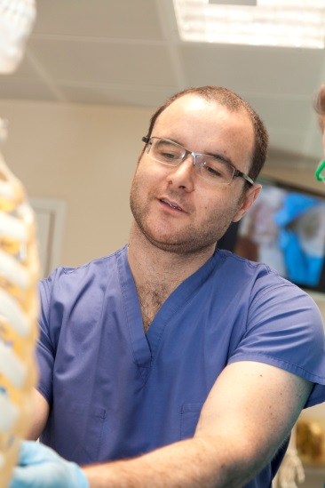
Demonstrators
Anatomy Demonstrators are essential members of our teaching team and are important players in the development of our students thorough guidance, support and delivery of high quality anatomical teaching. Our five demonstrators are enthusiastic teachers, good communicators and display excellent interpersonal skills. There are two different demonstrator positions within BSMS:
A 12-month period as an Anatomy Demonstrator. Demonstrators on this programme are required to take part in a 1:5 rotation as Resident Medical Officer at the Nuffield Health Brighton Hospital, covering 24 hours per session.
http://www.nuffieldhealth.com/hospitals/brighton/our-hospital
Or, a four-month F2 Anatomy Demonstrator rotation as part of the Postgraduate Foundation Training Programme which follows medical school.
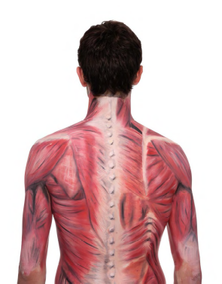
Divisional Assistants
Ms Lisa Costick and Mrs Ellen Thomas support the Anatomy Department in a job share role.
Lisa has been at BSMS since the early days of 2003 and Ellen joined in 2007.www.bsms.ac.uk

