Bones and Joints
Label the bones and joints of the lower limb;
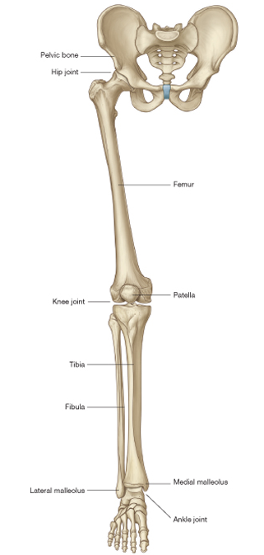
Bones and Joints
Label the movements at the hip joint;

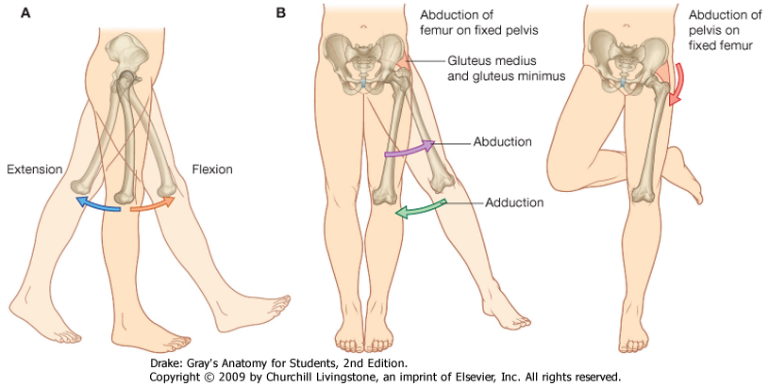
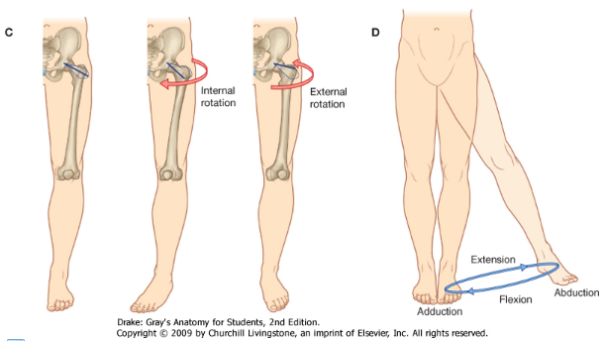
Bones and Joints
Label the movements at the knee and ankle joints;

