Anatomical Terms Wordsearch
ACROSS  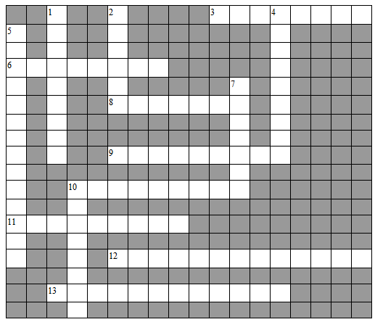  3. circular movement of a bone around its own axis  6. situated at or directed toward the front  8. denoting a position farther from the median plane or midline of the body or a structure; the side or outside  9. movement of a limb away from the midline or axis of the body  10. a "straightening" movement allowed by certain joints of the skeleton that increases the angle between two adjoining bones  11. movement of the foot where the plantar surface is tilted to face the midline of the body  12. circular movement of a limb  13. upward or backward flexion of the foot | DOWN  1. directed toward or situated at the back  2. pertaining to, situated in, or oriented toward the midline of the body  4. the movement of a limb toward the midline or axis of the body  5. a toe-down motion of the foot at the ankle  7. a movement allowed by certain joints of the skeleton that decreases the angle between two adjoining bones  10. movement of the foot where the plantar surface is tilted away from the midline  Choose from this list of words;  Anterior  Posterior  Medial  Lateral  Flexion  Extension  Abduction  Adduction  Circumduction  Rotation  Plantarflexion  Dorsiflexion  Inversion  Eversion

