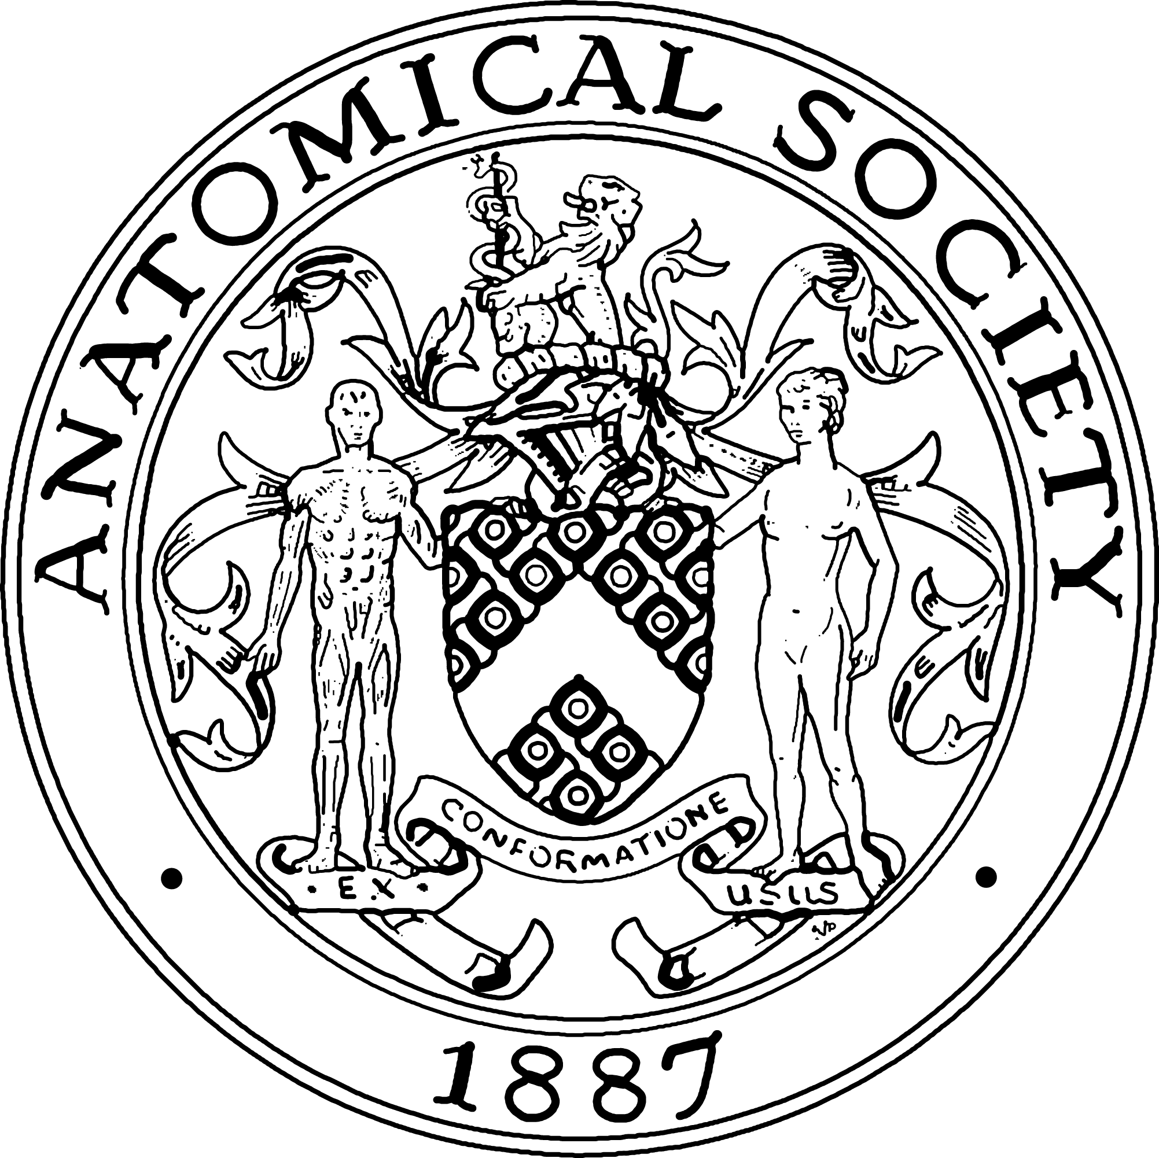
Public engagement and Outreach Grant Guidelines

These grants aim to
- Ignite curiosity in young and old audiences about the anatomy of humans and animals.
- Stimulate Anatomists to share their stories, passion and expertise in innovative ways with wider audiences, particularly those that are traditionally hard to reach
- Increase dialogue between researchers and the public, in particular on topics such as the animal research and the relevance of such research to health and medicine.
- Support primary, secondary, and tertiary teaching through linking schools with academics experts
- Stimulate an interest in Anatomy and Anatomy teaching

Grants can provide funding for
- Resources e.g. printed material, display items
- Speaker and demonstrator expenses e.g. travel and accommodation
- Marketing material/merchandise from the Anat Soc
- Festival stand costs and expenses e.g. travel and accommodation
- Prizes for student events

Grants cannot provide funding for
- Honoraria
- Food and drinks receptions

Terms and conditions
- Grants are for up to £500, with up to 10 grants awarded a year
- Applications can only be made by Members
- Applications should be submitted by the deadlines stated on the society webpages
- Retrospective applications (from the date the Prizes and Awards committee meets as published on the Society Website) will not be considered
- Funds received through this grant scheme must only be used for the purposes outlined
- Funds will be provided after the event upon the production of receipts using the society’s Expense Claim Form. Completed Forms and original paper receipts must be sent within one month of the event to the Honorary Treasurer of the Anatomical Society.

Professor Kieran McDermott
Honorary Treasurer Anatomical Society
Graduate Entry Medical School
Rm3-008
University of Limerick
Limerick V94 T9PX
Ireland

- Expenses over the original awarded grant will not be met by the Society.
- Copies of generated material should be submitted to the Society where applicable.
- The Society must be acknowledged in all promotional material, website and at the event itself, and logo usage must be signed off by the office.
- Upon completion of the project/event you will be required to produce a detailed post-activity report detailing activities, outcomes and recommendations within one month of the event to be sent to the Society’s Outreach officer.
- Expenses will not be paid in the absence of a report.
- Please confirm that you have obtained permission from the people in any photographs submitted as part of your report or separately that they are content for their image to appear in any publicity produced by the Society e.g. Anastomosis (Newsletter, Website, Social Media).

If you do not comply with the terms and conditions set out here, or if the grant is not used for the purpose with which it is given, the funds will be withheld at the discretion of the Anatomical Society.

File: PE&O Updated Guidelines – v2-260220

