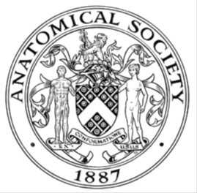
_______________________________________________________________________________________
AWARDEE REPORT FORM
_______________________________________________________________________________________

NAME |  | Orla McCorry
UNIVERSITY |  | University of Glasgow
NAME OF AWARD |  | Barclay Smith Travel Fund
PURPOSE OF AWARD conference/event attended/organised (full name) with city and dates.
To attend the International Federation of Associations of Anatomists conference in London August 9th-11th 2019.

REPORT: What were your anticipated benefits?
I anticipated the conference to be a great networking event to meet many anatomists with different experiences and research interests. I was also presenting a poster for the first time and therefore learning how scientific poster presentations are run and how to answer questions about my work.
COMMENTS: Describe your experience at the conference / lab visit / course / seminar/ event.
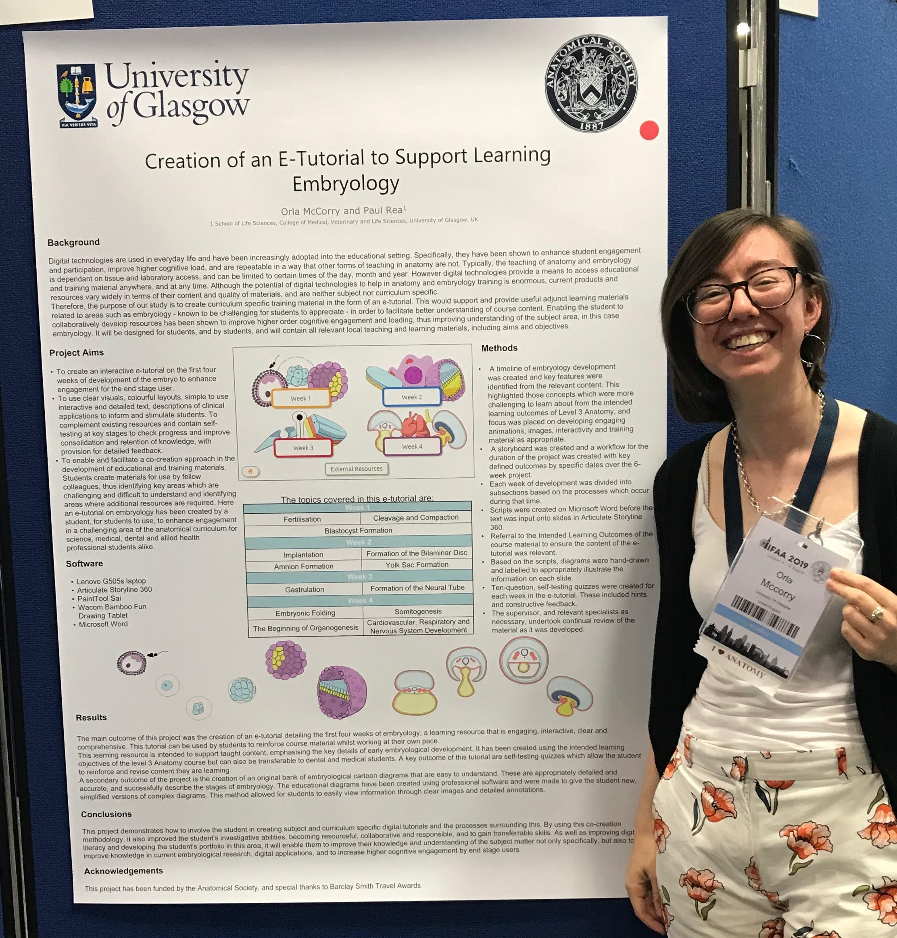
The conference was brilliant. It was the first large-scale conference I have attended, and I didn’t truly know what to expect from it.
The speakers and presenters were very interesting and it was great to learn more about topics and research that these people are so passionate about. There were plenty of talks to choose between and it was great to see the diversity of topics available to learn more about.
On the Sunday I had the opportunity of presenting a poster of my own work. It was an amazing experience to show off research achievements and it made me feel part of the community and my participation here was validated.
The atmosphere was much more relaxed than I thought it would be. There was a valuable emphasis on the social aspect of the conference, which I really enjoyed. It was lovely to meet other people with similar interests as well as interests that I was previously unaware of. The conference showed off the great sense of community that surrounds anatomy.

REPORT: In relation to skills, what were the most important things you gained? (does not apply to equipment grant. For public engagement/outreach awards what did your audience gain and how did you evaluate success?
I gained invaluable experience presenting a poster at the conference, these included presentation skills and engagement skills, as well as gaining the knowledge of how to create an informative scientific poster.
Presenting was also good experience in answering questions about my work. I also gained networking skills with anatomists from across the world.

REPORT: How do you think you will put this learning experience into practice in the future? For public engagement/outreach awards how with the materials/knowledge generated by this activity be used in the future?
I now understand better what a conference is for and how to present scientific findings in small digestible parts but remaining interesting and engaging. I hope to attend more conferences in the future and learn more about what research is current in the anatomy community. I aim to integrate further by presenting my work at future Society meetings

Data Protection/GDPR: I consent to the data included in this submission being collected, processed and stored by the Anatomical Society.
YES/NO Yes
Graphical Images: If you include graphical images you must obtain consent from people appearing in any photos and confirm that you have consent. A consent statement from you must accompany each report if relevant. A short narrative should accompany the image.
YES/NO Yes

Copyright: If you submit images you must either own the copyright to the image or have gained the explicit permission of the copyright holder for the image to be submitted as part of the report for upload to the Society’s website, Newsletter, social media and so forth. A copyright statement must accompany each report if relevant.
YES/NO Yes

SIGNATURE | Orla McCorry |  | DATE | 4/9/19
If submitted electronically, a type-written name is acceptable in place of a hand-written signature

File: AS-Award-Report-Form-BLANKCO-SEAL-date110216-Amended AT-070818

