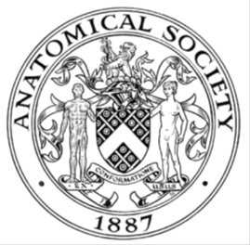
_______________________________________________________________________________________
AWARDEE REPORT FORM
_______________________________________________________________________________________

NAME |  | Natalia Penar
UNIVERSITY |  | University of Edinburgh
NAME OF AWARD |  | The Barclay-Smith Travelling Fund
PURPOSE OF AWARD conference/event attended/organised (full name) with city and dates.
Anatomical Society Winter Meeting July 2022
Dublin
04-06.07.2022

REPORT: What were your anticipated benefits?
The Meeting in Dublin was the first Anatomical Society conference I have attended. I expected to meet and connect with other members of the Society, get insight into the work of fellow scientists, share my own work and gain experience in presenting it.
COMMENTS: Describe your experience at the conference / lab visit / course / seminar/ event.
The Meeting was overall a fantastic experience. I have met inspiring scientists at different stages of their careers and had an opportunity to discuss the research presented at the conference. I found the talks interesting, and took notes of topics I found particularly relevant to my own research.

It was the very first time I have presented my work at a conference. I did it both in a form of a poster and as a flash talk presentation. I enjoyed both forms of presenting my work, and received some insightful suggestions regarding my future work while talking about my project with others.

REPORT: In relation to skills, what were the most important things you gained? (does not apply to equipment grant. For public engagement/outreach awards what did your audience gain and how did you evaluate success?
For the purpose of this Meeting, I have learnt to present my research in form of both a poster and a short presentation. The conference was also a great opportunity to practice my public speaking skills. Since the skill to share one’s work with others is so crucial in research, I believe all of those gained and improved abilities to be extremely important.

REPORT: How do you think you will put this learning experience into practice in the future? For public engagement/outreach awards how with the materials/knowledge generated by this activity be used in the future?
Learning how to present my research will help me in doing so at the future conferences, in which I hope to share even longer presentations than just the flash talk. I also believe this learning experience will help me in communicating my work with others even more effectively.

Data Protection/GDPR: I consent to the data included in this submission being collected, processed and stored by the Anatomical Society. Answer YES or NO in the Box below
YES
Graphical Images: If you include graphical images you must obtain consent from people appearing in any photos and confirm that you have consent. A consent statement from you must accompany each report if relevant. A short narrative should accompany the image. Answer N/A not applicable, YES or NO in the box below
N/A

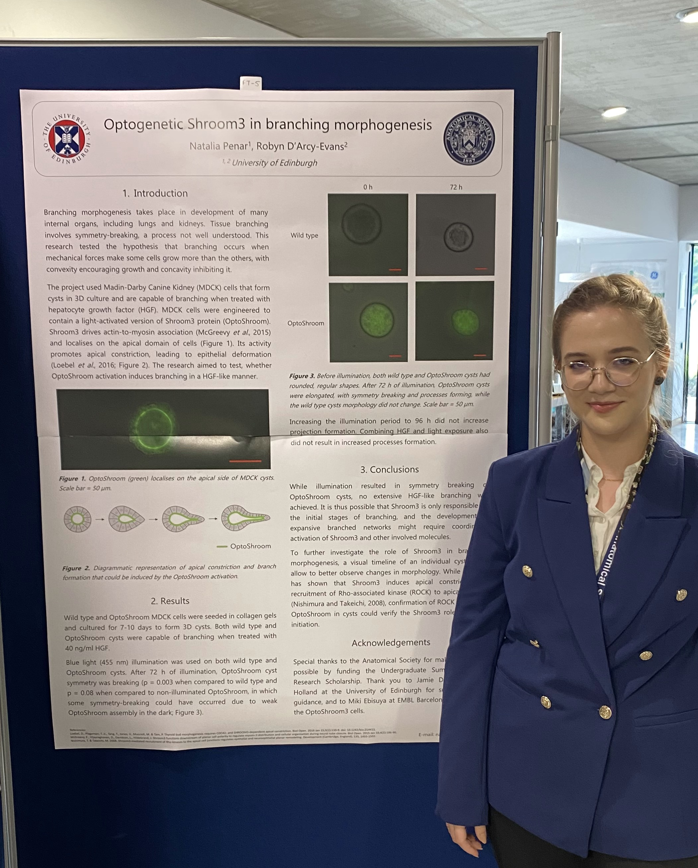
A photo of myself, standing next to my poster (Optogenetic Shroom3 in branching morphogenesis, co-author: Robyn D’Arcy-Evans).

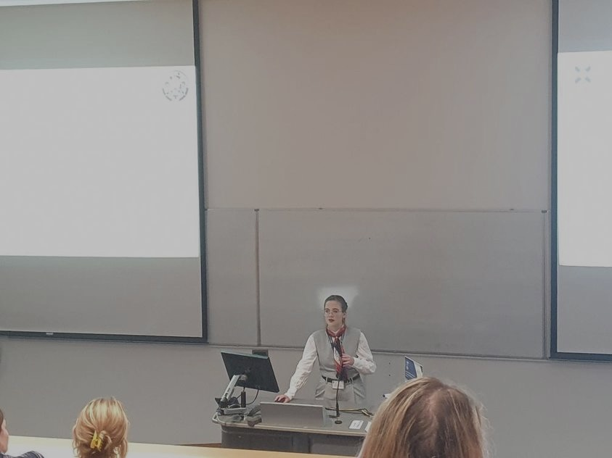
A photo taken during my Flash Talk presentation (Optogenetic Shroom3 in branching morphogenesis, co-author: Robyn D’Arcy-Evans).

Copyright: If you submit images you must either own the copyright to the image or have gained the explicit permission of the copyright holder for the image to be submitted as part of the report for upload to the Society’s website, Newsletter, social media and so forth. A copyright statement must accompany each report if relevant. Answer N/A not applicable, YES or NO in the box below
YES

SIGNATURE | Natalia Penar |  | DATE | 31.07.2022
If submitted electronically, a type-written name is acceptable in place of a hand-written signature

File: AS-Award-Report-Form-190919

