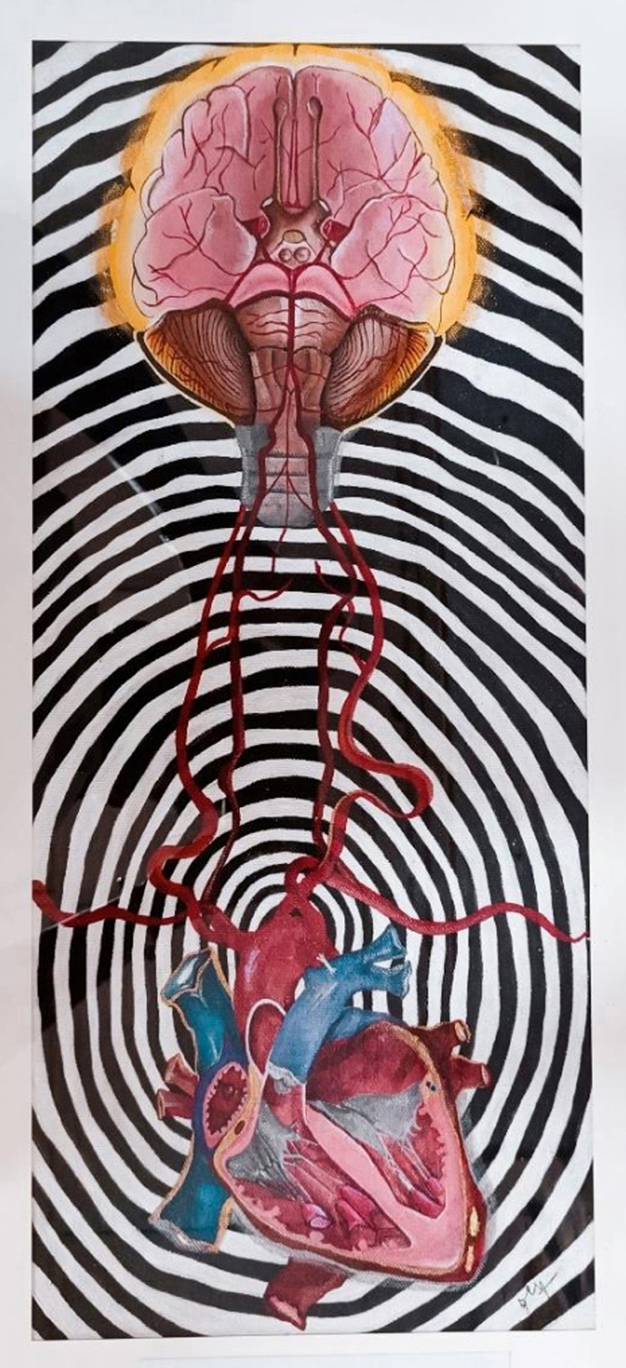
File: Arch of Aorta – website upload 190723

